Form 174 > User Manual

User Manuals
Integrated e-Filing and CPC 2.0
Project Module: e-Filing Forms
Use Case ID
Use Case Description | Form No.174  <Application for notification under Schedule V [Table: Sl. No.7.Note 5(a)(iii)(D)] (Pension Fund)[Form No. 174] (Formerly known as Form 10BBA as per Income-tax Act, 1961)
Confidentiality Agreement
"This document contains proprietary information exclusively vests with ITD. This document may not, in whole or in part, be copied, photocopied, stored, saved, reproduced, replicated, disseminated, translated, transmitted or reduced to in any medium (whether electronic, mechanical, machine-readable and/or any other tangible or intangible form of any nature), by the intended recipient/s or user/s without the express consent, in writing, from the Authorized Representative of ITD Management." All the Intellectual Property Rights (i.e. copyrights) as may be available under the applicable laws, pertaining to ITD's confidential information, shall exclusively vest with ITD only, and any breach thereof shall be subject to indemnification.
Revision History
Ver. | Date | Author | Reviewer/ Approver | Comments
0.1 | 13-03-2026 | Kanika Porwal | Sonia Rani | Initial document
Note: Once approved, unapproved versions will be removed from the list
Reviewed by:
Sl. | Organization | Name | Designation
1 | Infosys Ltd | Adrian Lasrado | Program Manager
2 | Infosys Ltd | Parul Aggarwal | Principal Consultant
3 | Infosys Ltd | Anu Malhotra | Senior Project Manager, Development
4 | Infosys Ltd | Manthuri Kavitha | Quality Engineering Lead
5 | Infosys Ltd | Jaisy Ann Cheriyan | Senior Technology Architect
6 | Infosys Ltd | Ravi Kiran Thallapureddy | Principal Technology Architect
7 | Income-tax Department | Ajay Robin Sir | Addl DIT
8 | Income-tax Department | Christabel D'Mello | JDIT
9 | Income-tax Department | Hari Kumar | JDIT(S)
10 | Income-tax Department | Praveen Sinha | JDIT
11 | Income-tax Department | M Devaki | DDIT
12 | Income-tax Department | K.S.A. Seshasailendra | DDIT
13 | Income-tax Department | Madhukar Peri | DDIT(S)

Table of Contents
About this document
Form 174 > User Manual
- Overview
- Prerequisites for availing this service
- About the Form
- Step-by-Step Guide
- Related Topics
- Glossary

About this document
The purpose of this document is to provide step-by-step instructions to the taxpayers to use the e-filing portal. The content in this document (in the following pages) will be converted into HTML pages and integrated with the e-Filing portal; the presentation of the content in terms of color, font, size will be as per the UI guidelines followed in the website.
The document also contains list of glossary terms specific to this document. These terms will also be added to the overall Glossary in the Help section of the website.

Form 174 > User Manual

1. Overview
Form 174 is filed by an Pension fund to avail 100% tax exemption to their dividend, interest, any sum referred to in section 92(2)(k) of Income Tax Act, 2025 and capital gains arising from under an investment made by a specified person in India, whether in the form of debt or share capital or unit.

2. Prerequisites for availing this service
- Taxpayer is registered at e-filing portal.
- Taxpayer has valid Username (PAN) and Password of E-filing 2.0 portal
- Status of PAN of the Taxpayer is "Active" as per PAN database
- Taxpayer should have a valid DSC to verify form through DSC Mode. It should be registered at e-filing portal & not expired.

3. About the Form

3.1 Purpose
Objective of filing this form is to avail 100% tax exemption to their dividend, interest, any sum referred to in section 92(2)(k) of Income Tax Act, 2025 and capital gains arising from under an investment made by a specified person in India, whether in the form of debt or share capital or unit.

3.2 Who can use it?
Form 174 is filed by an Pension fund - as per Schedule V [Table: Sl. No.7.Note 5(a)(iii)(D)] of the Income-tax Act, 2025. A pension fund which is specified by the Central Government, by notification for this purpose and fulfils conditions specified in such notification; and satisfies such other conditions as prescribed.

3.3 Form at a Glance
Form 174 has four panels:
- Part A - Particulars of the Pension Fund
- Part B - Certification
- Attachments
- Verification
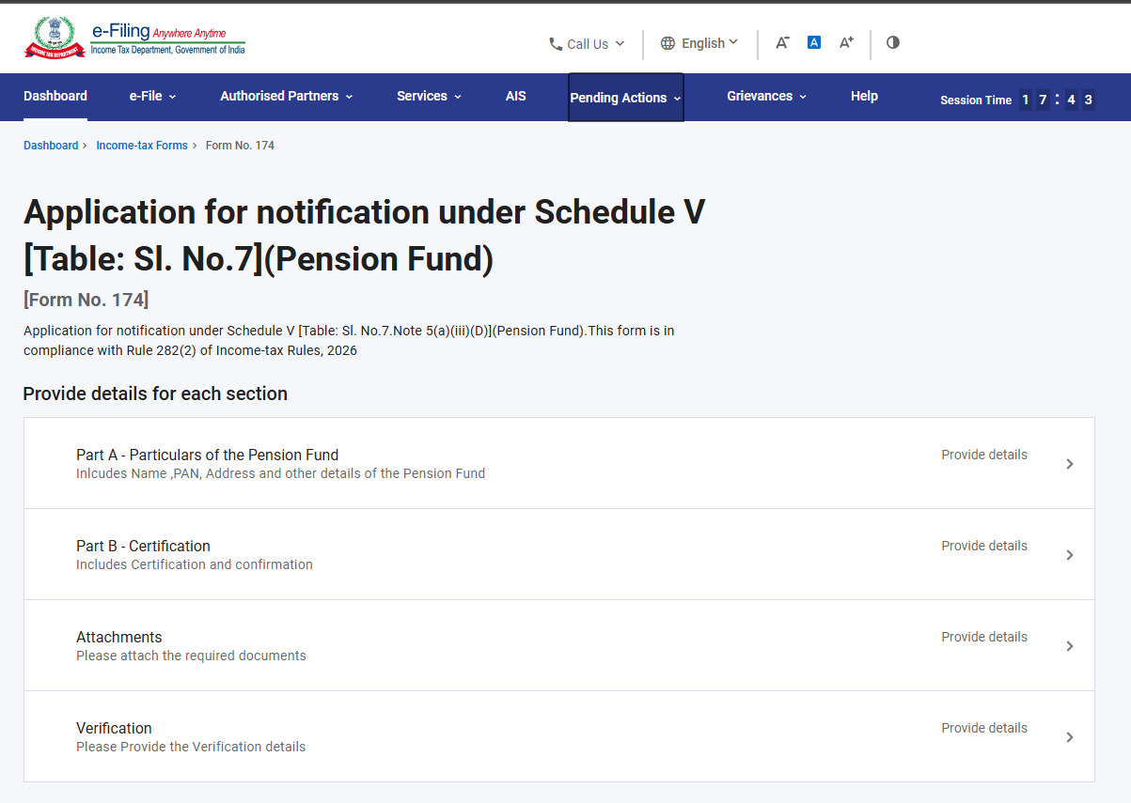

4. Step-by-Step Guide
Step 1: Log in to the e-Filing portal with your User ID and Password.

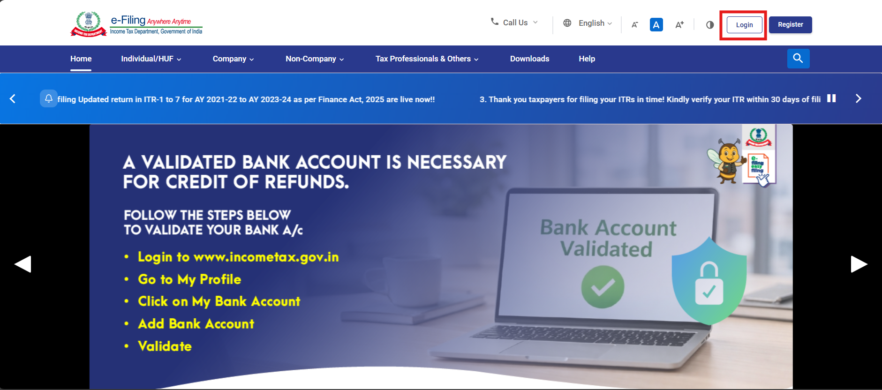

Step 2: Enter the User ID (PAN) and Password.
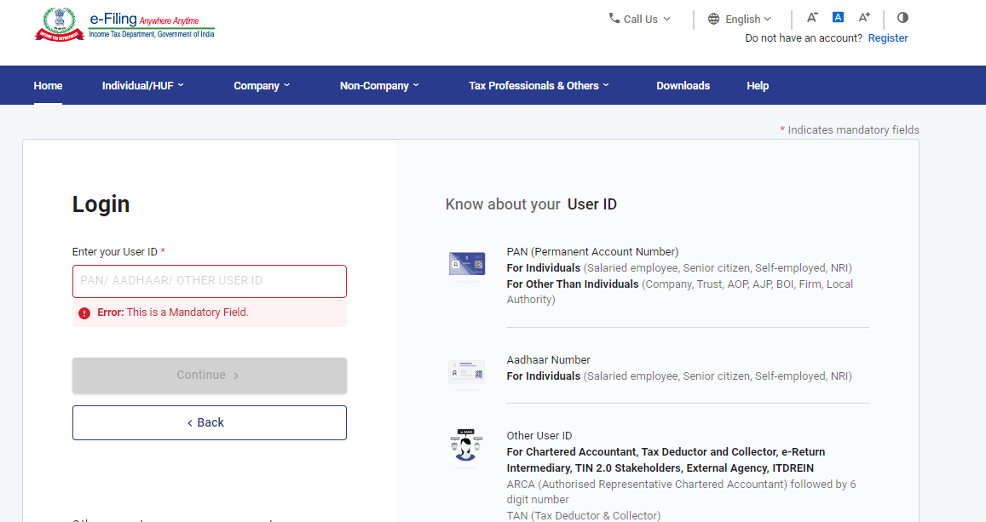

Step 3 : Go to e-file >Income Tax Forms > File Income Tax Forms
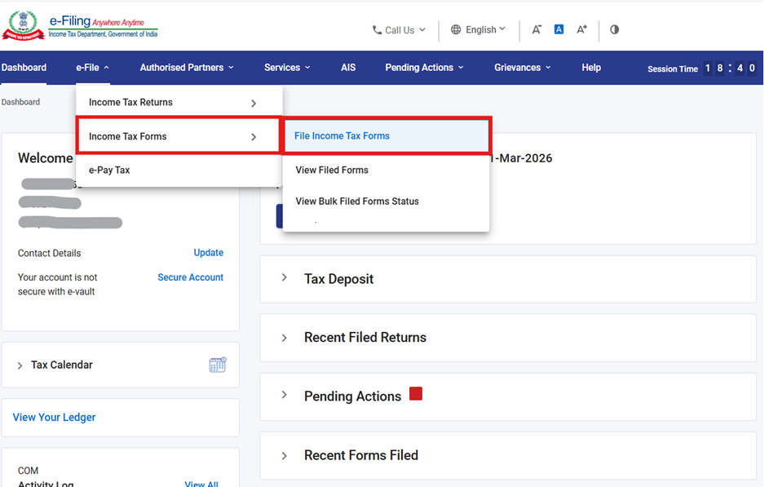

Step 4: Of the three tabs, please Select the Forms as per Income Tax Act 2025 tab, select or search for Form 174, and click the File Now button.

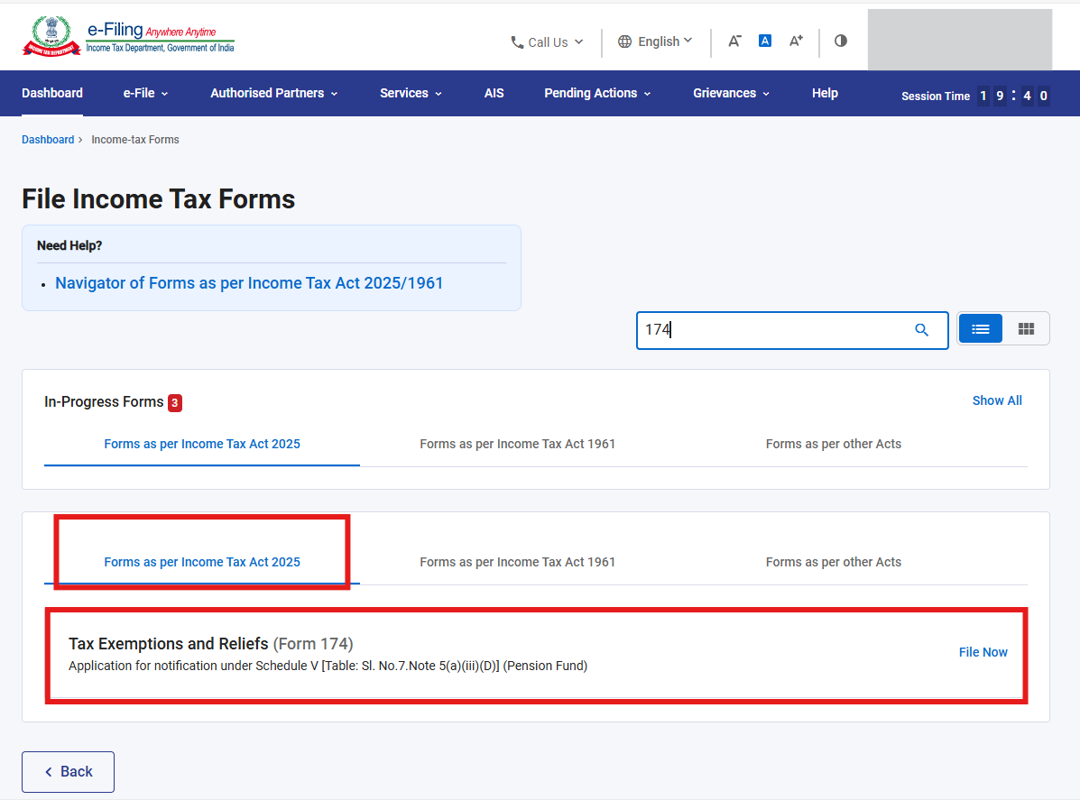

Step 5: Check the PAN, Submission Mode, Filing Type and select the applicable Tax Year (T.Y) and click on Continue button.
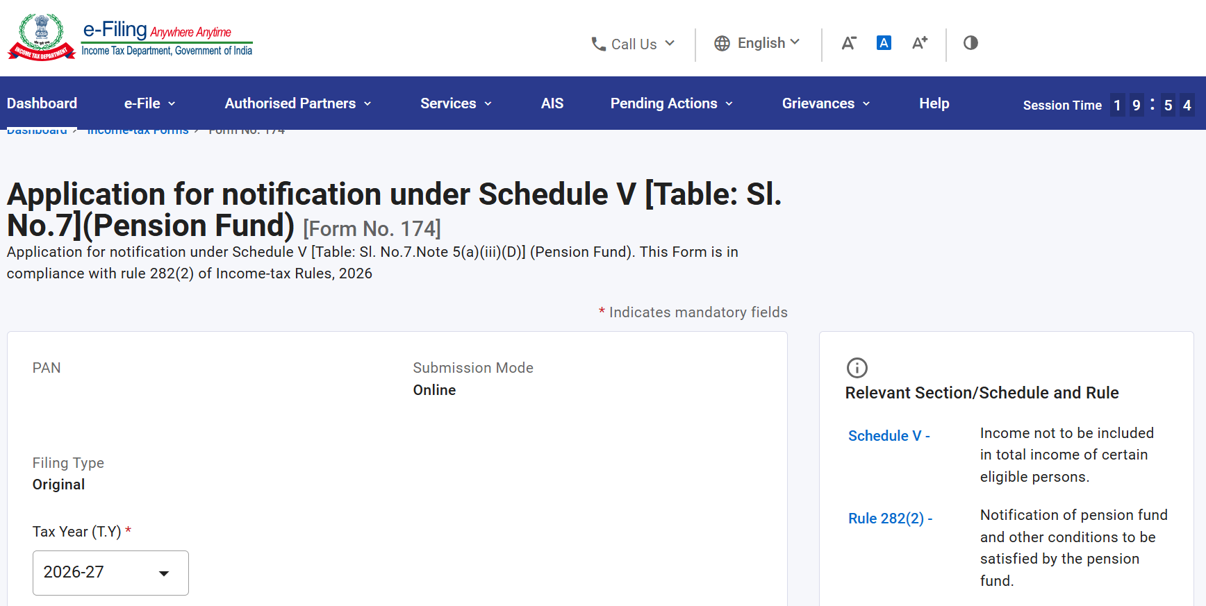
Step 6. Click on Let’s Get Started
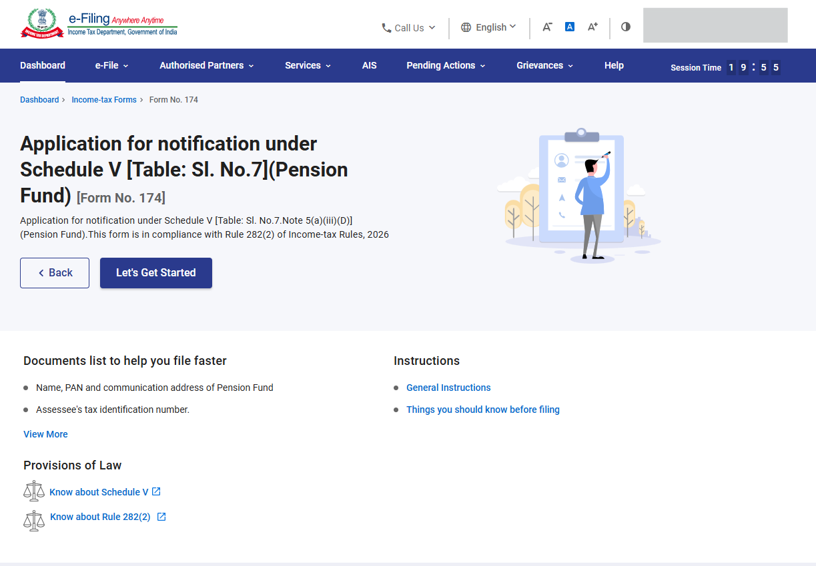

Step 7 : Upon clicking "Let's Get Started", the user will be navigated to the Panel screen. Select the 1st Panel: Part A - Particulars of the Pension Fund to proceed. Fill the relevant details, verify and click Save.
Note : Please ensure that all mandatory details under "My Profile" section including address is completed. You can update your contact and address details by clicking on hyperlink “My Profile”.

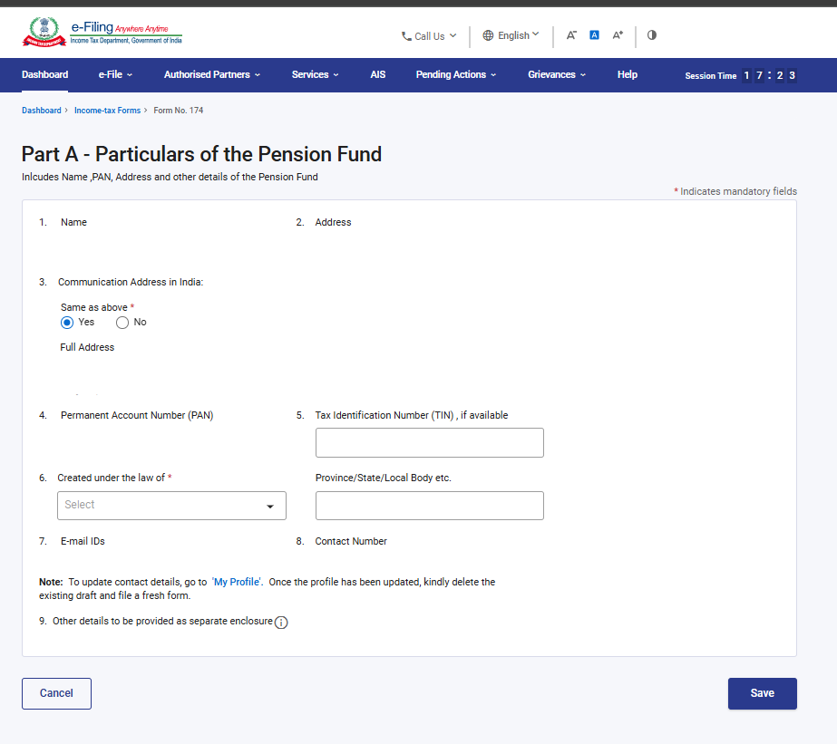

Step 8 : Post saving the 1st panel, select the 2nd Panel: Part B – Certification.
Please click on the checkbox and click on Save.
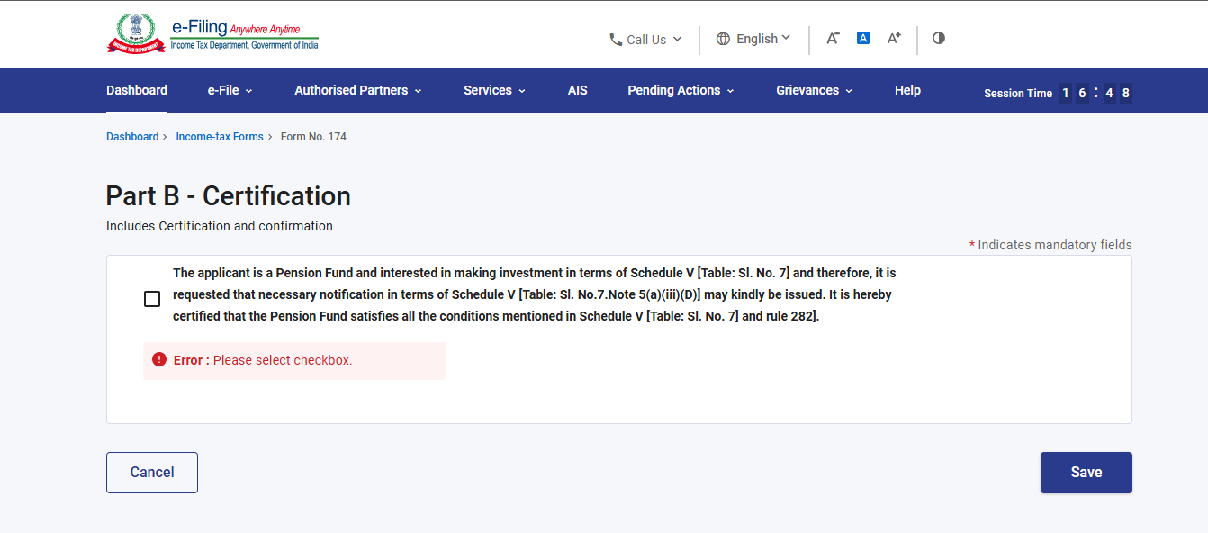

Step 9 : Post saving the 2nd panel, select the 3rd Panel: Attachment. Please attach the relevant documents in this panel “Attachments” and click on Save

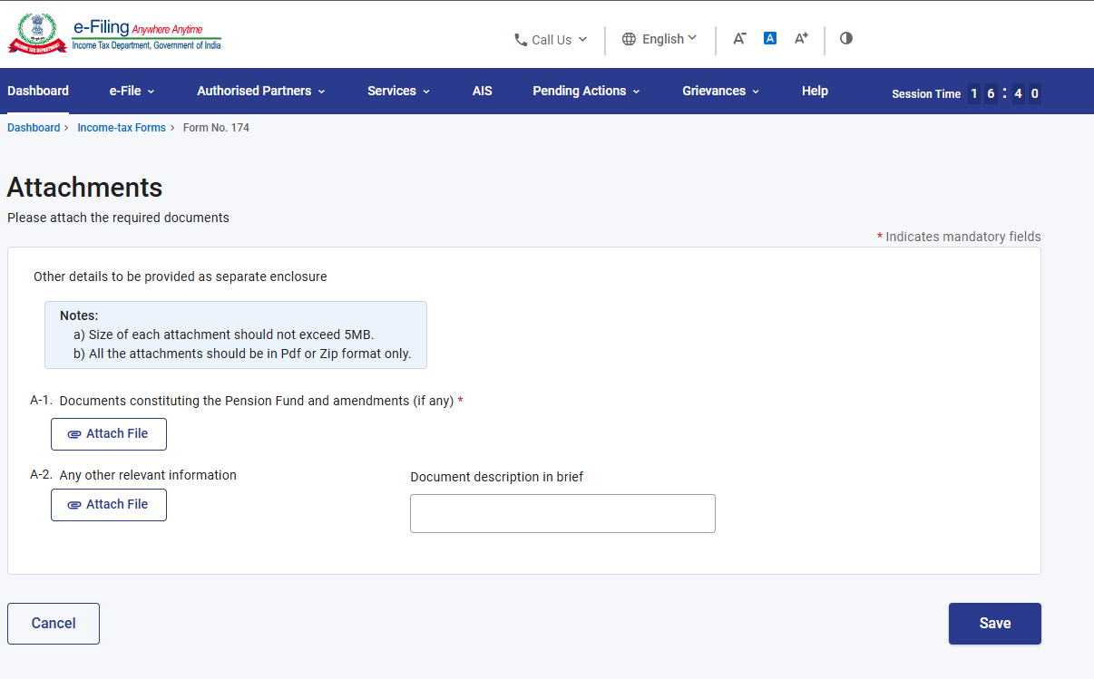
Step 10: Post saving the 3rd panel, select the “Verification” Panel. Confirm the Verification panel and click on Save.

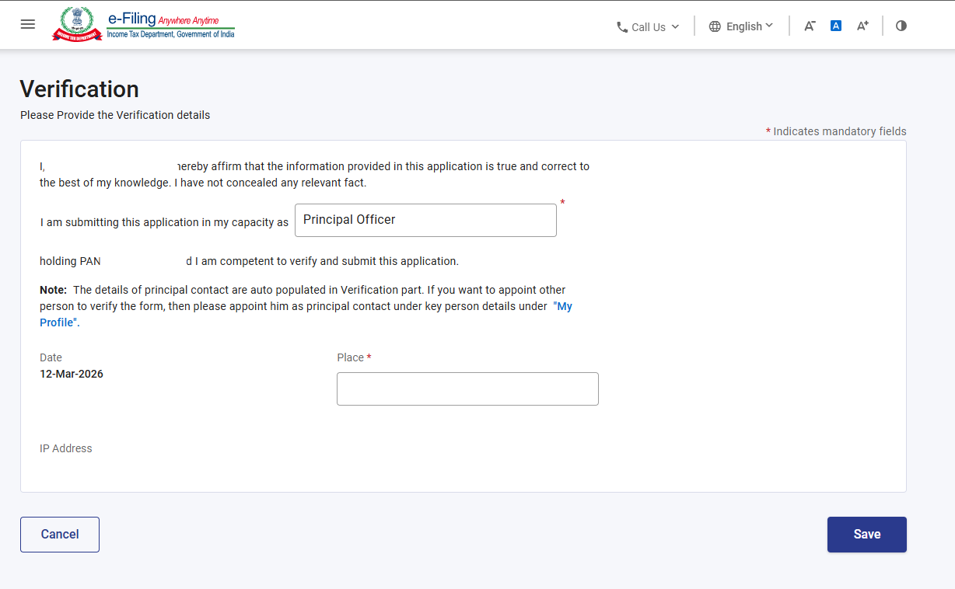

Step 11: Post saving the Verification panel, status of panel will be displayed as Completed then Preview button will be enabled

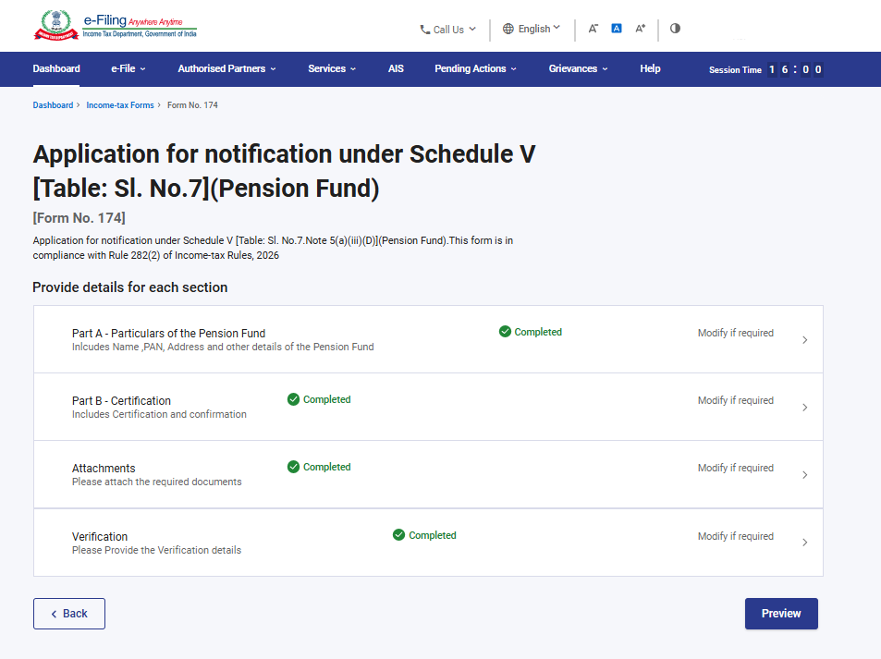
Step 12: On the Preview page, verify the details and click Proceed to e-Verify.
Note: By clicking the “Download” button, the user can download the preview PDF and verify the details before proceeding with e-verification

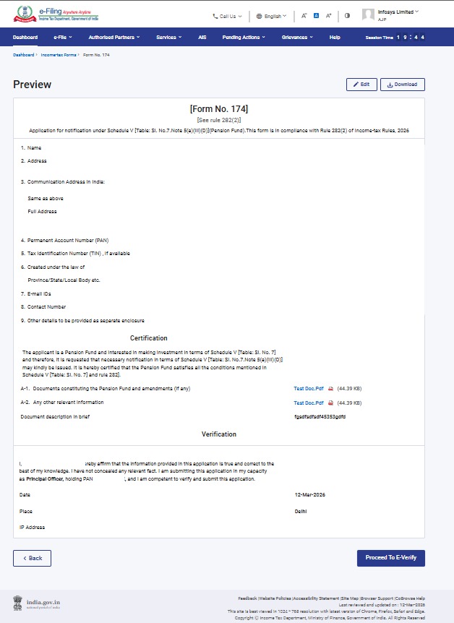Step 13: Post clicking on Proceed to E-Verify button, a popup confirmation displaying that you would like to proceed to E-Verify. Click on Yes

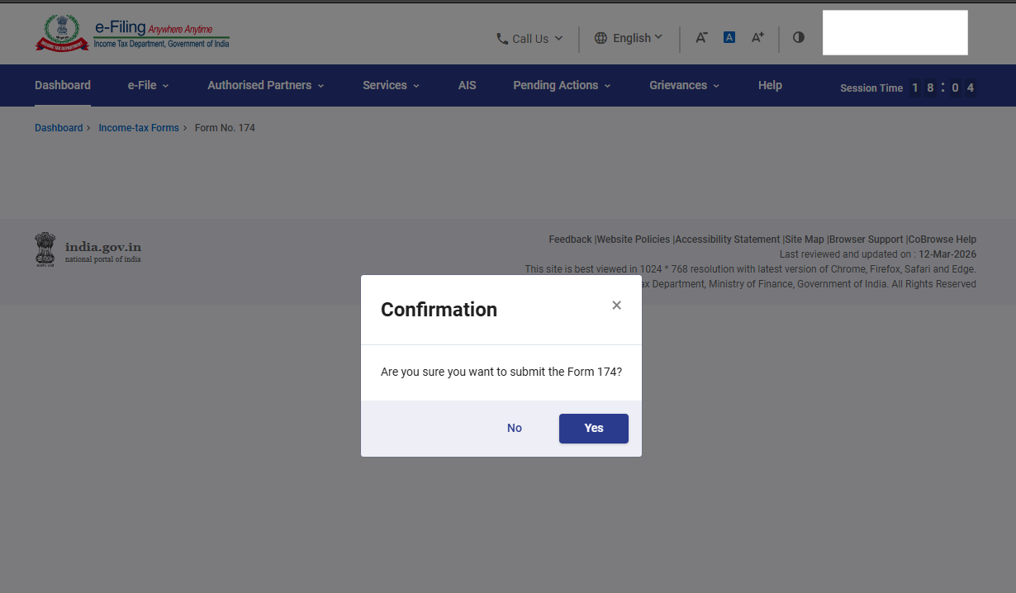

Step 14: On clicking Yes, you will be navigated to the E-Verify page where you can verify the Form 174 using DSC/EVC.
Note: Refer to the How to e-Verify user manual to learn more

Step 15: After successful e-Verification, a success message is displayed along with a Transaction ID and Acknowledgement Receipt Number. Please keep a note of the Transaction ID and Acknowledgement Receipt Number for future reference. You will also receive a confirmation message on the email ID(s) and mobile number(s) registered with the e-Filing portal.
Click on download button to download the Acknowledgement receipt

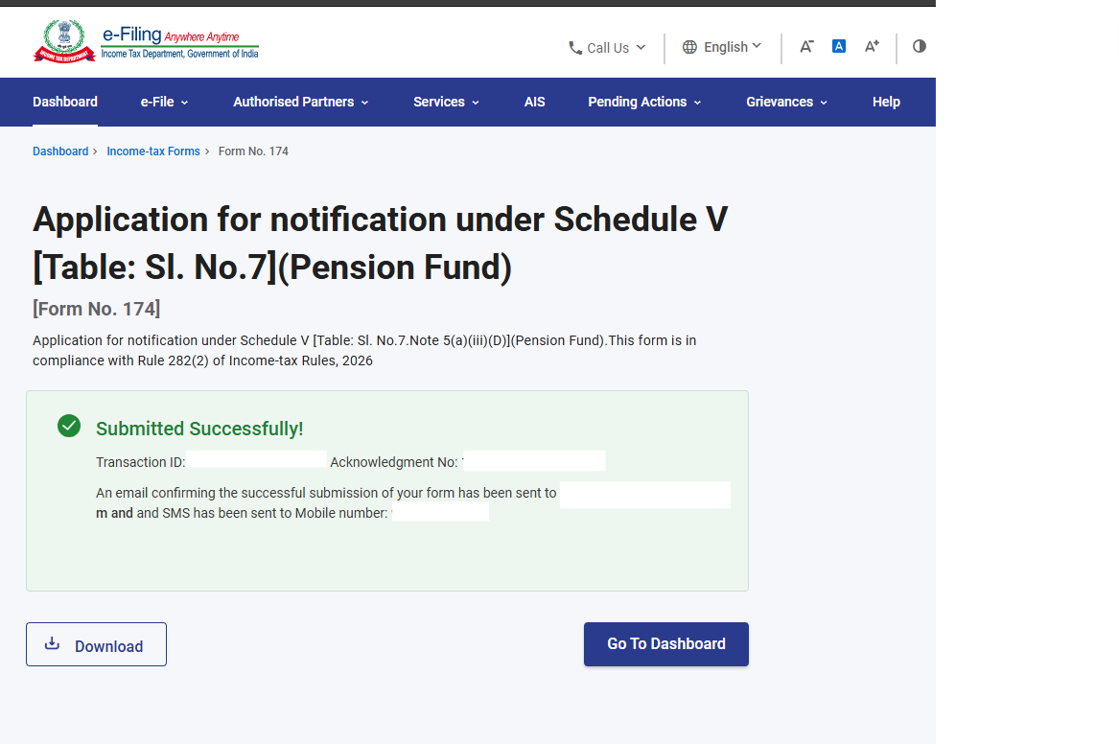
After successful submission of form 189 the user can view the filled form under - On your Dashboard, click e-File > File Income Tax Forms > View Filed Forms> View Filed Form tab under Income Tax Act 2025.
Note: Refer view filled form user manual to learn more

5. Related Topics
- Login
- Dashboard
- How to e-Verify
- Income Tax Forms (Upload)
- Register DSC

6.Glossary

Acronym/Abbreviation | Description/Full Form
DSC | Digital Signature Certificate
EVC | Electronic Verification Certificate
ARN | Acknowledgement Receipt Number
PY | Previous Year
FY | Financial Year
TY | Tax Year

