Form 180 > User Manual

User Manuals
Integrated e-Filing and CPC 2.0
Project Module: e-Filing Forms
Use Case ID
Use Case Description | Form No.180  Application for grant of approval to a fund referred to in Schedule VII [Table: Sl. No. 2]  (Formerly known as Form 9 as per Income Tax Act, 1961)
Confidentiality Agreement
"This document contains proprietary information exclusively vests with ITD. This document may not, in whole or in part, be copied, photocopied, stored, saved, reproduced, replicated, disseminated, translated, transmitted or reduced to in any medium (whether electronic, mechanical, machine-readable and/or any other tangible or intangible form of any nature), by the intended recipient/s or user/s without the express consent, in writing, from the Authorized Representative of ITD Management." All the Intellectual Property Rights (i.e. copyrights) as may be available under the applicable laws, pertaining to ITD's confidential information, shall exclusively vest with ITD only, and any breach thereof shall be subject to indemnification.
Revision History
Ver. | Date | Comments | Reviewer
0.1 | 11-03-2026 | Initial document | Sonia Rani
Note: Once approved, unapproved versions will be removed from the list

Reviewed by:
Sl. | Organization | Name | Designation
1 | Infosys Ltd | Adrian Lasrado | Program Manager
2 | Infosys Ltd | Parul Aggarwal | Principal Consultant
3 | Infosys Ltd | Anu Malhotra | Senior Project Manager, Development
4 | Infosys Ltd | Manthuri Kavitha | Quality Engineering Lead
5 | Infosys Ltd | Jaisy Ann Cheriyan | Senior Technology Architect
6 | Infosys Ltd | Ravi Kiran Thallapureddy | Principal Technology Architect
7 | Income-tax Department | Ajay Robin Sir | Addl DIT
8 | Income-tax Department | Christabel D'Mello | JDIT
9 | Income-tax Department | Hari Kumar | JDIT(S)
10 | Income-tax Department | Praveen Sinha | JDIT
11 | Income-tax Department | M Devaki | DDIT
12 | Income-tax Department | K.S.A. Seshasailendra | DDIT
13 | Income-tax Department | Madhukar Peri | DDIT(S)

Table of Contents
About this document
Form 180 > User Manual
- Overview
- Prerequisites for availing this service
- About the Form
- Step-by-Step Guide
- Related Topics
- Glossary

About this document
The purpose of this document is to provide step-by-step instructions to the taxpayers to use the e-filing portal. The content in this document (in the following pages) will be converted into HTML pages and integrated with the e-Filing portal; the presentation of the content in terms of colour, font, size will be as per the UI guidelines followed in the website.
The document also contains list of glossary terms specific to this document. These terms will also be added to the overall Glossary in the Help section of the website.
To facilitate search on the Internet, metadata will be added to the HTML pages. The keywords to be added to metadata are also added in this document.
In addition, assessment questions have also been designed that will be used for training of call-center agents.

Form 180 > User Manual

1. Overview
- Form 180 is a compliance form used by employee welfare funds to seek recognition as an approved fund under the Income Tax Act, 2025.
- This form applies to funds that are set up as a trust, receive regular employee contributions, utilize their income solely for employee welfare, and invest only in the prescribed modes specified under Section 350.
- Approval granted by the Principal Commissioner or Commissioner remains valid for up to three tax years, after which the fund must apply again for continued approval.

2. Prerequisites for availing this service
- You should be a registered user on the e-Filing portal
- Status of PAN of the taxpayer should be "Active"
- You should have a valid DSC to verify the form through DSC mode, and it must be registered on the e-filing portal and not expired

3. About the Form

3.1 Purpose
- The purpose of Form 180 is to formally request tax-exemption approval from the Principal Commissioner or Commissioner.
- By submitting this form, an employee welfare fund demonstrates eligibility for exemption by declaring that it meets the legal conditions relating to formation, contributions, utilization of income, and permitted investments.

3.2 Who can file it?

Any fund established for the welfare of employees or their dependents, where such employees are members of the fund, and the fund is:
- Established for purposes notified by the Board
- Formed under a trust evidenced by a trust deed
- Funded by employees through periodical subscriptions

3.3 Form at a Glance
Form 180 has four panels:
- Part A: Particulars of the Applicant (Trust/Fund)
- Part B: Residential Information
- Attachments
- Verification

4. Step-by-Step Guide
Step 1: Log in to the e-Filing portal with your User ID and Password.

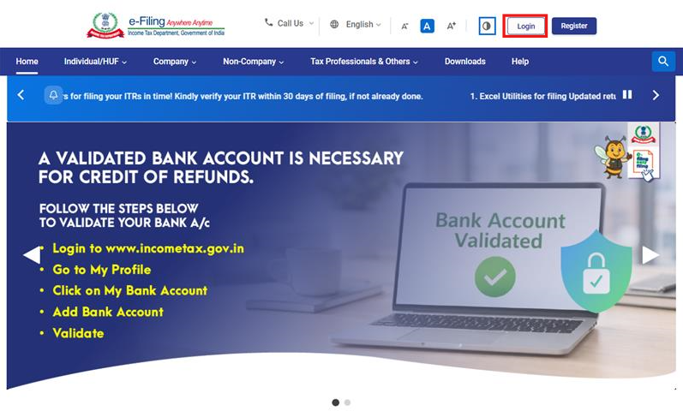

Step 2: Enter the User ID (PAN) and Password.
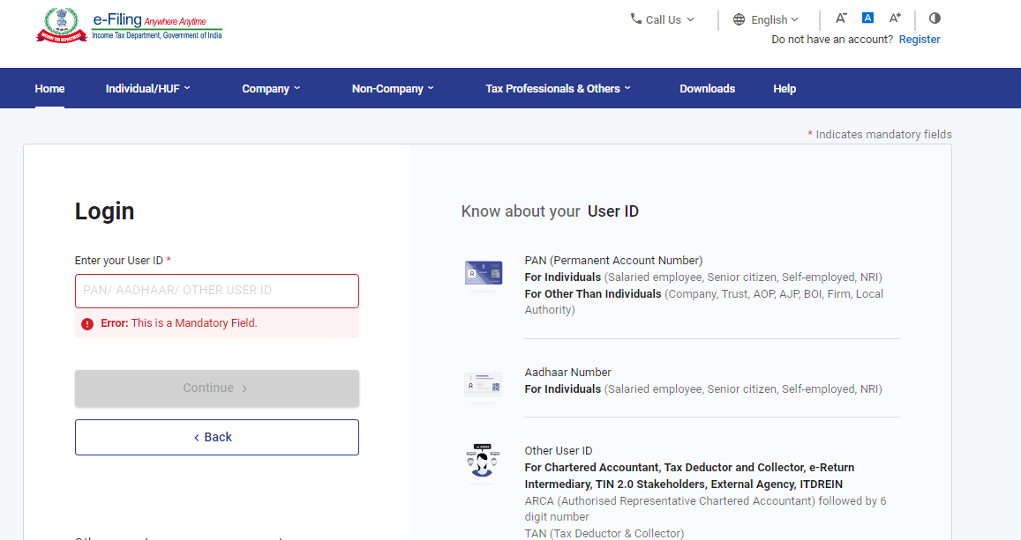

Step 3 : Go to e-file >Income Tax Forms > File Income Tax Forms
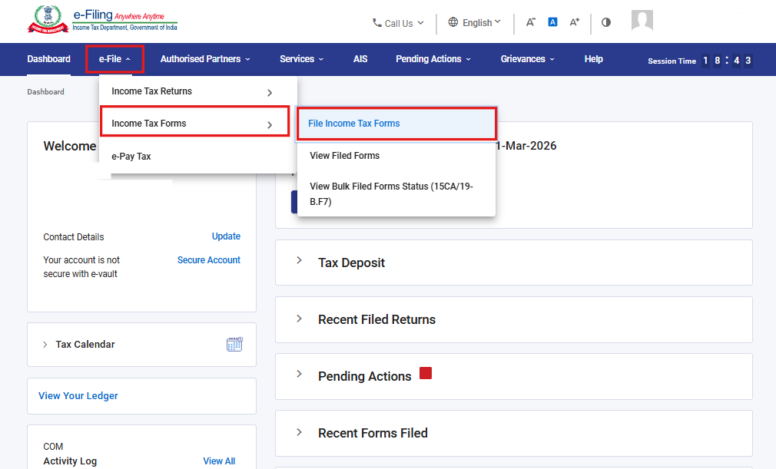

Step 4: Select the Forms as per Income Tax Act 2025 tab, select Form 180, and click the File Now button
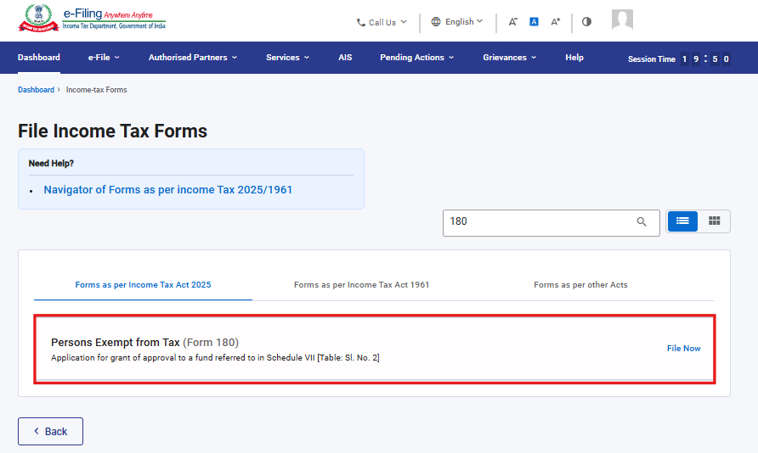

Step 5: Select the applicable Tax Year (T.Y) and click on Continue button.
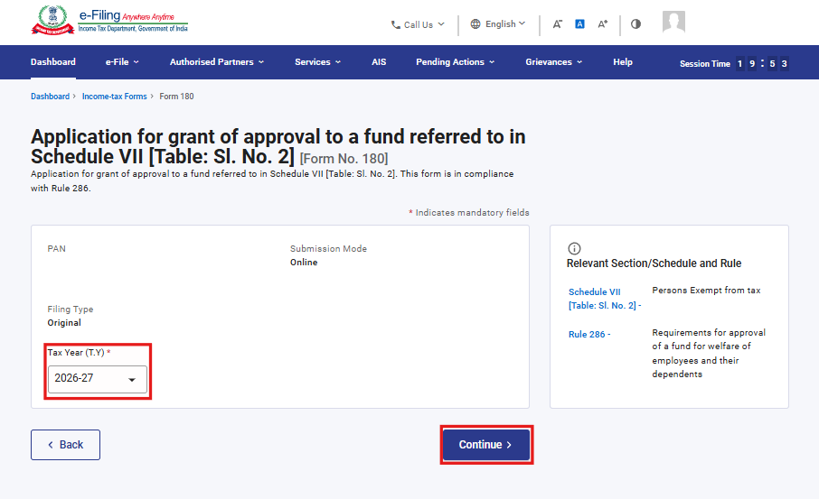
Step 6. Click on Let’s Get Started
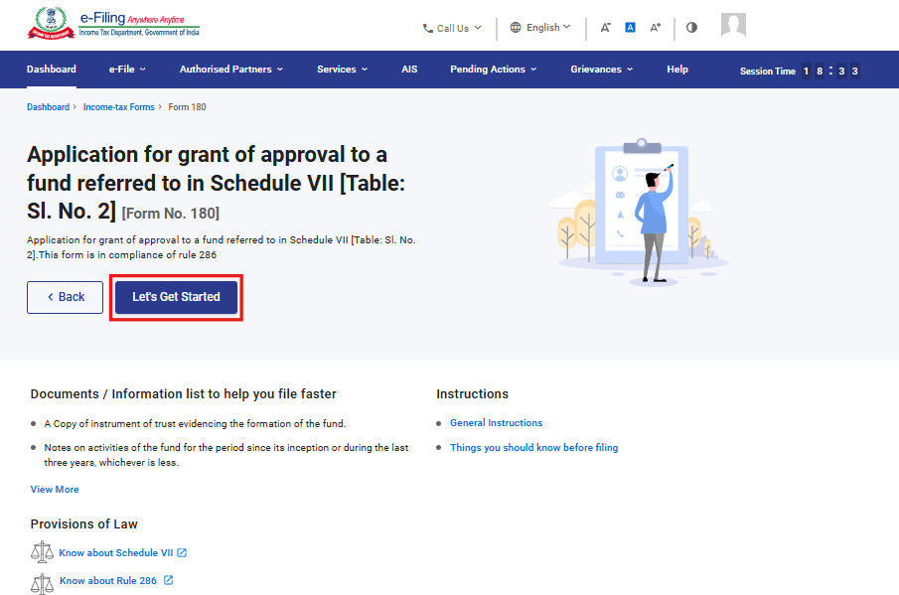

Step 7: Upon clicking Let's Get Started, the user is navigated to the Panel screen. Select the first panel: Part A: Particulars of the Applicant (Trust/Fund)
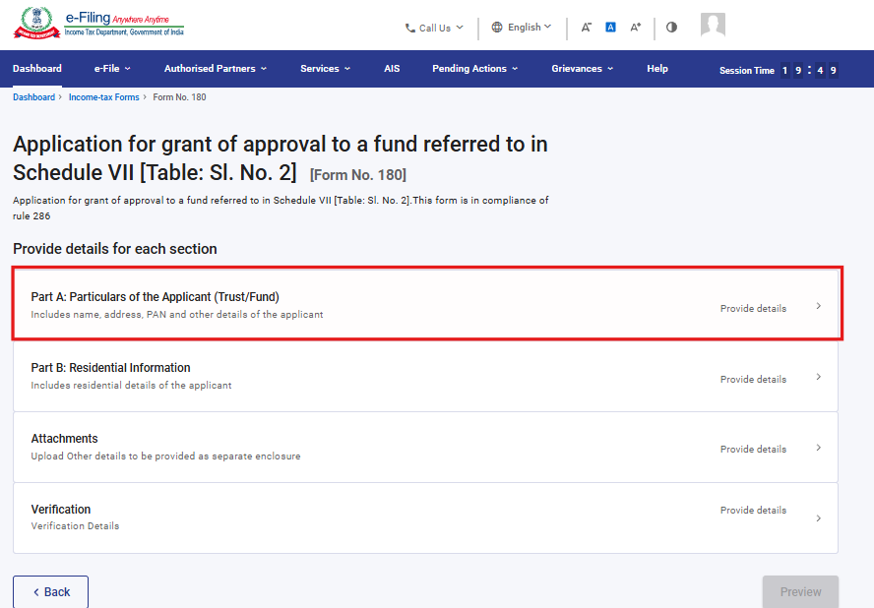
Step 8: Verify the Particulars and click on Save.
Note: Please ensure that all mandatory details under "My Profile" section including address are completed. You can update your contact and address details by clicking on hyperlink “My Profile”.
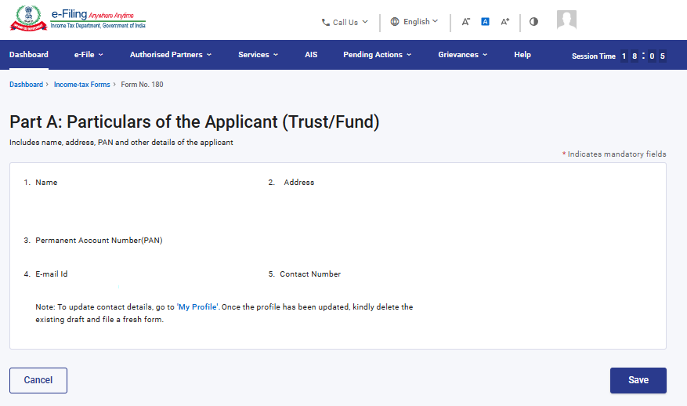

Step 9: After saving the first panel, select the second panel: Part B: Residential Information
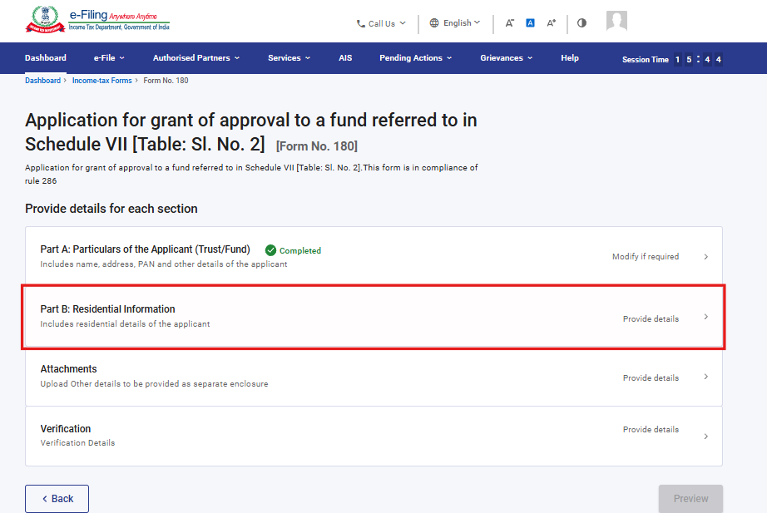
Step 10: Fill in and verify the details under the Part B: Residential Information panel, then click Save.
The field No 8 ‘Objects of the fund’ contains the dropdown menu, user can select an option from the available list.
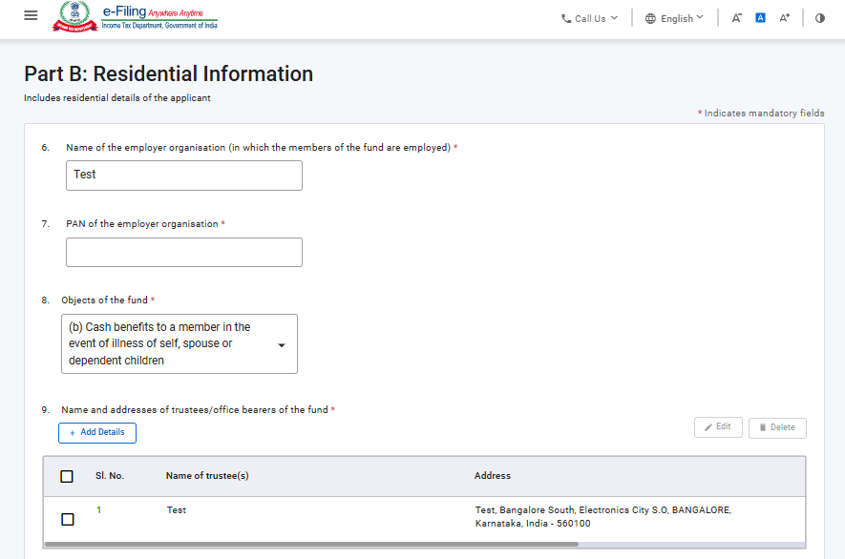
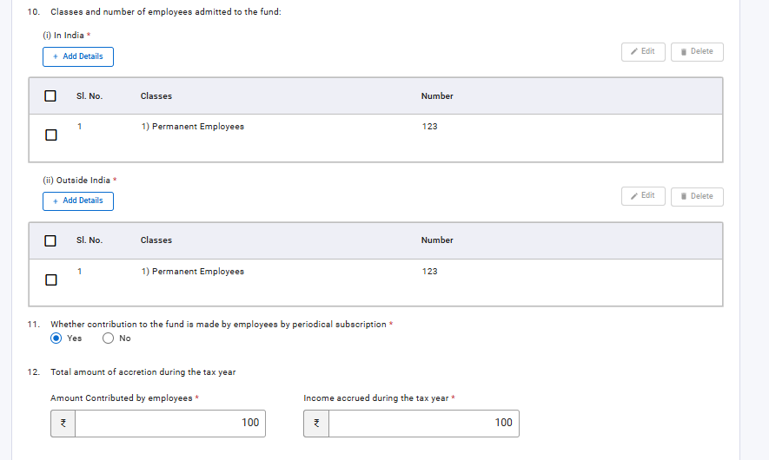
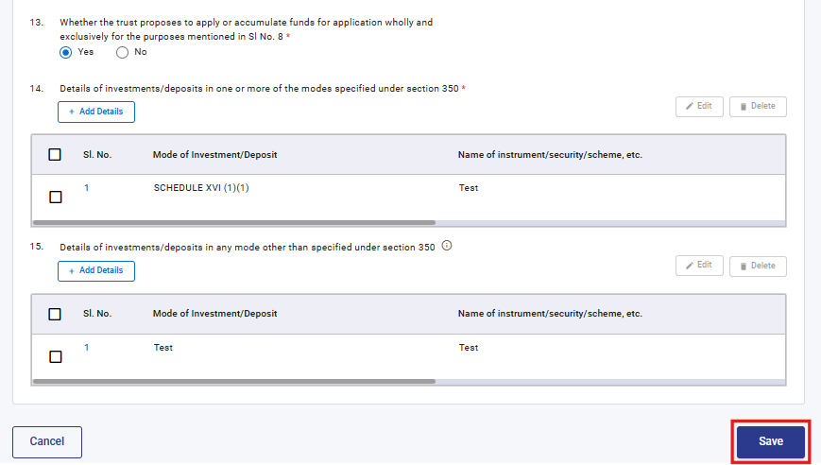

Under Serial No. 9, Click 'Add Details', provide the relevant details, and click 'Add' to proceed.

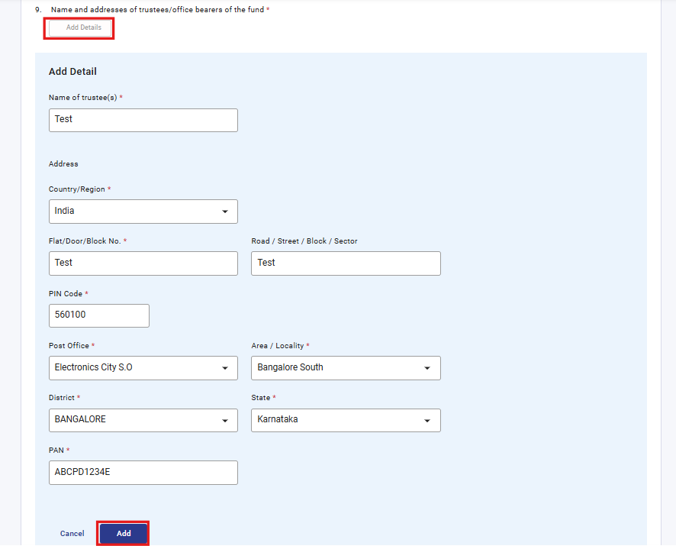

Under Serial No. 10(i), select 'Add Details', complete the required fields, and click 'Add' to proceed. The field ‘Classes’ contains the dropdown menu, user can select an option from the available list.

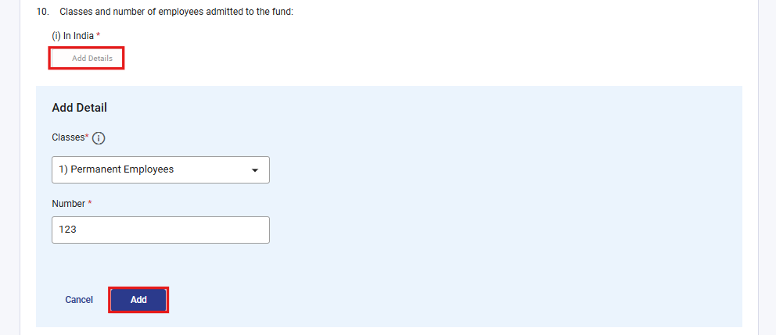

Under Serial No. 10(ii), select 'Add Details', complete the required fields, and click 'Add' to proceed. The field ‘Classes’ contains the dropdown menu, user can select an option from the available list.

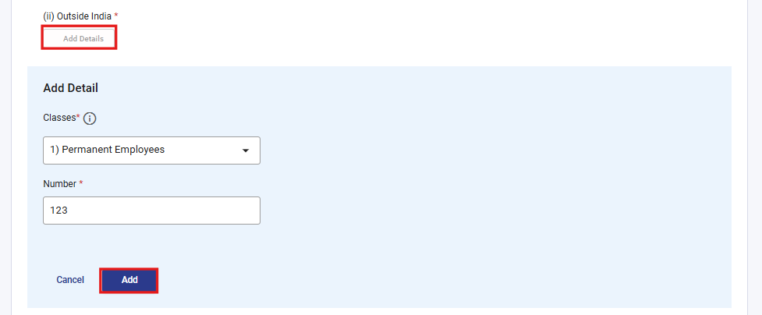

Under Serial No. 14, select 'Add Details', complete the required fields, and click 'Add' to proceed. The field ‘Mode of Investment /Deposit’ contains the dropdown menu, user can select an option from the available list.

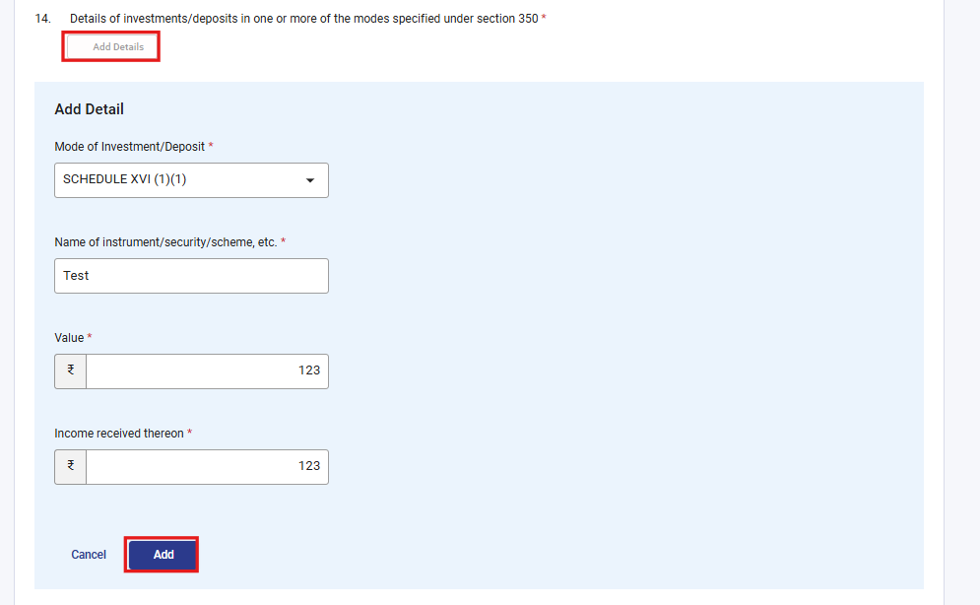
Under Serial No. 15, select 'Add Details', fill the required fields, and click 'Add' to proceed.

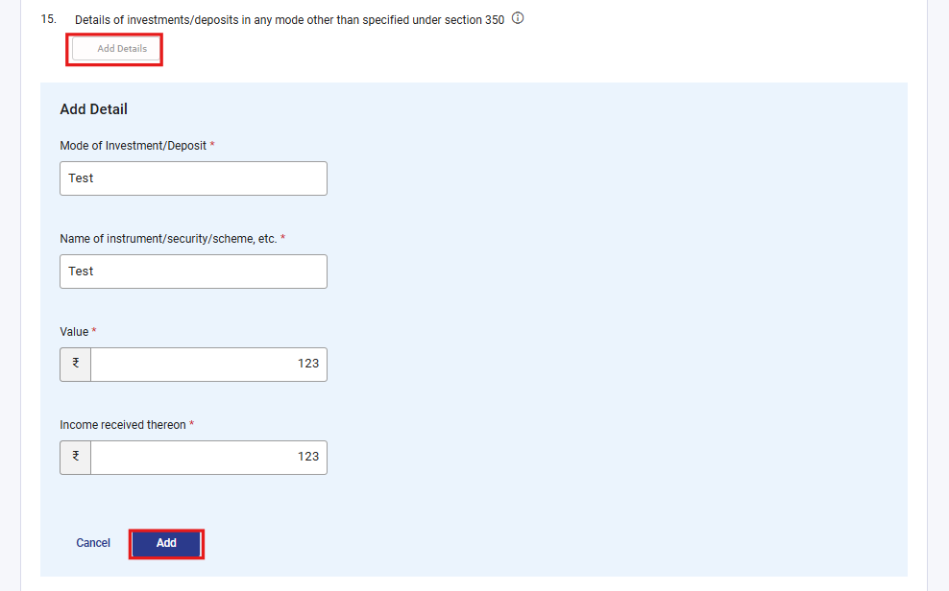

Step 11: After saving the third panel, navigate to the fourth panel: Attachments

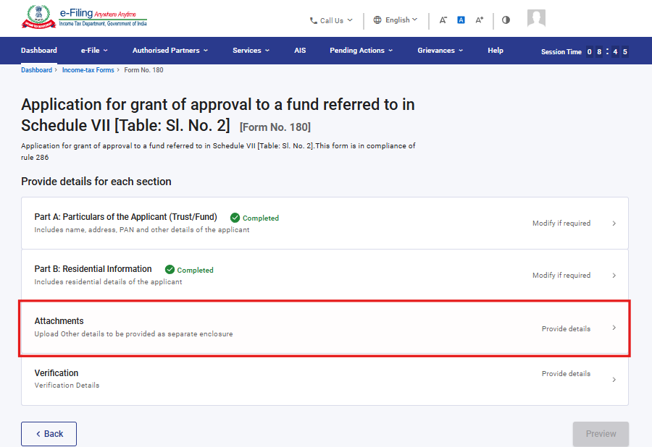
Step 12: Attach the relevant documents and click Save.
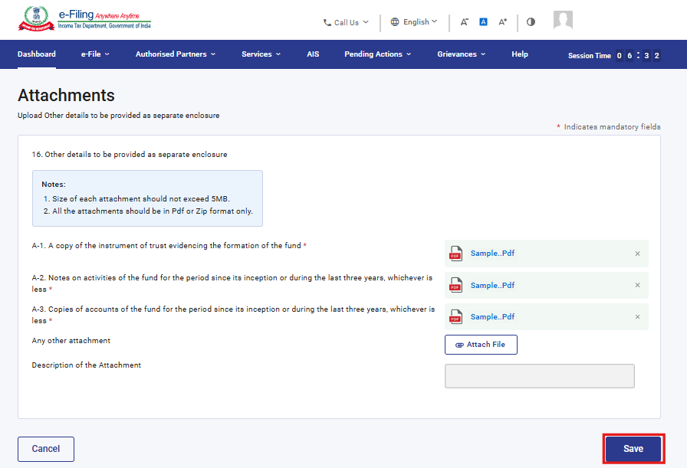

Step 13: After saving the third panel, select the Verification panel
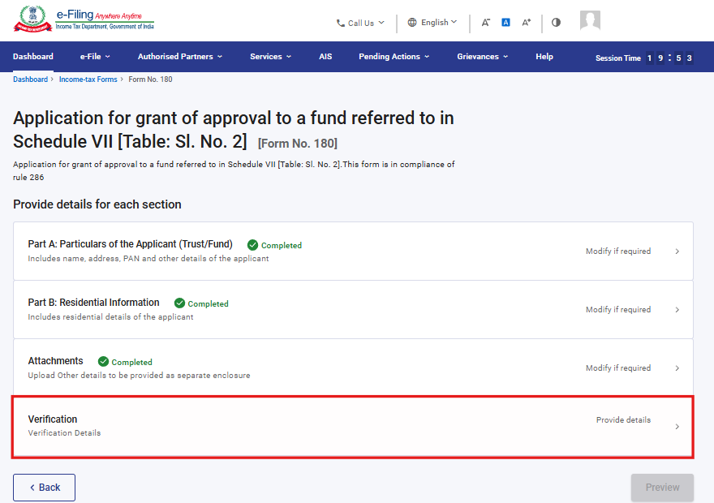
Step 14: Confirm the undertaking and click Save.
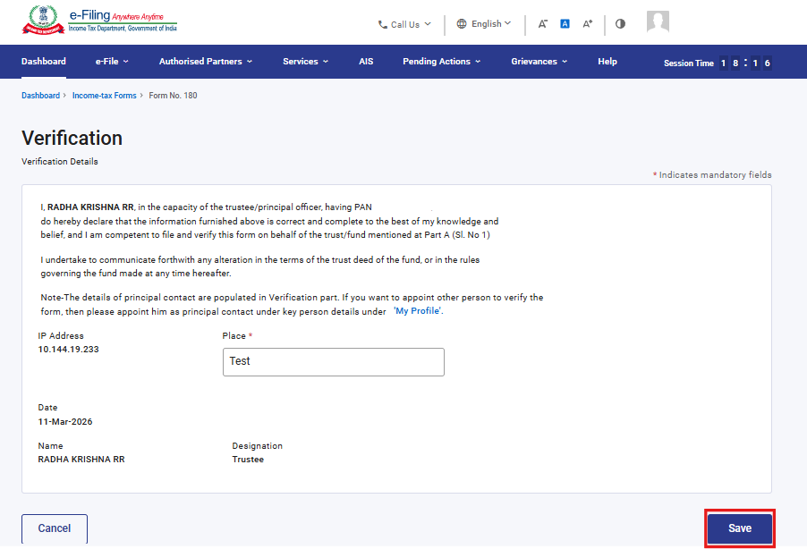
Step 17: After saving the Verification panel, click Preview.
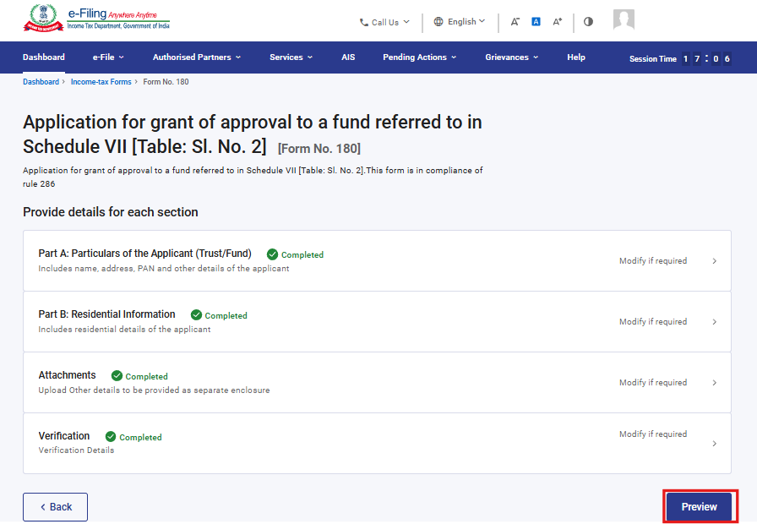
Step 18: Review the details on the Preview page and click Proceed to e-Verify.
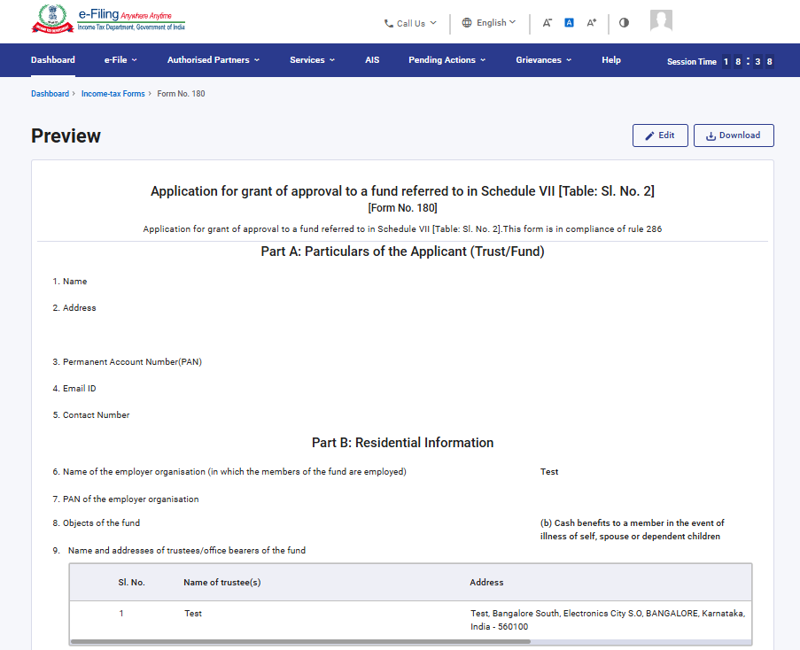
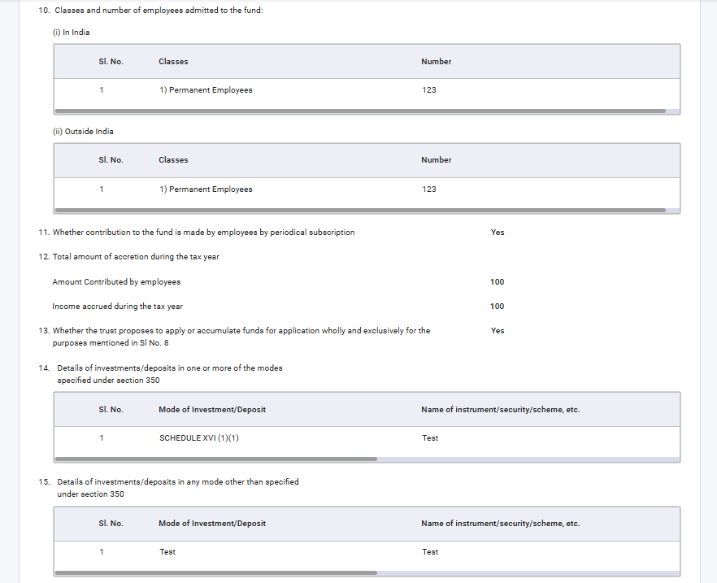
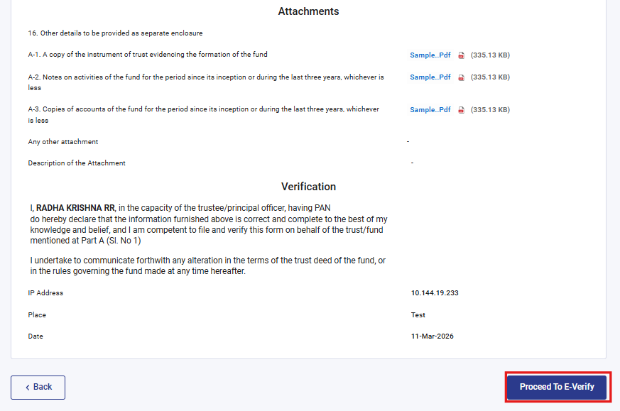

Step 19: Upon clicking Proceed to e-Verify, a confirmation popup appears. Click Yes to proceed

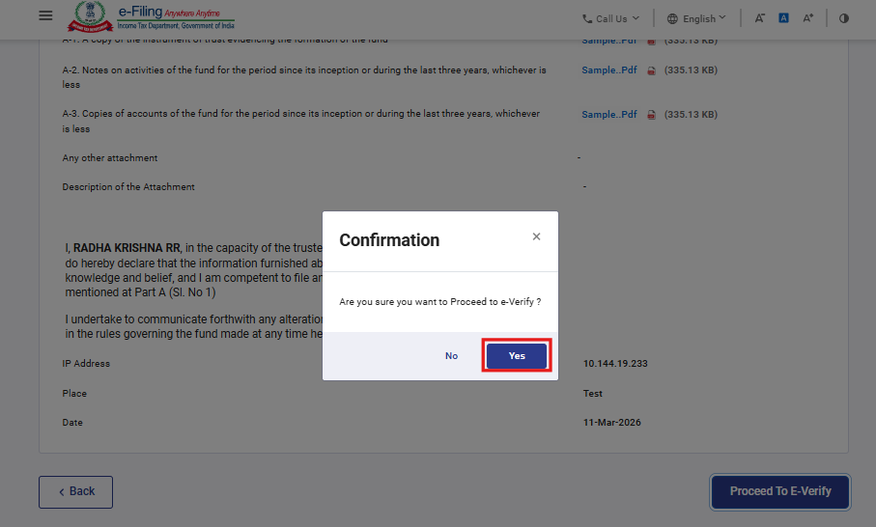
Step 20: On clicking Yes, you will be navigated to the e-Verify page where you can verify the Form 180 using DSC/EVC (as applicable).
Note: Refer to the How to e-Verify user manual to learn more.
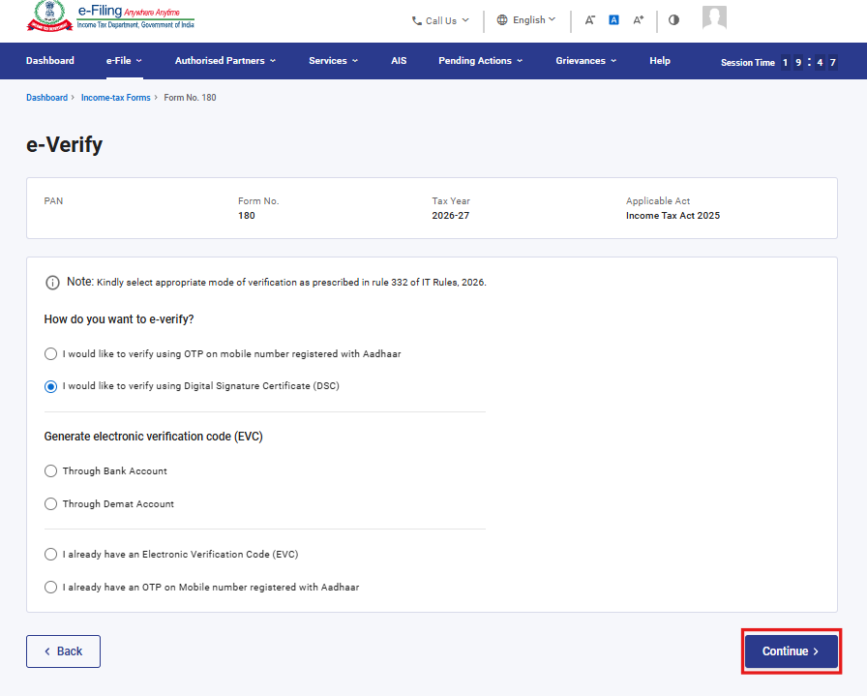
Step 21: After successful e-Verification, a success message is displayed along with a Transaction ID and Acknowledgement Receipt Number. Please keep a note of the Transaction ID and Acknowledgement Receipt Number for future reference. You will also receive a confirmation message on the email ID(s) and mobile number(s) registered with the e-Filing portal.
Click on download button to download the Acknowledgement receipt
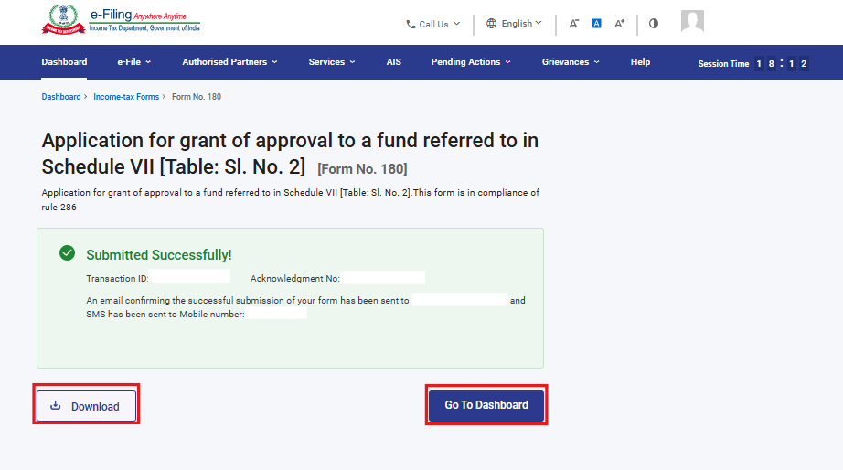
After successful submission of form 180 the user can view the filled form under - On your Dashboard, click e-File > File Income Tax Forms > View Filed Forms> View Filed Form tab under Income Tax Act 2025.

Note: Refer view filled form user manual to learn more

5. Related Topics
- Login
- Dashboard
- How to e-Verify
- Income Tax Forms (Upload)
- Register DSC

6.Glossary

Acronym/Abbreviation | Description/Full Form
DSC | Digital Signature Certificate
EVC | Electronic Verification Certificate
ARN | Acknowledgement Receipt Number
PY | Previous Year
FY | Financial Year
TY | Tax Year

