Form 189 > User Manual

User Manuals
Integrated e-Filing and CPC 2.0
Project Module: e-Filing Forms
Use Case ID
Use Case Description | Form No.189  Application for approval of issue of public companies under Schedule XV: Paragraph 1(z)(i) of the Income-tax Act, 2025  (Formerly known as Form 59 as per Income-tax Act, 1961)
Confidentiality Agreement
"This document contains proprietary information exclusively vests with ITD. This document may not, in whole or in part, be copied, photocopied, stored, saved, reproduced, replicated, disseminated, translated, transmitted or reduced to in any medium (whether electronic, mechanical, machine-readable and/or any other tangible or intangible form of any nature), by the intended recipient/s or user/s without the express consent, in writing, from the Authorized Representative of ITD Management." All the Intellectual Property Rights (i.e. copyrights) as may be available under the applicable laws, pertaining to ITD's confidential information, shall exclusively vest with ITD only, and any breach thereof shall be subject to indemnification.
Revision History
Ver. | Date | Author | Reviewer | Comments
0.1 | 07-03-2026 | Sathish Kumar | Sonia Rani | Initial document
Note: Once approved, unapproved versions will be removed from the list

Reviewed by:
Sl. | Organization | Name | Designation
1 | Infosys Ltd | Adrian Lasrado | Program Manager
2 | Infosys Ltd | Parul Aggarwal | Principal Consultant
3 | Infosys Ltd | Anu Malhotra | Senior Project Manager, Development
4 | Infosys Ltd | Manthuri Kavitha | Quality Engineering Lead
5 | Infosys Ltd | Jaisy Ann Cheriyan | Senior Technology Architect
6 | Infosys Ltd | Ravi Kiran Thallapureddy | Principal Technology Architect
7 | Income-tax Department | Ajay Robin Sir | Addl DIT
8 | Income-tax Department | Christabel D'Mello | JDIT
9 | Income-tax Department | Hari Kumar | JDIT(S)
10 | Income-tax Department | Praveen Sinha | JDIT
11 | Income-tax Department | M Devaki | DDIT
12 | Income-tax Department | K.S.A. Seshasailendra | DDIT
13 | Income-tax Department | Madhukar Peri | DDIT(S)

Table of Contents
About this document
Form 189 > User Manual

- Overview
- Prerequisites for availing this service
- About the Form
- Step-by-Step Guide
- Related Topics
- Glossary

About this document
The purpose of this document is to provide step-by-step instructions to the taxpayers to use the e-filing portal. The content in this document (in the following pages) will be converted into HTML pages and integrated with the e-Filing portal; the presentation of the content in terms of colour, font, size will be as per the UI guidelines followed in the website.
The document also contains list of glossary terms specific to this document. These terms will also be added to the overall Glossary in the Help section of the website.
To facilitate search on the Internet, metadata will be added to the HTML pages. The keywords to be added to metadata are also added in this document.
In addition, assessment questions have also been designed that will be used for training of call-center agents.

Form 189 > User Manual

1. Overview
- Form 189 is submitted under Rule 331 of the Income-tax Rules, 2026 by a public company or public financial institution that intends to raise capital from the public through equity shares or debentures.
- This form must be filed at least three months before the proposed issue and acts as a compliance requirement to ensure that only eligible entities raise funds.
- Along with Form 189, the company must also provide supporting documents such as its Certificate of Incorporation under the Companies Act, 2013, and its audited financial statements (Balance Sheet and Profit & Loss account) for the last three years or since incorporation, whichever is shorter

2. Prerequisites for availing this service
- You should be a registered user on the e-Filing portal
- Status of PAN of the taxpayer should be "Active"
- You should have a valid DSC to verify the form through DSC mode, and it must be registered on the e-filing portal and not expired

3. About the Form

3.1 Purpose

Form 189 is filed to obtain prior approval from the Board for raising capital through a public issue, ensuring the company meets the prescribed eligibility and compliance conditions.

3.2 Who can use it?
Public companies or public financial institutions that intend to raise capital from the public through an eligible issue of equity shares or debentures can file this form.

3.3 Form at a Glance
Form 189 has four panels:
- Part A
- Part B
- Part C
- Attachments
- Verification

4. Step-by-Step Guide
Step 1: Log in to the e-Filing portal with your User ID and Password.

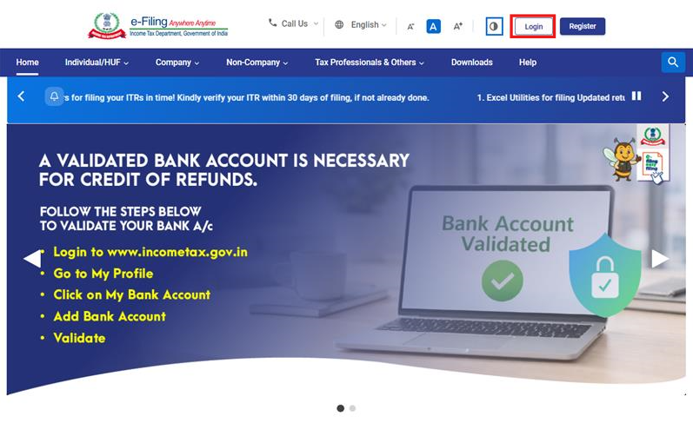

Step 2: Enter the User ID (PAN) and Password.
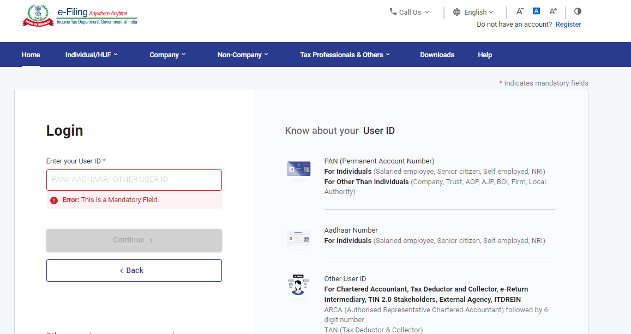

Step 3: Go to e-file >Income Tax Forms > File Income Tax Forms
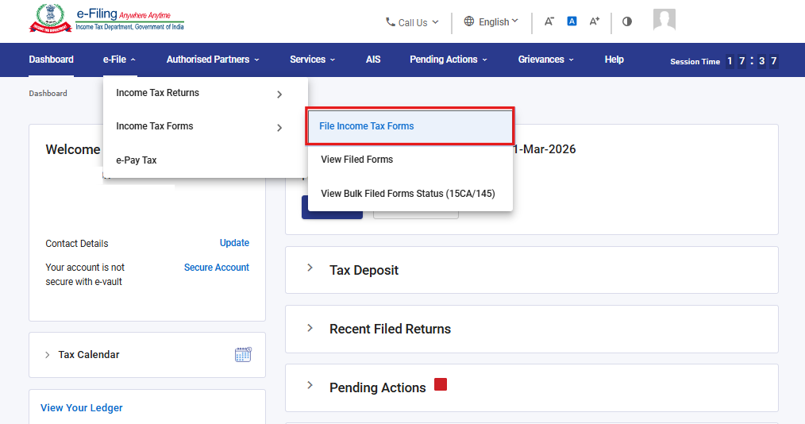

Step 4: Under the Forms as per Income Tax Act 2025 tab, select Form 189 and click File Now
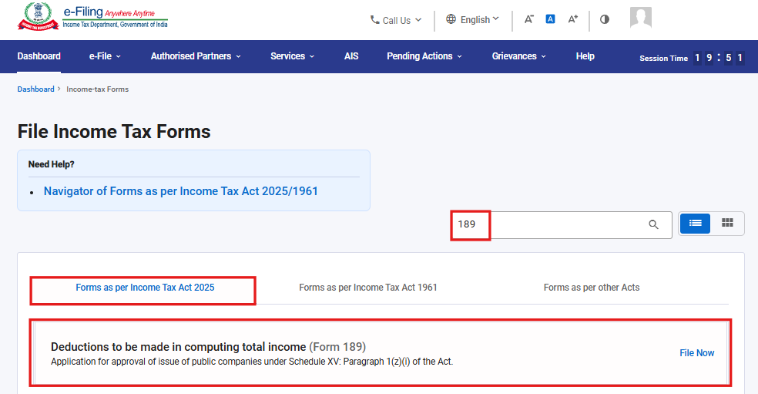

Step 5: Select the applicable Tax Year (T.Y) and click on Continue button.
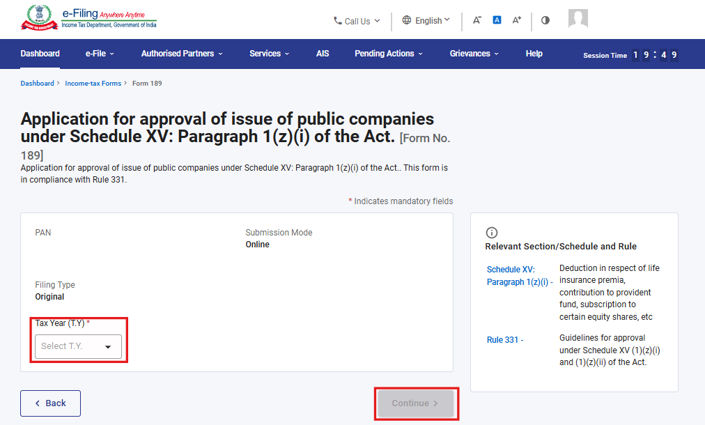

Step 6. Click on Let’s Get Started
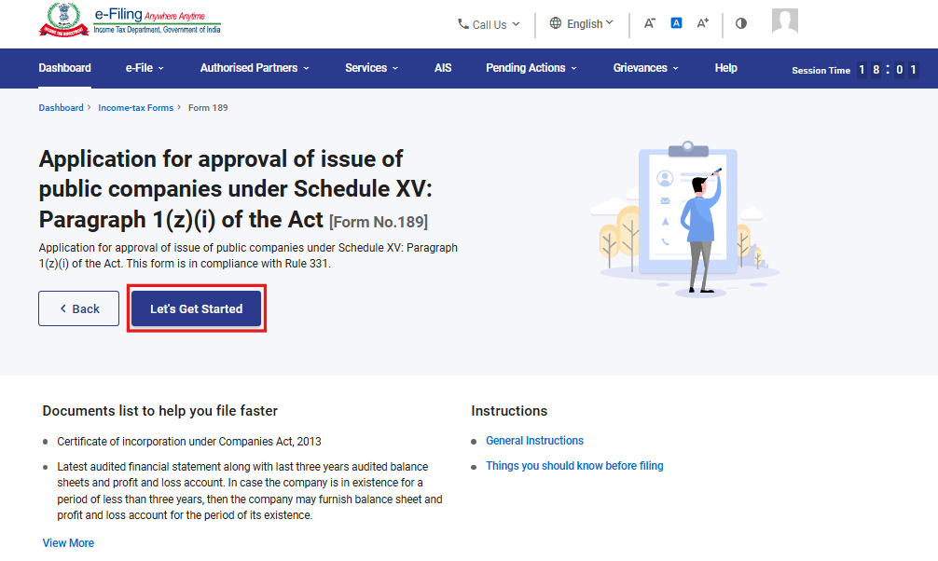

Step 7: Upon clicking Let's Get Started, the user is navigated to the Panel screen. Select the first panel: Part A
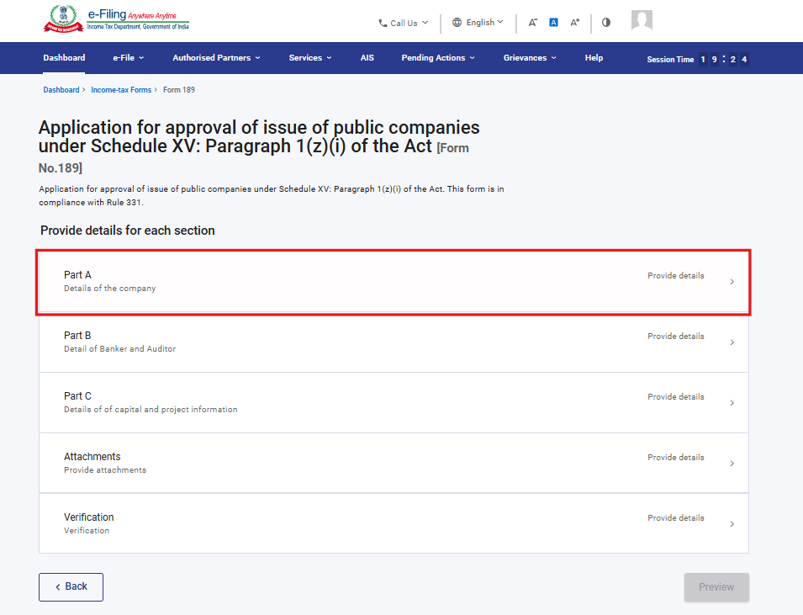

Step 8: Fill the relevant details, verify and click Save.
Note: Please ensure that all mandatory details under "My Profile" section including address is completed. You can update your contact and address details by clicking on hyperlink “My Profile”.
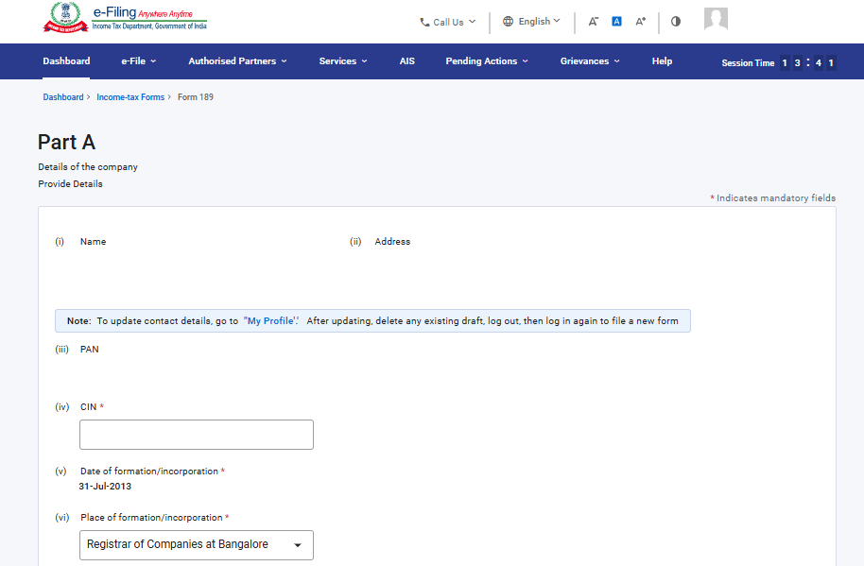
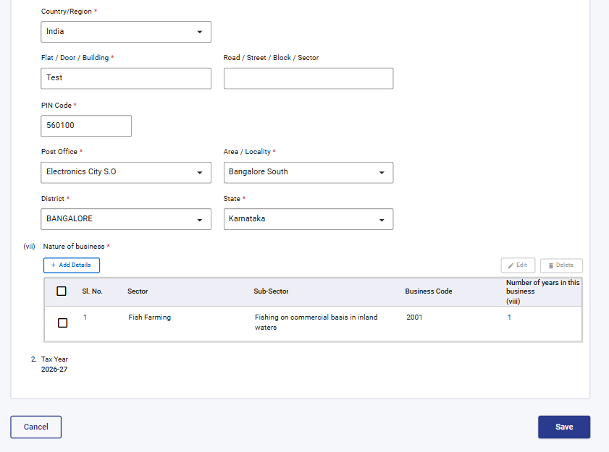

Under Serial No. (vii) Nature of business, select 'Add Details', enter the required details, and click 'Add' to proceed. Dropdown menus are provided for the field “Sector & sub sector” user can select from the available options.
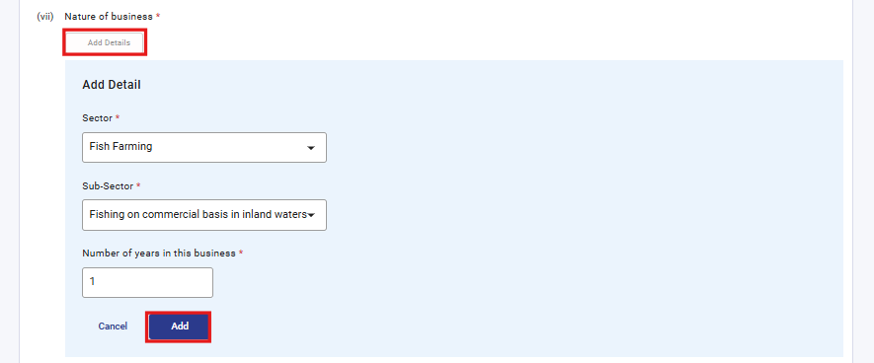

Step 9: After saving the first panel, select the second panel: Part B
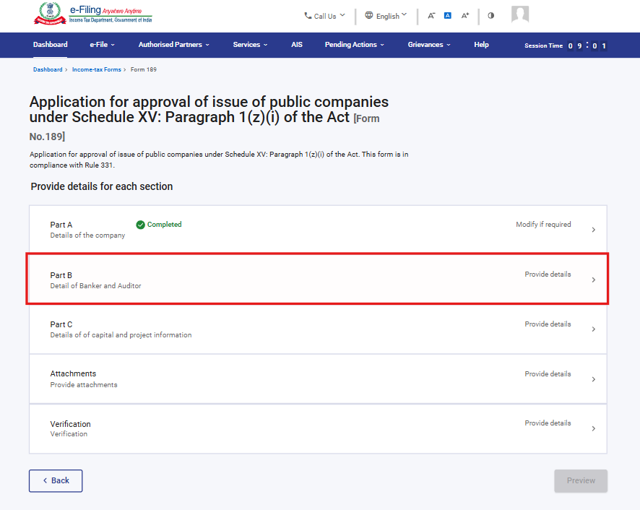
Step 10: Fill in and verify the details under the Part B panel, then click Save
Under Serial No. 3 Name and address of bankers, select 'Add Details', fill the required fields, and click 'Add' to proceed.
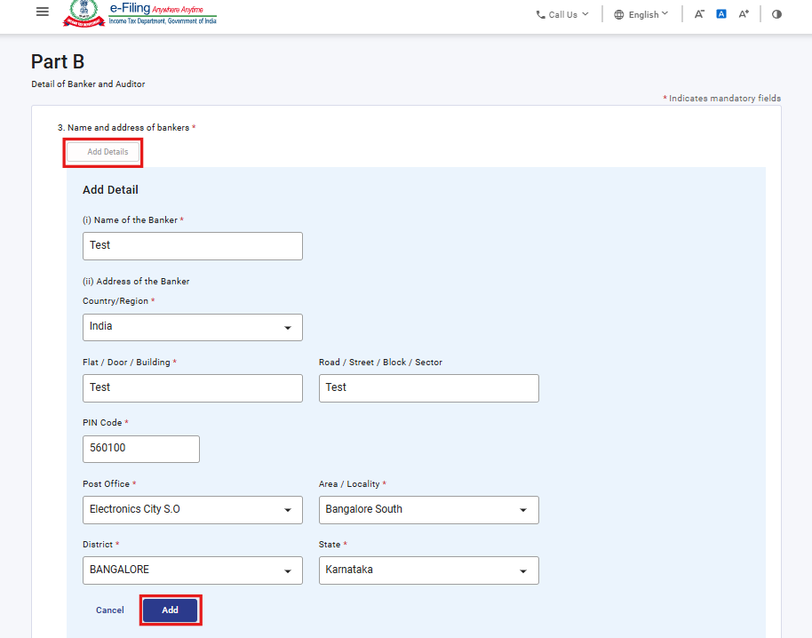

Under Serial No. 4 Name and address of Auditors, select 'Add Details', fill the required fields, and click 'Add' to proceed.
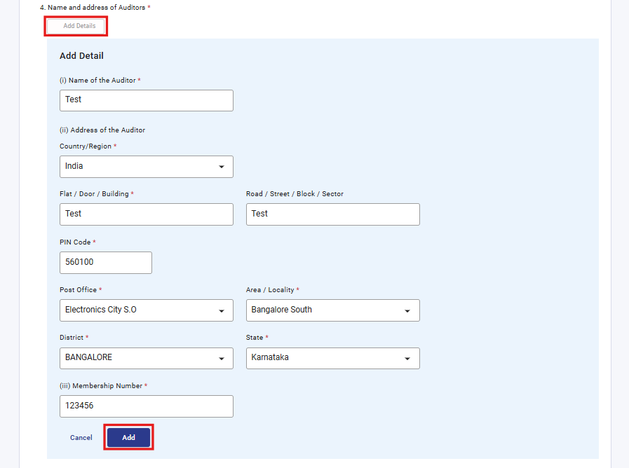
The details entered under Serial No. 3 and 4 will be reflected in a table once added. User can add up to 50 records by clicking on “Add Details” button.
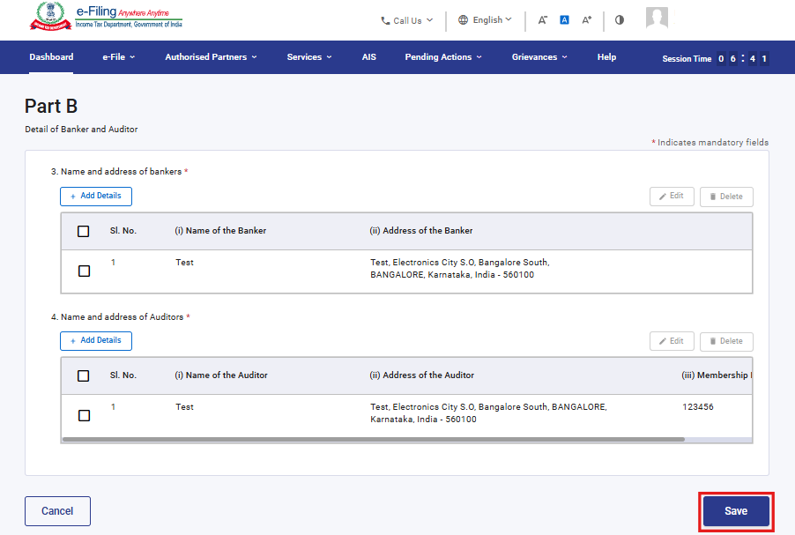

Step 11: After saving the second panel, select the third panel: Part C
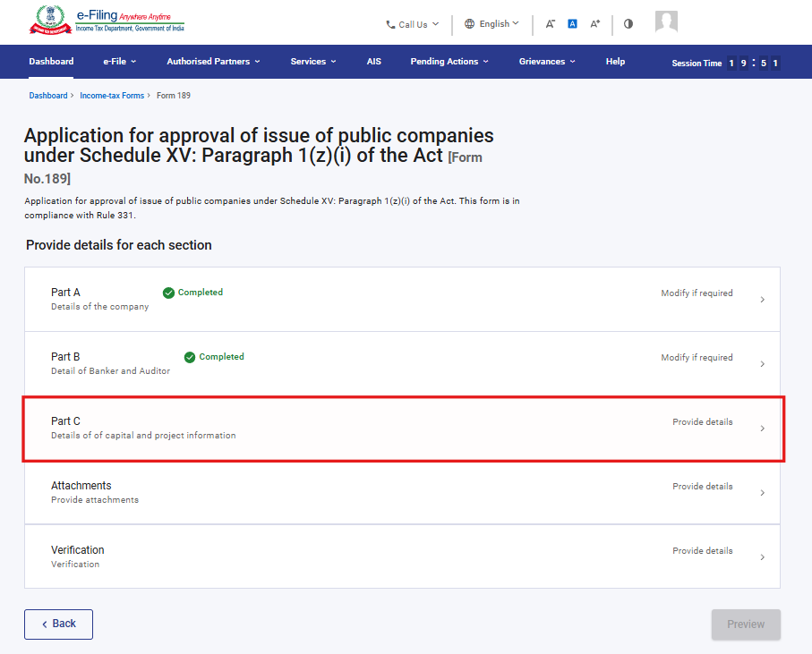

Step 12: Fill the relevant details in “Part C” panel and click Save.
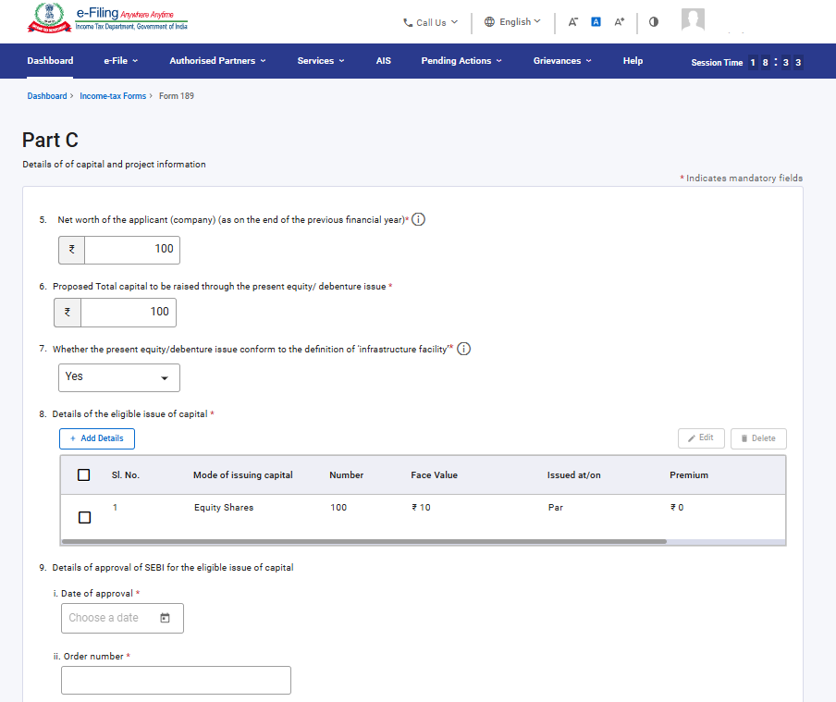

Under Serial No. 8, select 'Add Details', fill the required fields, and click 'Add' to proceed. The fields ‘Please select mode of issuing capital & issued at/on’ contains a dropdown menu from which the user can choose an option.
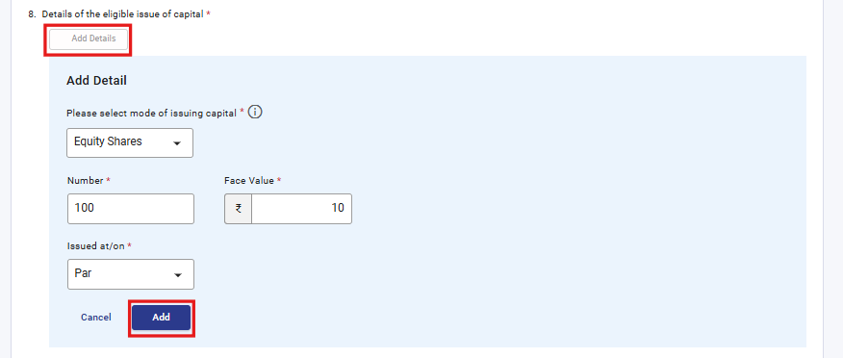
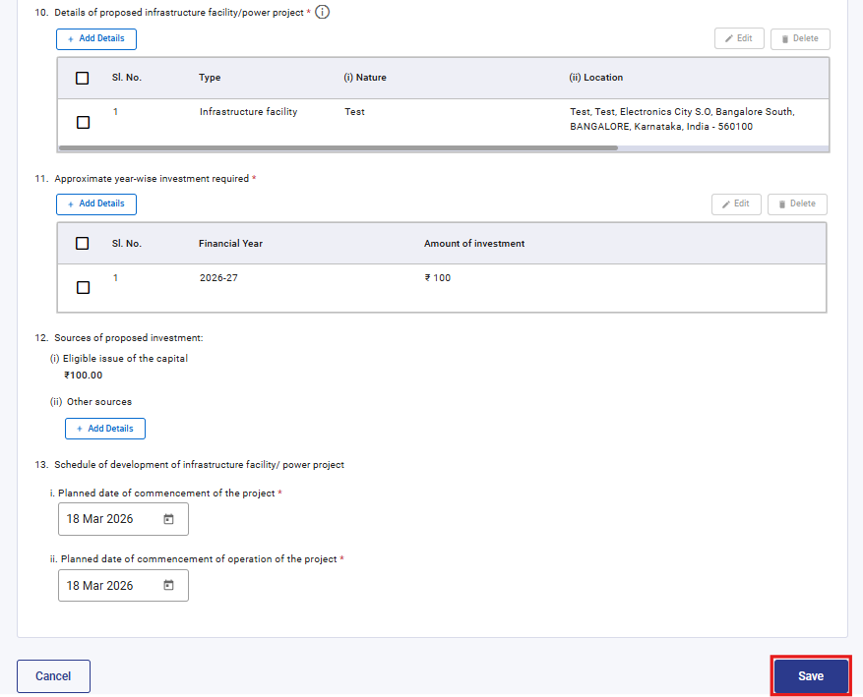
Under Serial No. 10, select 'Add Details', complete the required fields, and click 'Add' to proceed. The field ‘Type’ provides a dropdown menu from which the user can choose an option.
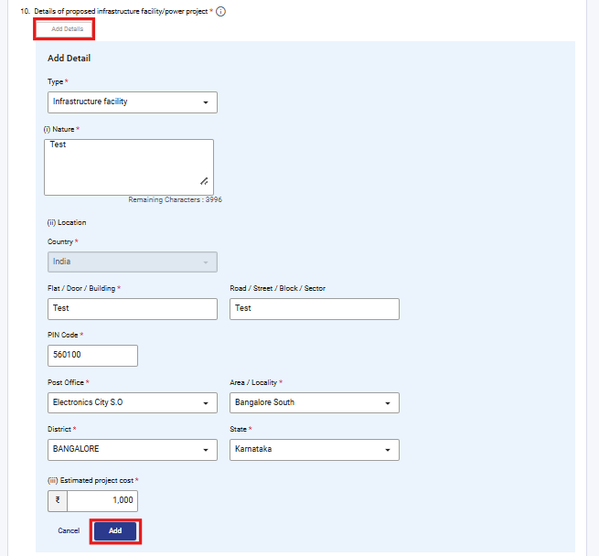
Under Serial No. 11, select 'Add Details', complete the required fields, and click 'Add' to proceed. The field ‘Financial year’ contains a dropdown menu from which the user can choose an option.

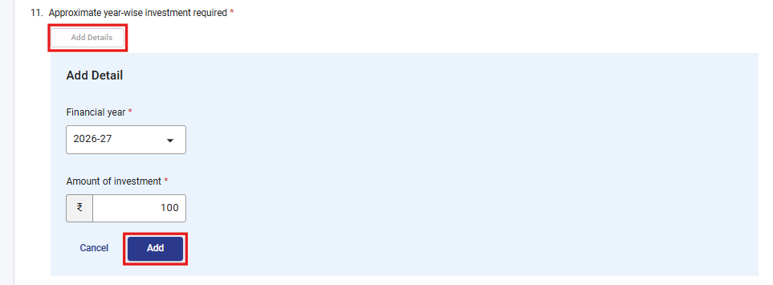

Under Serial No. 12, select 'Add Details', complete the required fields, and click 'Add' to proceed.
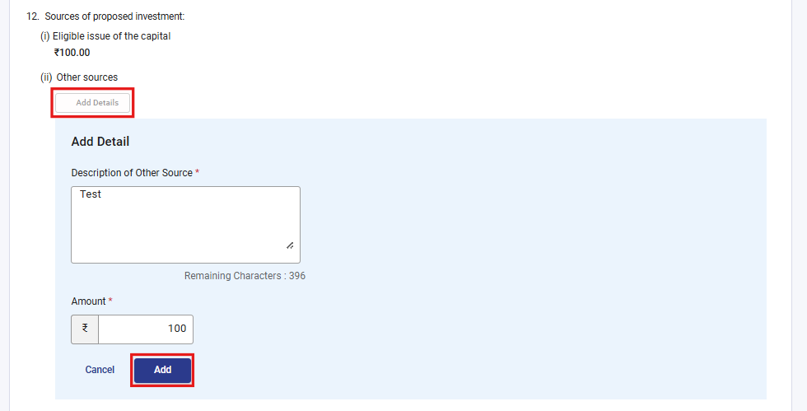

Step 13: After saving the third panel, select the fourth panel: Attachments

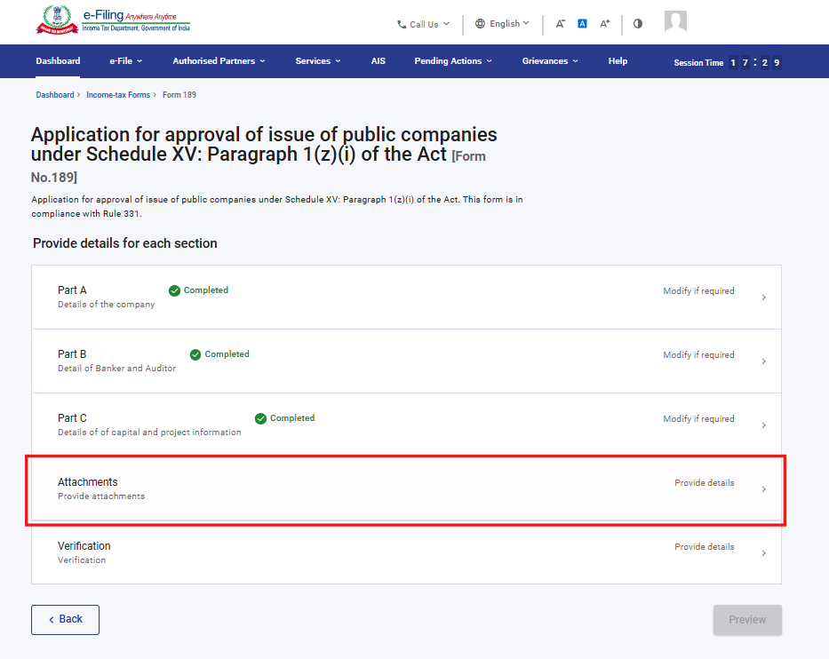

Step 14: Please attach the mandatory documents and click on Save.
Note:
In Attachment A-2, if the user uploads any file, the description text box becomes mandatory.
Attachment A-6 becomes mandatory if user selects “Yes” in field no 7.
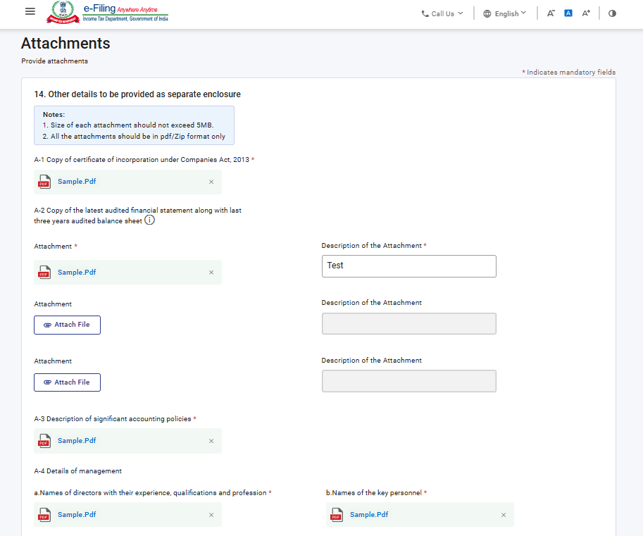
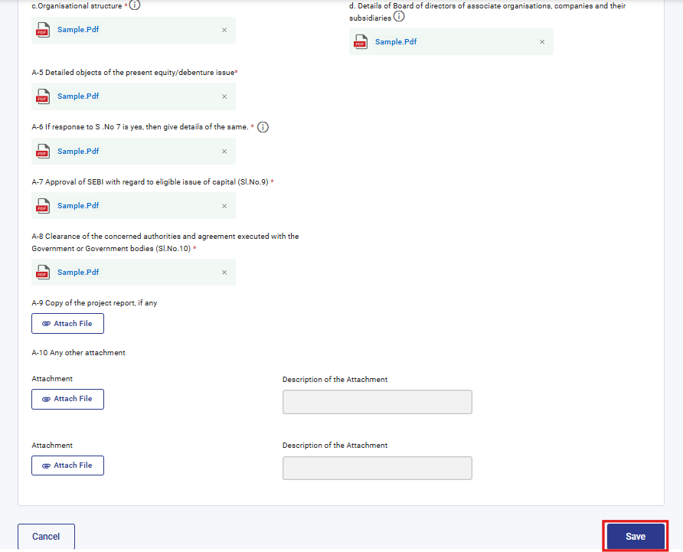
Step 15: After saving the fourth panel, select the Verification panel.
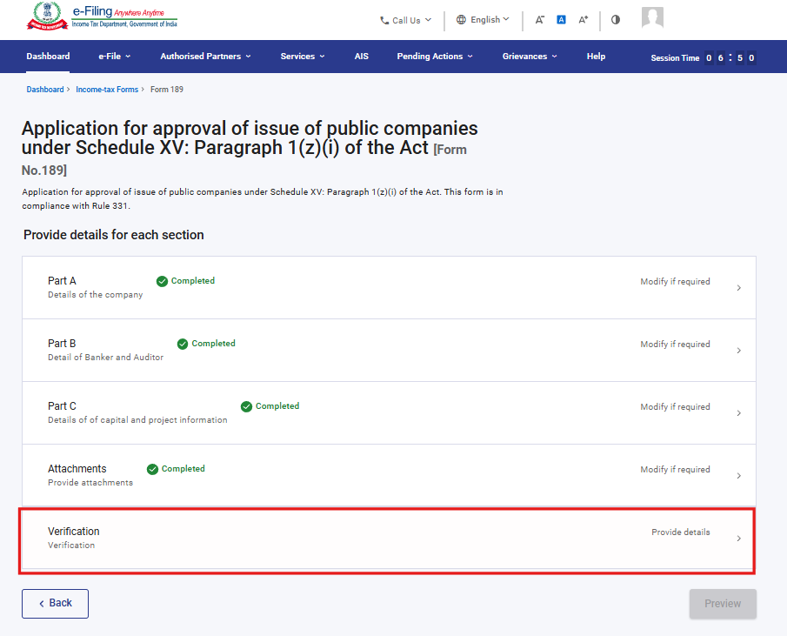
Step 16: Confirm the undertaking and click on Save.
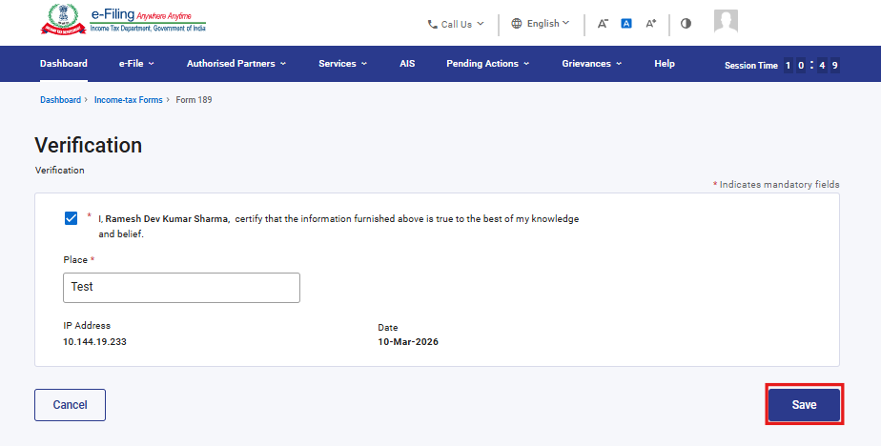
Step 17: Post saving the Verification panel, click on Preview.
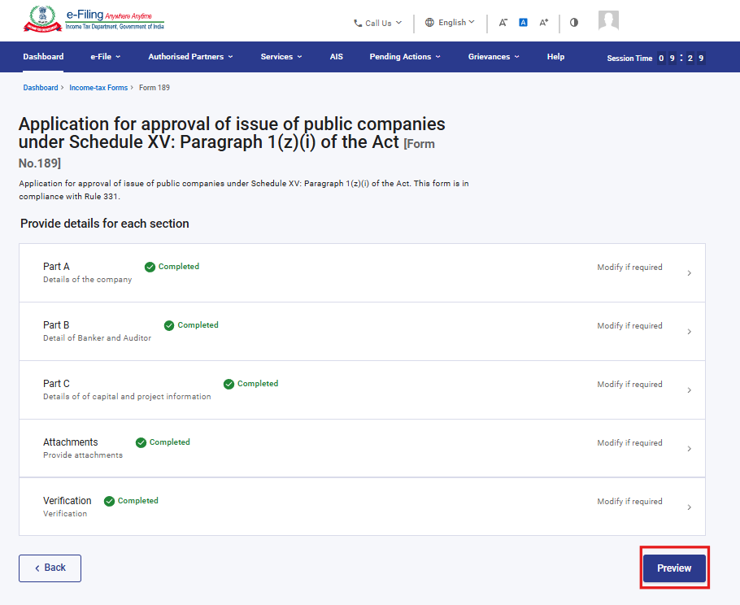
Step 18: On the Preview page, verify the details and click Proceed to e-Verify.
Note: By clicking the “Download” button, the user can download the preview PDF and verify the details before proceeding with e-verification
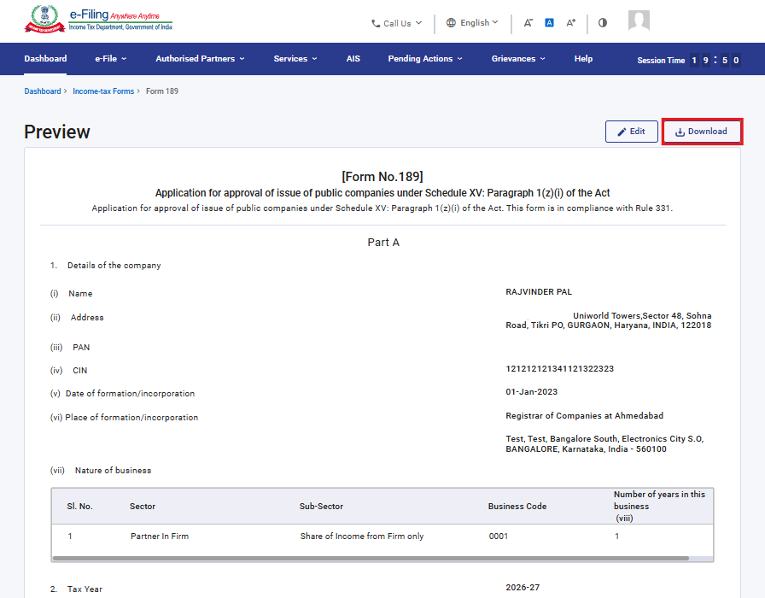
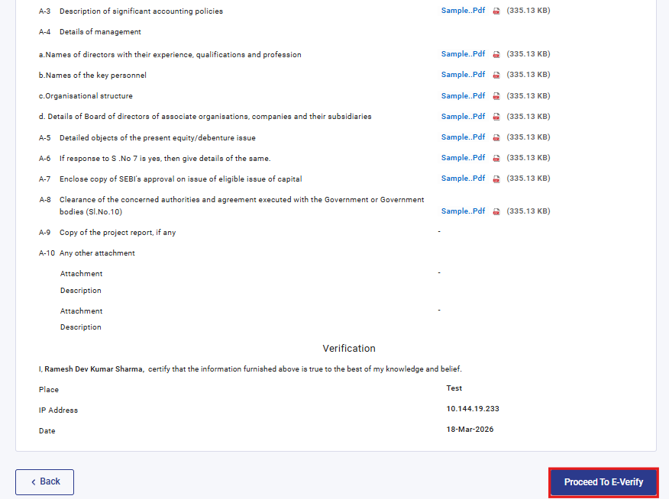
Step 19: Upon clicking the “Proceed to e-Verify” button, a popup confirmation display, that you would like to proceed to e-Verify. Click on “Yes”

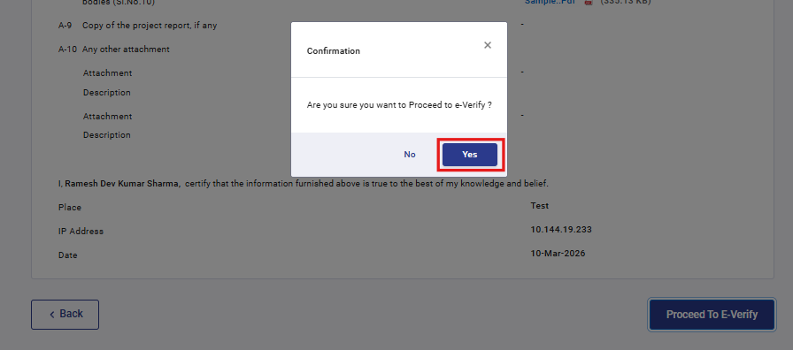

Step 20: On clicking Yes, you will be navigated to the e-Verify page where you can verify the Form 189 using DSC/EVC (as applicable).
Note: Refer to the How to e-Verify user manual to learn more.

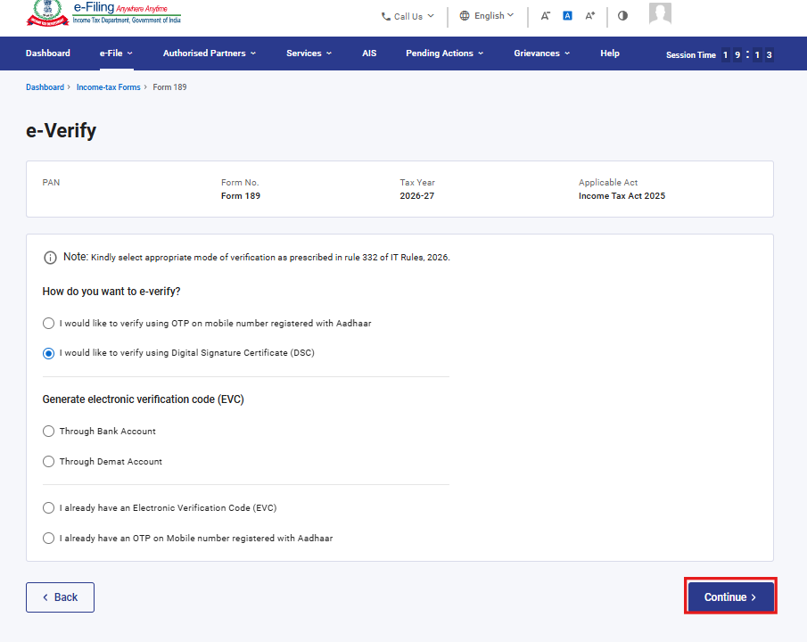
Step 21: After successful e-Verification, a success message is displayed along with a Transaction ID and Acknowledgement Receipt Number. Please keep a note of the Transaction ID and Acknowledgement Receipt Number for future reference. You will also receive a confirmation message on the email ID(s) and mobile number(s) registered with the e-Filing portal.
Click on download button to download the Acknowledgement receipt

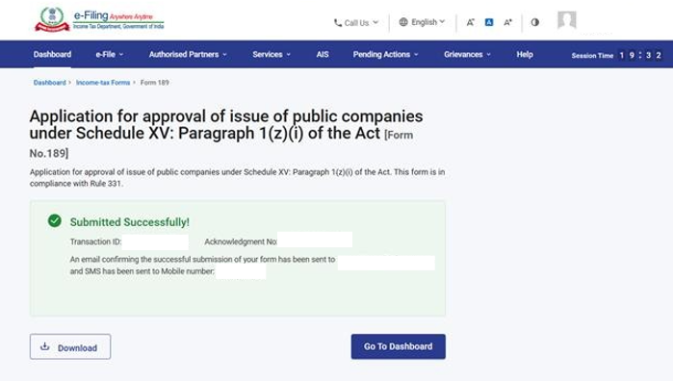

After successful submission of form 189 the user can view the filled form under - On your Dashboard, click e-File > File Income Tax Forms > View Filed Forms> View Filed Form tab under Income Tax Act 2025.
Note: Refer view filled form user manual to learn more

5. Related Topics

- Login
- Dashboard
- How to e-Verify
- Income Tax Forms (Upload)
- Register DSC

6.Glossary

Acronym/Abbreviation | Description/Full Form
DSC | Digital Signature Certificate
EVC | Electronic Verification Certificate
ARN | Acknowledgement Receipt Number
PY | Previous Year
FY | Financial Year
TY | Tax Year

