Form 55 > User Manual

User Manuals
Integrated e-Filing and CPC 2.0
Project Module: e-Filing Forms
Use Case ID
Use Case Description | Form No. 55  Form of application for an assessee, resident in India, seeking to invoke mutual agreement procedure provided for in agreements with other countries or specified territories  (Formerly known as Form 34F as per Income-tax Act, 1961)
Confidentiality Agreement
"This document contains proprietary information exclusively vests with ITD. This document may not, in whole or in part, be copied, photocopied, stored, saved, reproduced, replicated, disseminated, translated, transmitted or reduced to in any medium (whether electronic, mechanical, machine-readable and/or any other tangible or intangible form of any nature), by the intended recipient/s or user/s without the express consent, in writing, from the Authorized Representative of ITD Management." All the Intellectual Property Rights (i.e. copyrights) as may be available under the applicable laws, pertaining to ITD's confidential information, shall exclusively vest with ITD only, and any breach thereof shall be subject to indemnification.
Revision History
Ver. | Date | Author | Reviewer/ Approver | Comments
0.1 | 07-03-2026 | Sathish Kumar | Parul Aggarwal | Initial document
Note: Once approved, unapproved versions will be removed from the list

Reviewed by:
Sl. | Organization | Name | Designation
1 | Infosys Ltd | Adrian Lasrado | Program Manager
2 | Infosys Ltd | Parul Aggarwal | Principal Consultant
3 | Infosys Ltd | Anu Malhotra | Senior Project Manager, Development
4 | Infosys Ltd | Manthuri Kavitha | Quality Engineering Lead
5 | Infosys Ltd | Jaisy Ann Cheriyan | Senior Technology Architect
6 | Infosys Ltd | Ravi Kiran Thallapureddy | Principal Technology Architect
7 | Income-tax Department | Ajay Robin Sir | Addl DIT
8 | Income-tax Department | Christabel D'Mello | JDIT
9 | Income-tax Department | Hari Kumar | JDIT(S)
10 | Income-tax Department | Praveen Sinha | JDIT
11 | Income-tax Department | M Devaki | DDIT
12 | Income-tax Department | K.S.A. Seshasailendra | DDIT
13 | Income-tax Department | Madhukar Peri | DDIT(S)

Table of Contents
About this document
Form 55 > User Manual

- Overview
- Prerequisites for availing this service
- About the Form
- Step-by-Step Guide
- Related Topics
- Glossary

About this document
The purpose of this document is to provide step-by-step instructions to the taxpayers to use the e-filing portal. The content in this document (in the following pages) will be converted into HTML pages and integrated with the e-Filing portal; the presentation of the content in terms of colour, font, size will be as per the UI guidelines followed in the website.
The document also contains list of glossary terms specific to this document. These terms will also be added to the overall Glossary in the Help section of the website.
To facilitate search on the Internet, metadata will be added to the HTML pages. The keywords to be added to metadata are also added in this document.
In addition, assessment questions have also been designed that will be used for training of call-center agents.

Form 55 > User Manual

1. Overview
- Taxpayers who wish to seek assistance from the Indian Competent Authority for resolving such cases of double taxation must apply in Form 55. This form enables the Income Tax Department to examine the details of the tax dispute, validate the information provided, and initiate discussions with the Competent Authority of the foreign country, wherever applicable.
- Form 55 must be filed online on the e‑Filing portal, along with relevant supporting documents such as assessment orders, demand notices, or correspondence with foreign tax authorities. Once the application is submitted successfully, the Competent Authority reviews the case and may request additional information if required.
- This process ensures that taxpayers are protected from unintended double taxation and that disputes arising from cross‑border tax issues are resolved through a structured and transparent mechanism provided under international tax treaties.

2. Prerequisites for availing this service
- You should be a registered user on the e-Filing portal
- Status of PAN of the taxpayer should be "Active"
- You should have a valid DSC to verify the form through DSC mode, and it must be registered on the e-filing portal and not expired

3. About the Form

3.1 Purpose

Form 55 is an application seeking to invoke mutual agreement procedure provided for in agreements with other countries or specified territories. (Refer Rule 121)

3.2 Who can use it?
Form 55 has to be filed by any assessee who is resident in India and seeking to invoke mutual agreement procedure provided for in agreements with other countries or specified territories.

3.3 Form at a Glance
Form 55 has four panels:
- Part A: Particulars of the Applicant
- Part B: Other details
- Attachment
- Verification

4. Step-by-Step Guide
Step 1: Log in to the e-Filing portal with your User ID and Password.

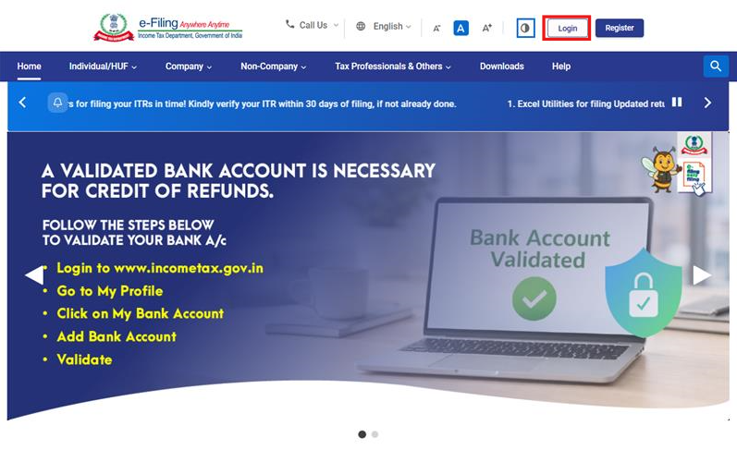

Step 2: Enter the User ID (PAN) and Password.
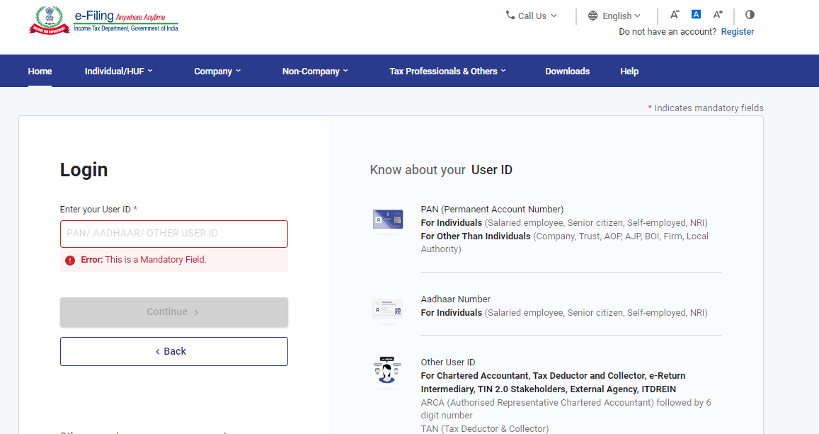

Step 3: Go to e-file >Income Tax Forms > File Income Tax Forms
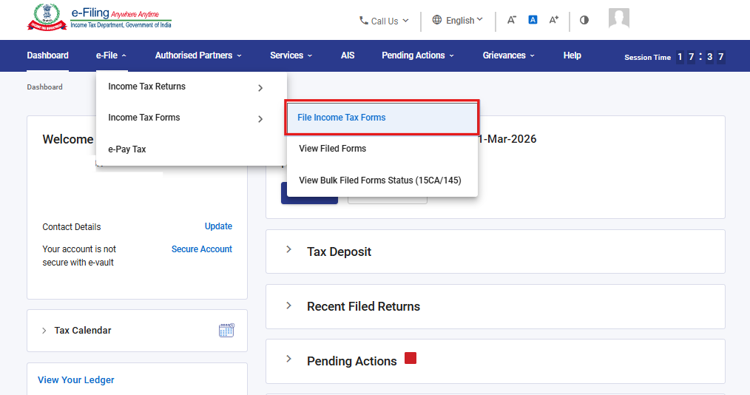

Step 4: Select the Forms as per Income Tax Act 2025 tab, select Form 55, and click the File Now button
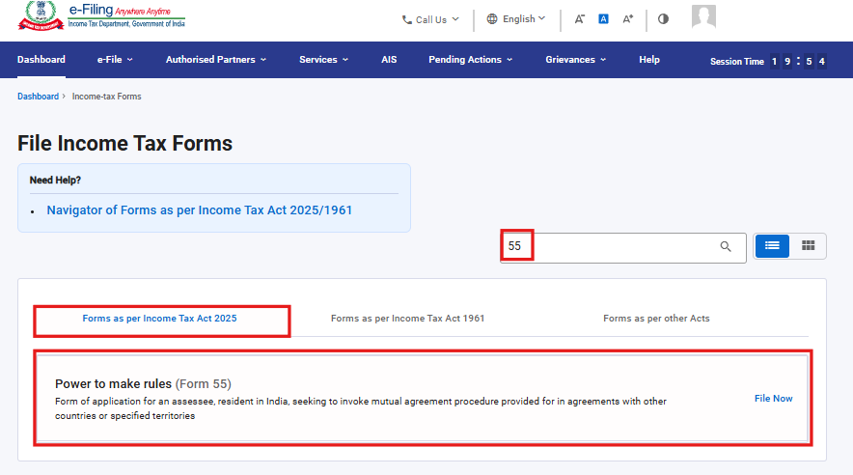

Step 5: Select the applicable Tax Year (T.Y) and click on Continue button.
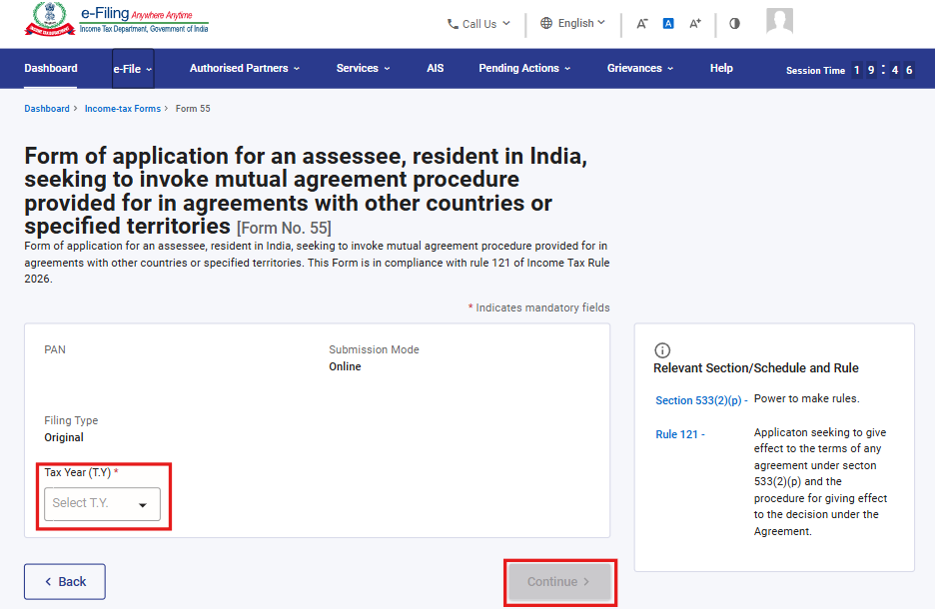
Step 6. Click on Let’s Get Started
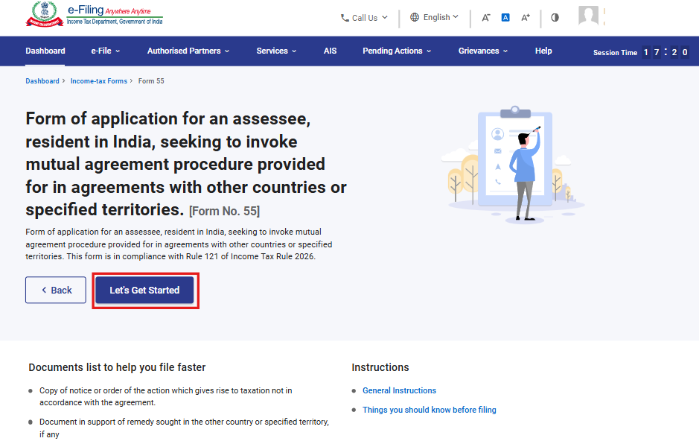

Step 7: Post clicking on Let’s Get Started screen, user will be navigated to Panel screen and select the 1st Panel: Part A: Particulars of the Applicant
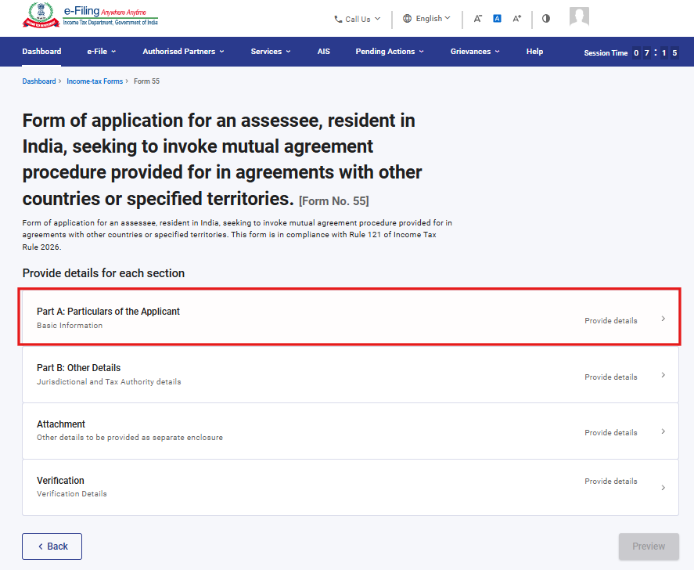
Step 8: Verify the Particulars and click on Save.
Note: Please ensure that all mandatory details under "My Profile" section including address are completed. You can update your contact and address details by clicking on hyperlink “My Profile”.
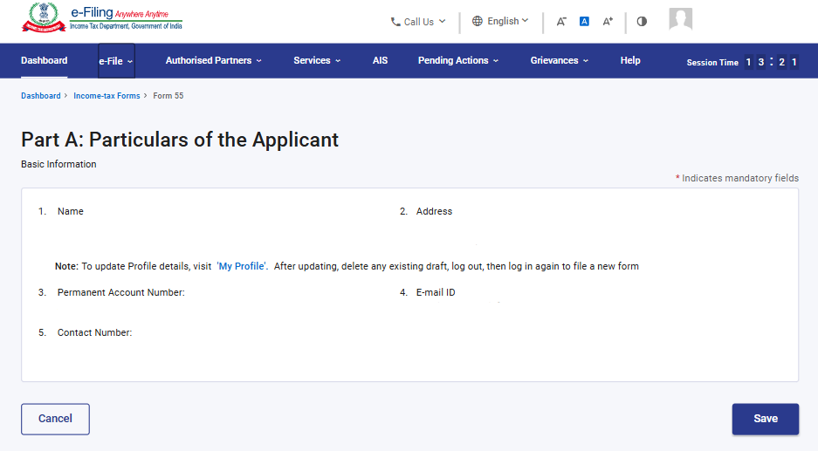

Step 9: Post saving the 1st panel, select the 2nd Panel: Part B: Other Details
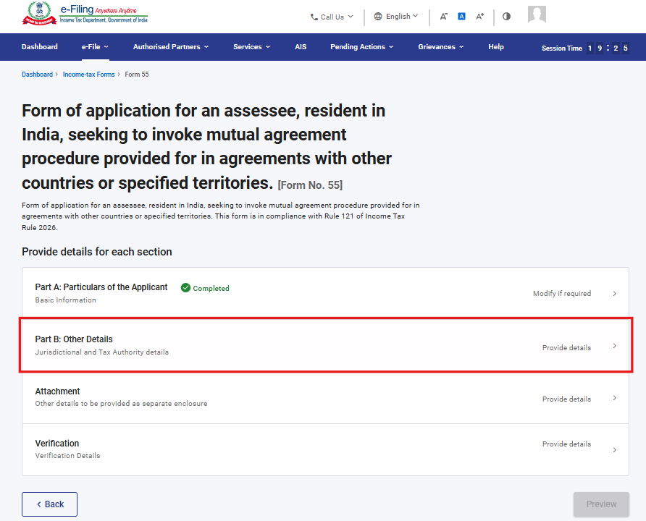
Step 10: Please fill and verify the “Part B: Other Details” panel and click on Save.
Note: In Serial No. 7, the user can select the multiple checkboxes for the field “Tax year(s)” to which the notice or order relates.
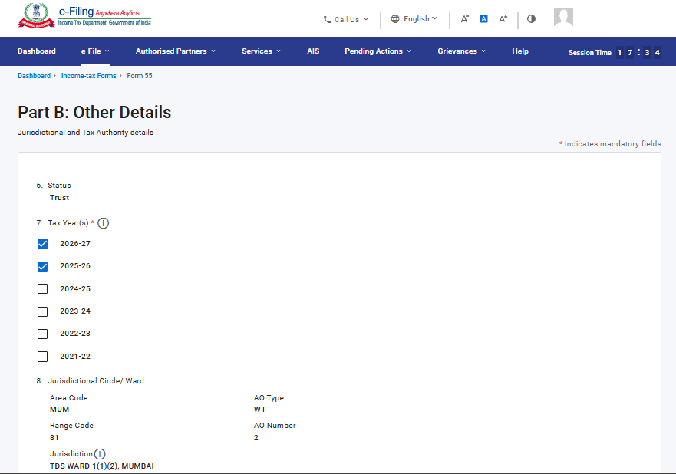
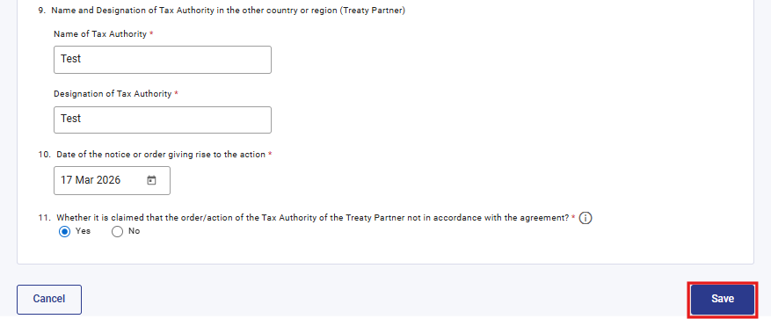

Step 11: Post saving the 2nd panel, select the 3rd Panel: Attachments

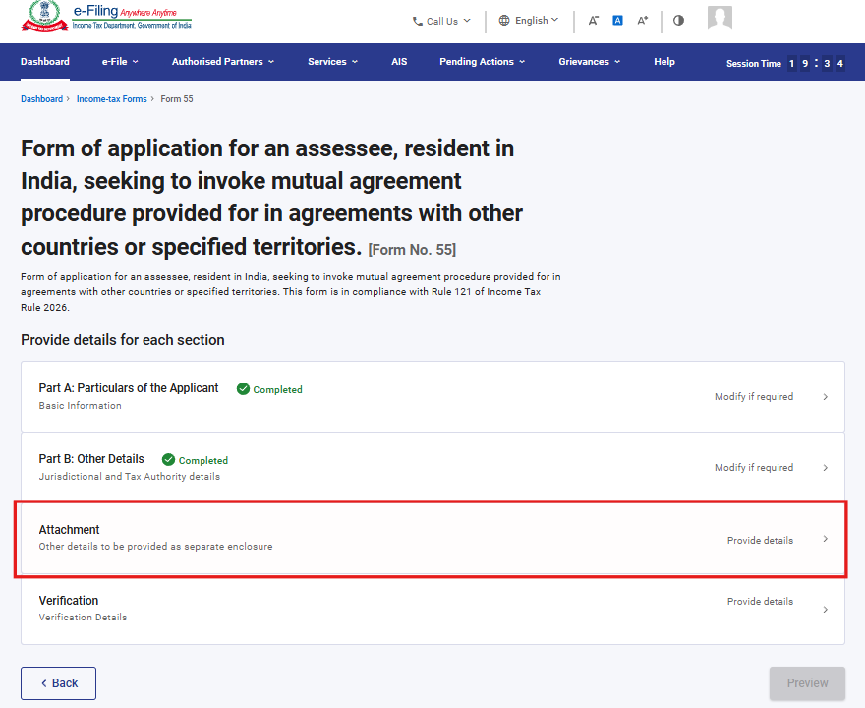

Step 12: Please attach the relevant documents and click on Save.
Note: - Attachment A-3 is mandatory if user selects “Yes” in field no 11.
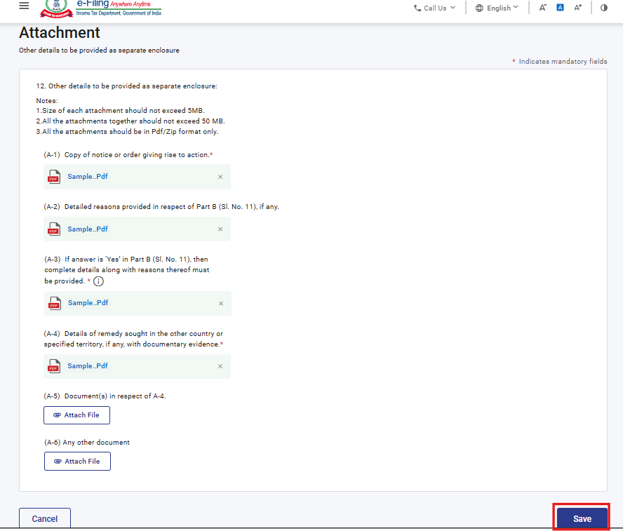
Step 13: Post saving the 3rd panel, select the “Verification” Panel
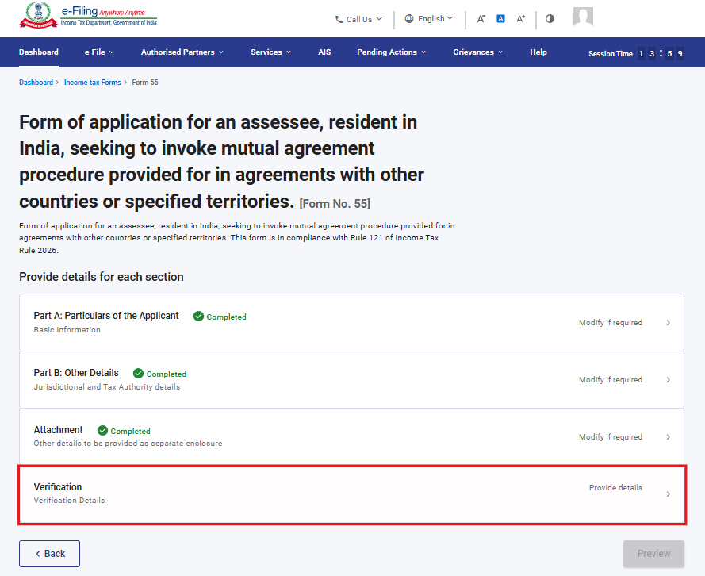
Step 14: Confirm the undertaking and click on Save.
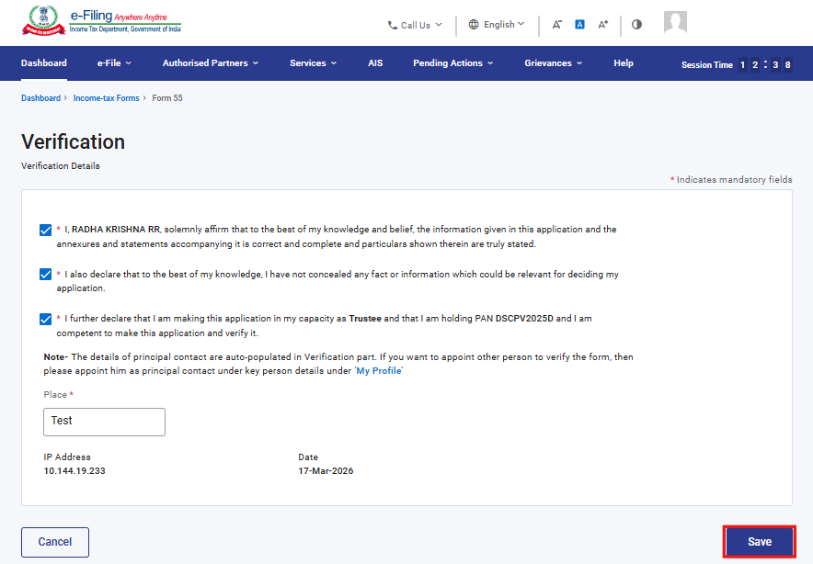

Step 15: Post saving the 4th panel, click on Preview.
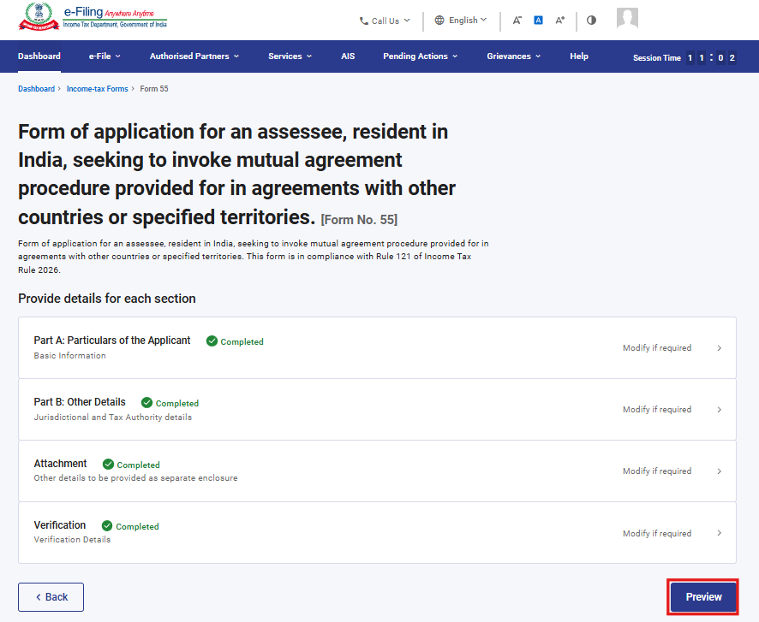
Step 16: On the Preview page, click “Download” to download the preview PDF and verify the details, then click Proceed to e-Verify
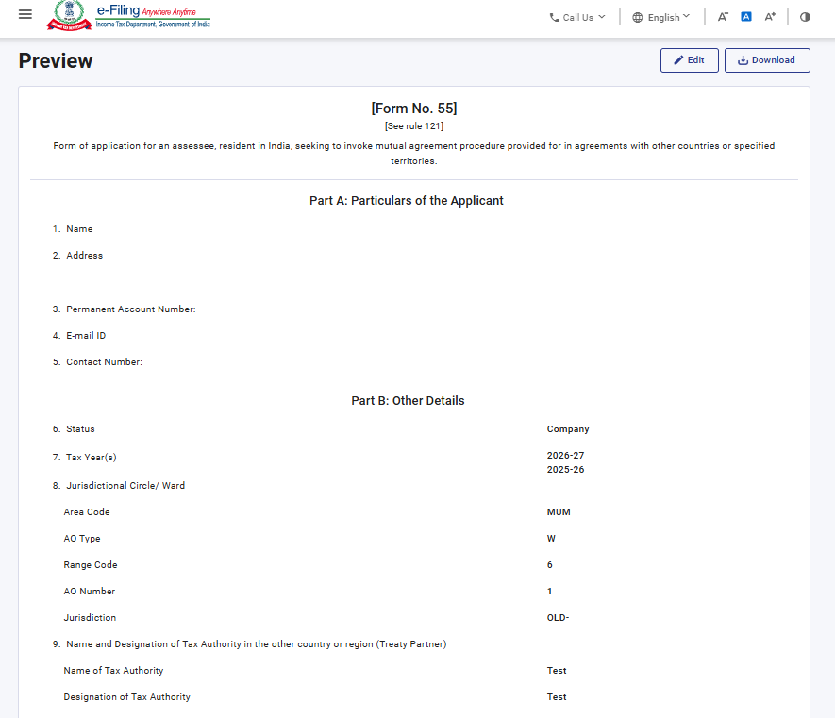
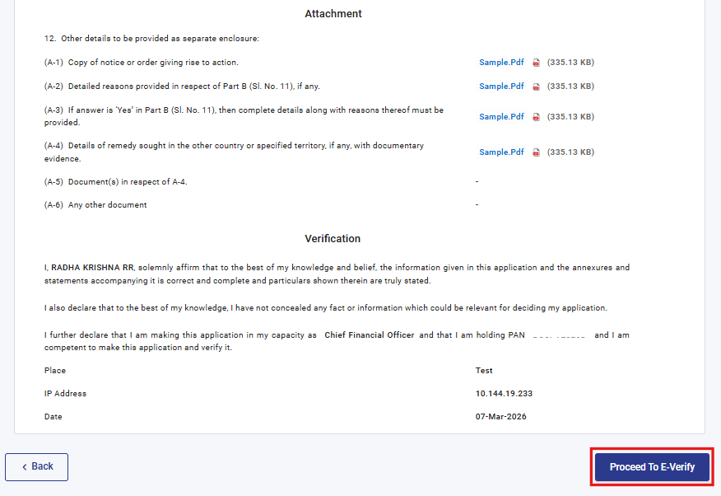
Step 17: Post clicking on Proceed to e-Verify button, a popup confirmation displaying that you would like to proceed to e-Verify. Click on Yes
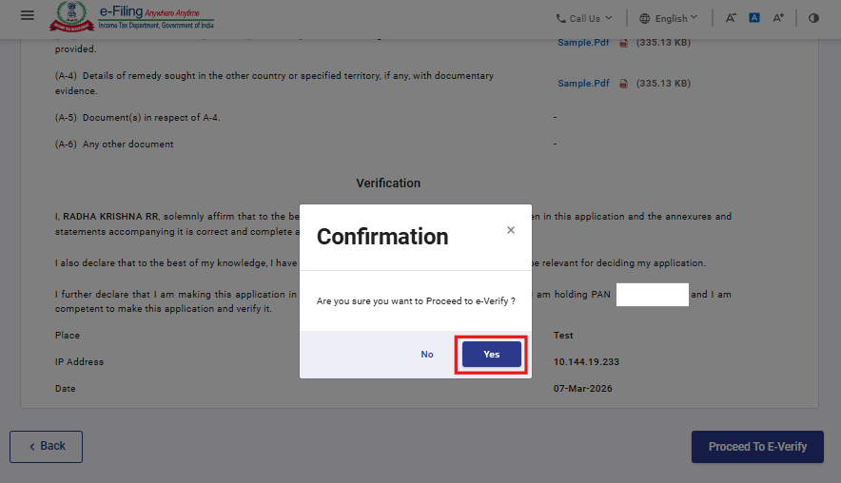

Step 18: On clicking Yes, you will be navigated to the e-Verify page where you can verify the Form 55 using DSC/EVC (as applicable).
Note: Refer to the How to e-Verify user manual to learn more.
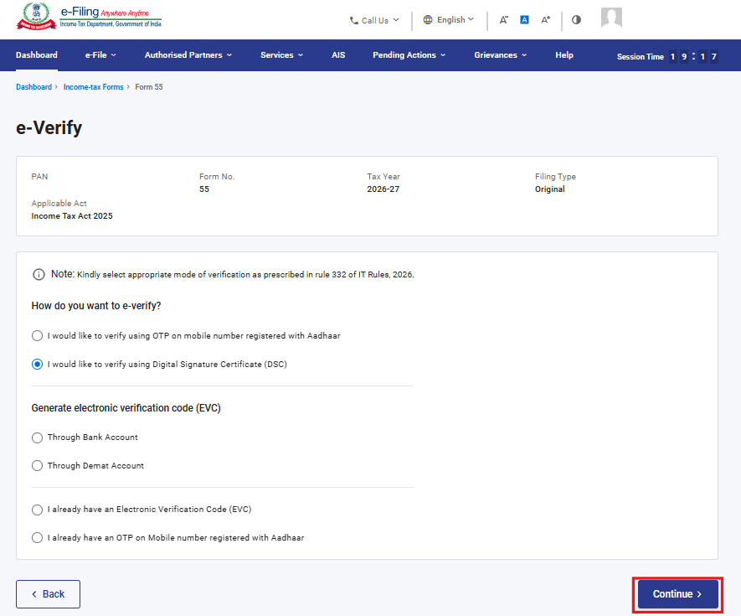
Step 19: After successful e-Verification, a success message is displayed along with a Transaction ID and Acknowledgement Receipt Number. Please keep a note of the Transaction ID and Acknowledgement Receipt Number for future reference. You will also receive a confirmation message on the email ID(s) and mobile number(s) registered with the e-Filing portal.
Click on download button to download the Acknowledgement receipt.

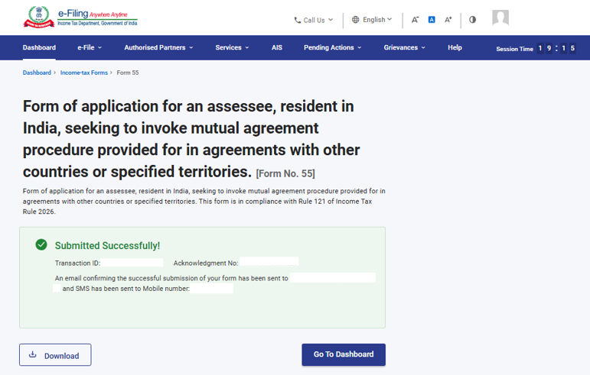
After successful submission of form 55 the user can view the filled form under - On your Dashboard, click e-File > File Income Tax Forms > View Filed Forms> View Filed Form tab under Income Tax Act 2025.
Note: Refer view filled form user manual to learn more

5. Related Topics
- Login
- Dashboard
- How to e-Verify
- Income Tax Forms (Upload)
- Register DSC

6.Glossary

Acronym/Abbreviation | Description/Full Form
DSC | Digital Signature Certificate
EVC | Electronic Verification Certificate
ARN | Acknowledgement Receipt Number
PY | Previous Year
FY | Financial Year
TY | Tax Year

