Form 67 User Manual: Statement of income from a country or specified territory outside India and Foreign Tax Credit
1. Overview
As per Rule 128 of the Income Tax Rules, 1962, a resident taxpayer is eligible to claim credit for any foreign tax paid, in a country or specified territory outside India. The credit shall be allowed only if the assessee furnishes the required particulars in Form 67 within the specified timelines.
Form 67 can only be submitted through online mode. This service enables the registered users to file Form 67 online through the e-Filing portal.
2. Prerequisites for availing this service
- You should be a registered user on the e-Filing portal.
- Status of PAN of the taxpayer should be "Active."
- PAN and Aadhaar of the taxpayer are linked. (Recommended)
3. About the Form
3.1 Purpose
A resident taxpayer who has credit for the amount of any foreign tax paid in a country outside India by way of deduction or otherwise will be required to furnish the statement in Form 67 on or before the due date specified for furnishing the return of income under sub-section (1) of Section 139 to claim credit of such taxes.
Form 67 will also be required to be furnished in case the carry backward of loss of the current year results in refund of foreign tax for which credit has been claimed in any earlier previous years.
3.2 Who can use it?
A resident taxpayer who has credit for the amount of any foreign tax paid in a country outside India by way of deduction or otherwise.
3.3 Form at a Glance
Form 67 has 4 parts:
- Part A
- Part B
- Verification
- Attachments
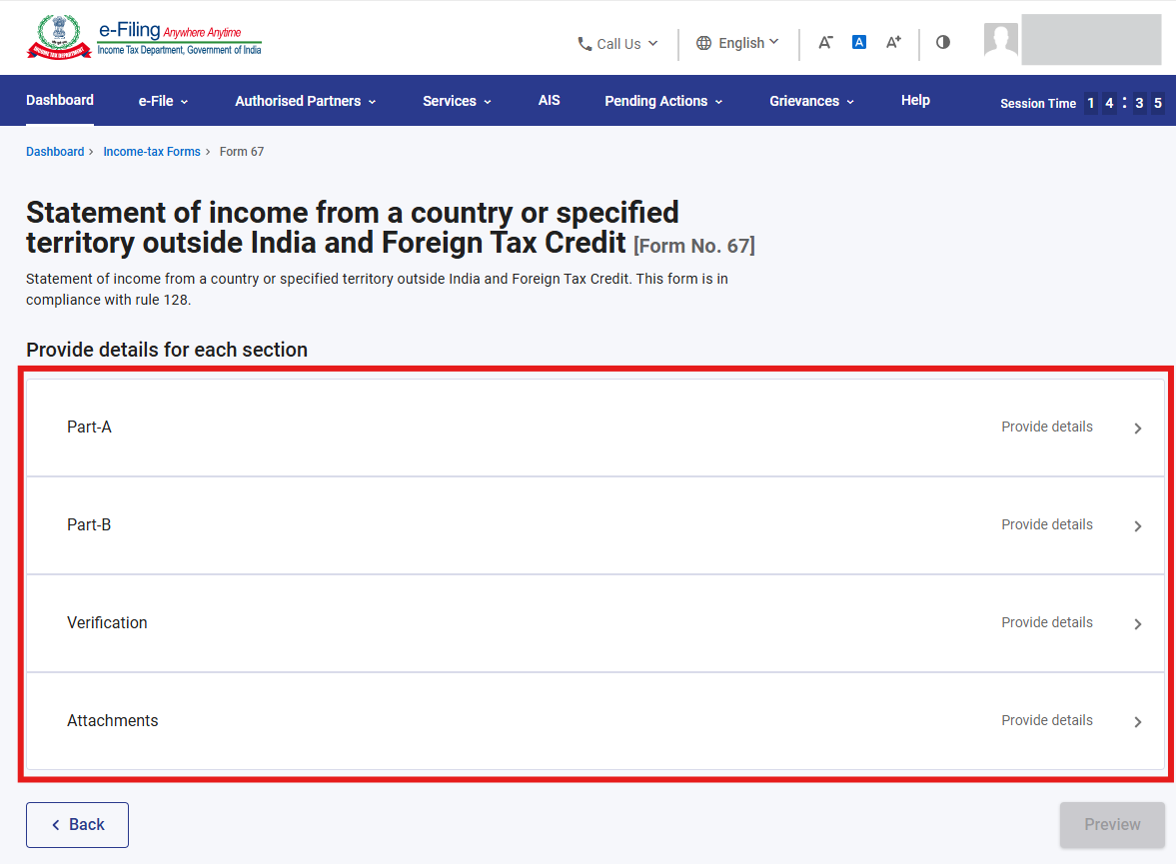
4. Step-by-Step Guide
Step 1: Log in to the e-Filing portal with your User ID and Password.
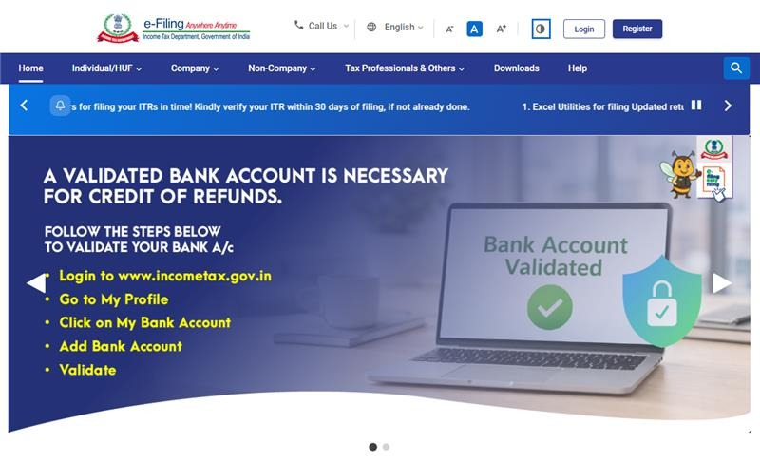
Step 2: Enter the User ID (PAN) and Password.
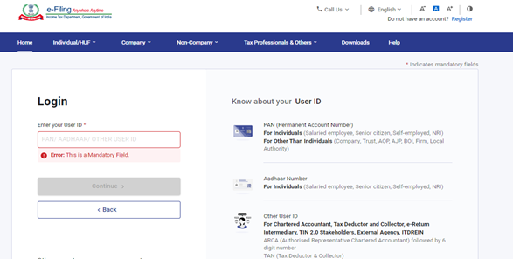
Step 3: Go to e-file >Income Tax Forms > File Income Tax Forms
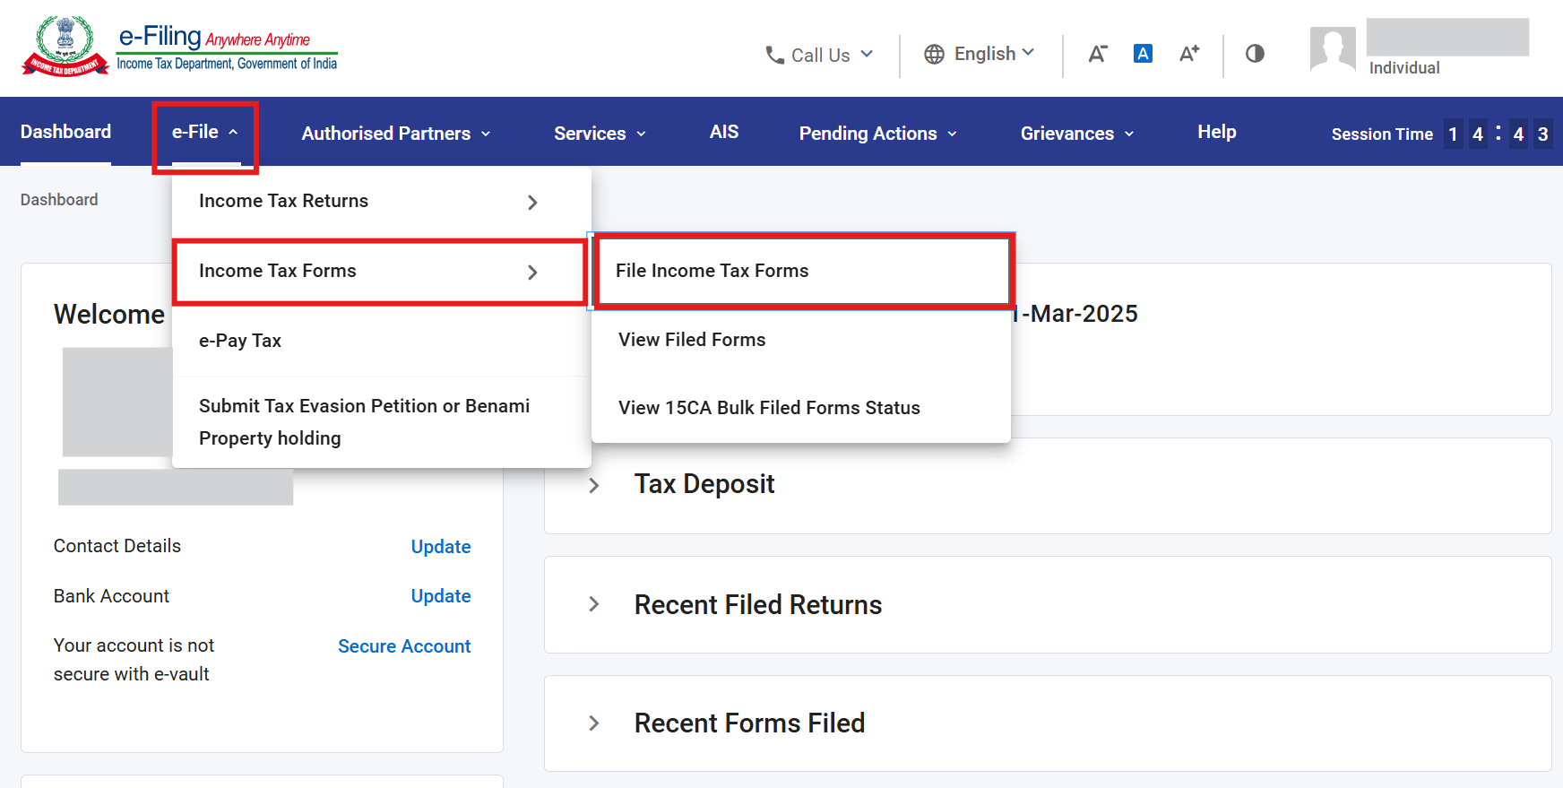
Step 4: Select/ Search Form 67 under Forms as per Income Tax Act 1961 tab.
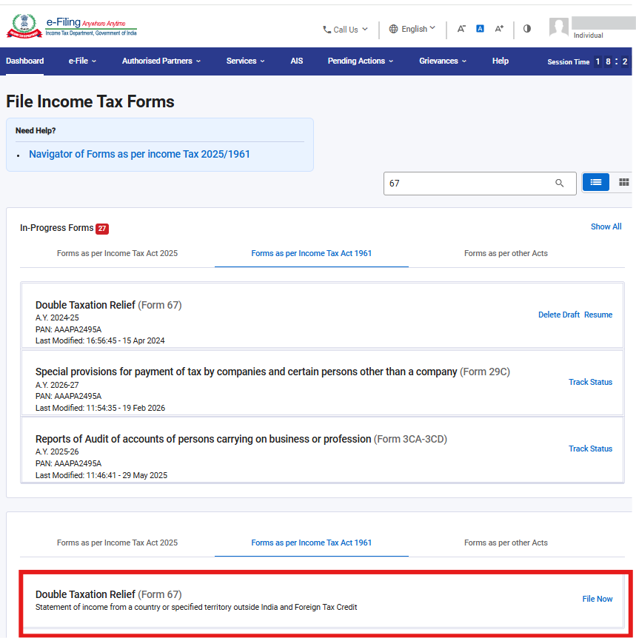
Step 5: Select AY and click Continue.
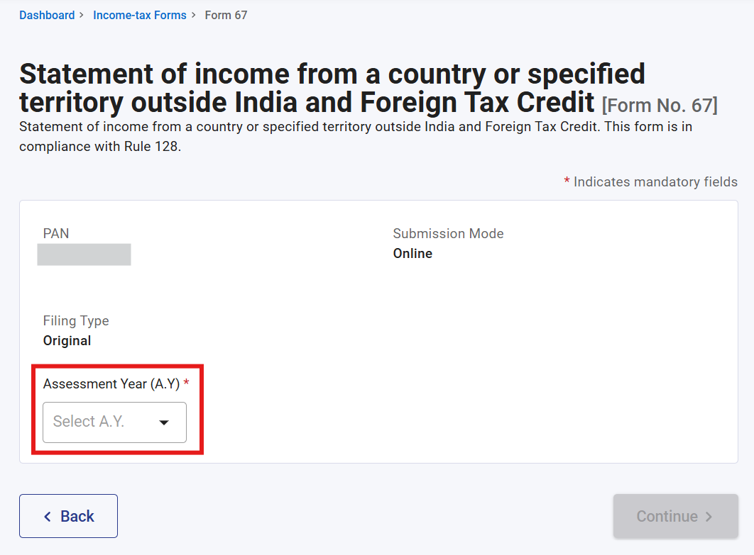
Step 6: Click on Let’s Get Started
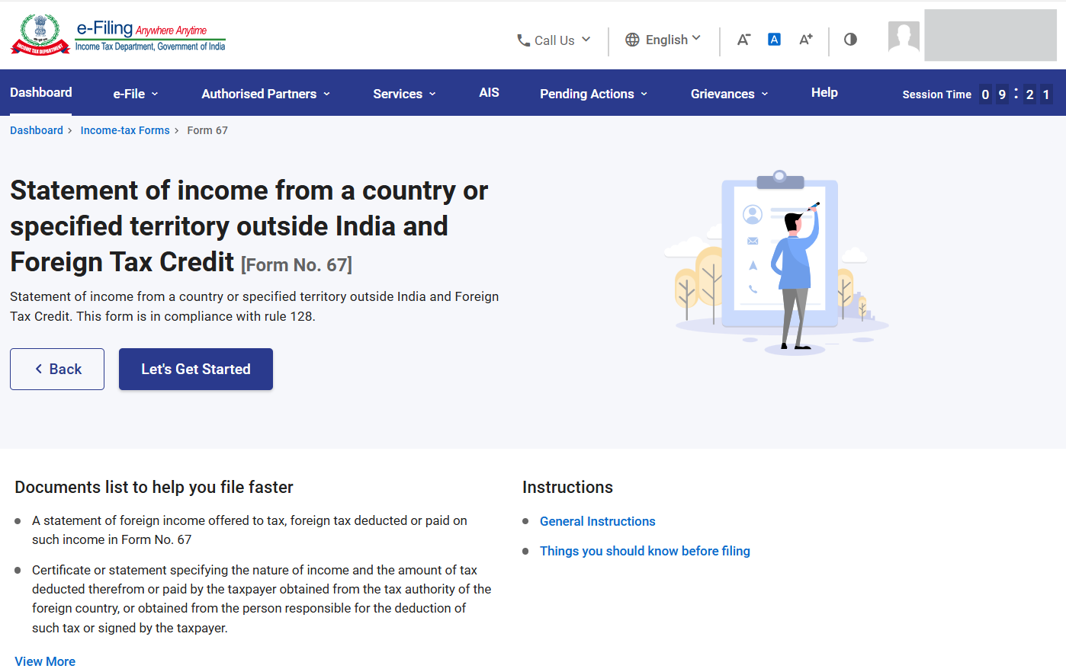
Step 7.1.a: On click of Let’s Get Started. Form 67 will be displayed. Click on “Part A” tab.
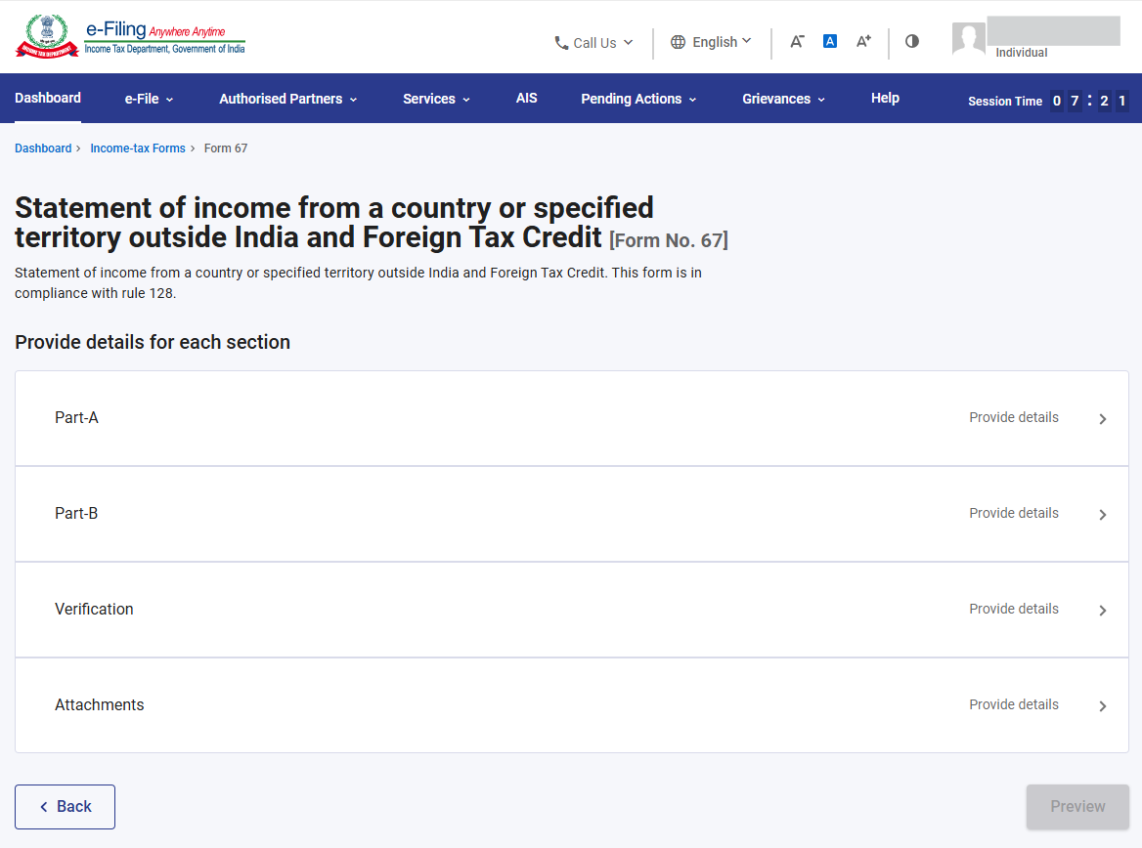
Step 8.1.b: This part contains basic details of the assessee and details of the income earned from a country or specified territory outside India and Foreign Tax Credit.
Note: To update contact details, click on “My Profile”.
Note: You can add income details either by entering them manually using the “Add Details” button or, if you have more than 50 records, by downloading the CSV template from the same page, filling the template accordingly, and then uploading it using the “Attach CSV File” option. Kindly download the instructions to fill in the csv template for more information and Click Save.
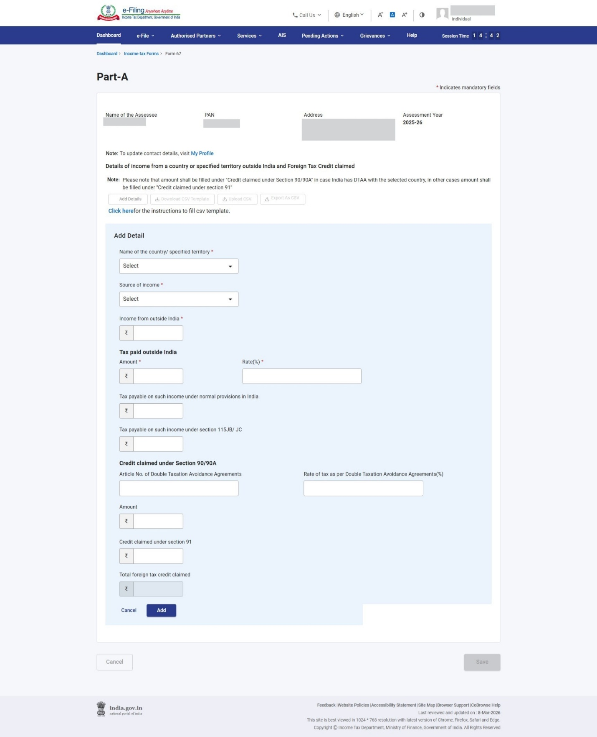
Step 7.2.a: Part A Tab is confirmed now, click on Part B tab.
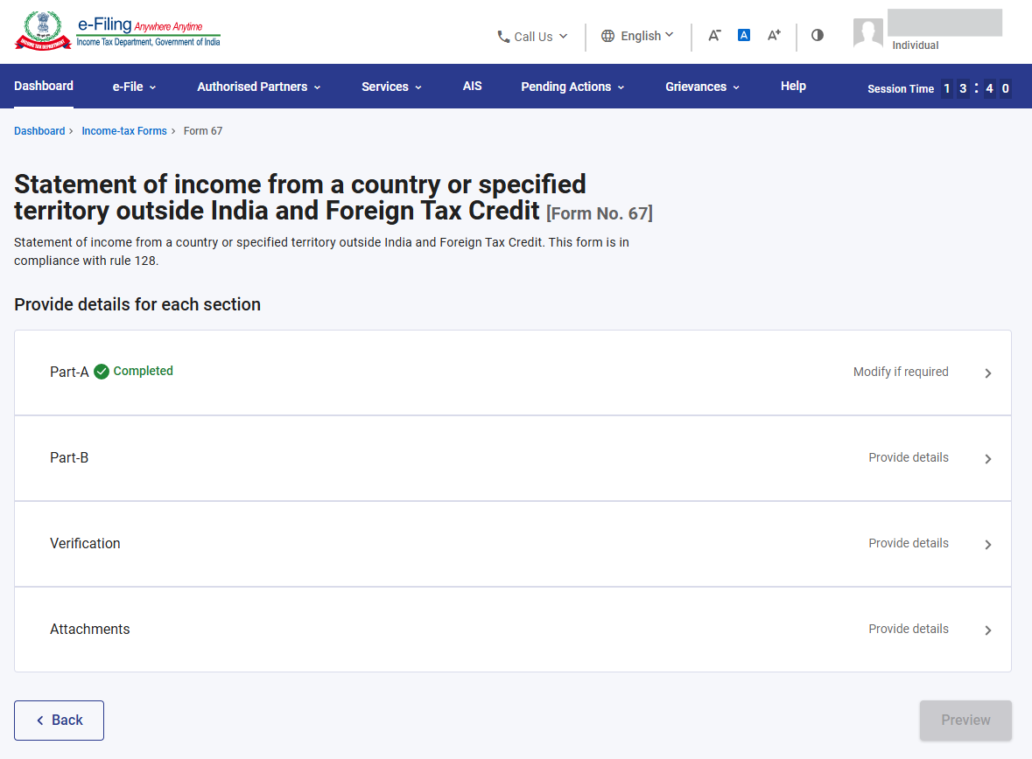
Step 7.2.b: This part contains 2 questions with respect to foreign tax.
Enter the details and click Save.
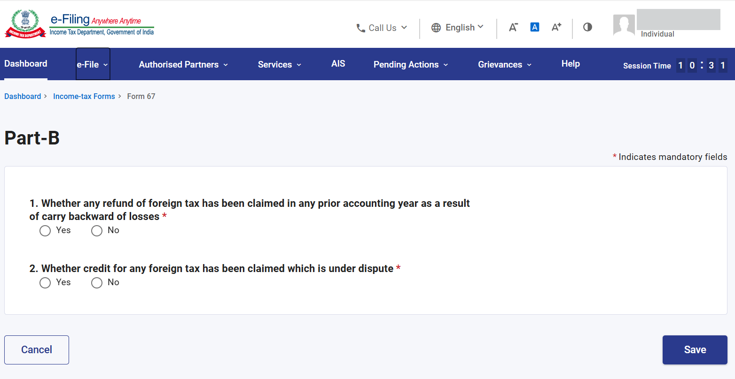
Step 7.3.a: Part B is confirmed now, click on Verification tab.
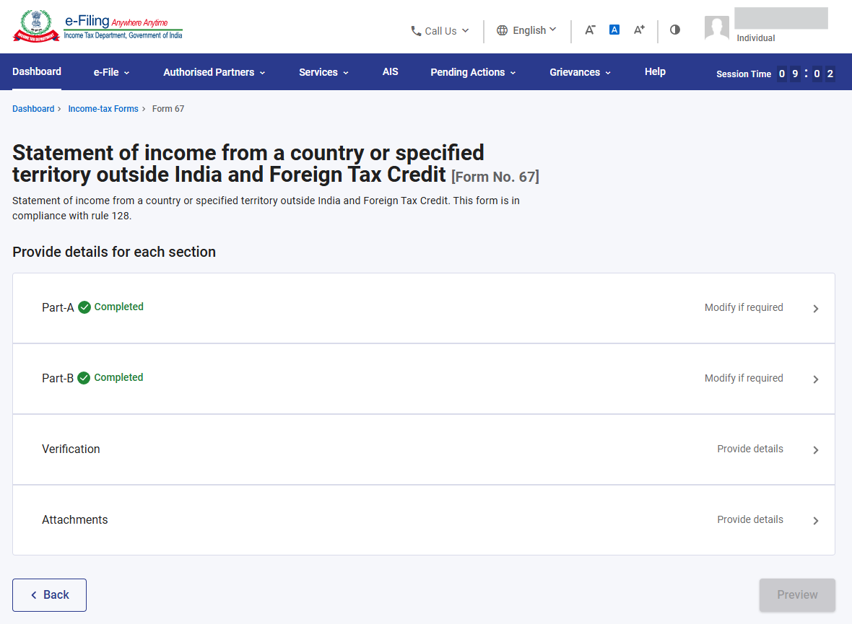
Step 7.3.b: Enter the details and click Save.
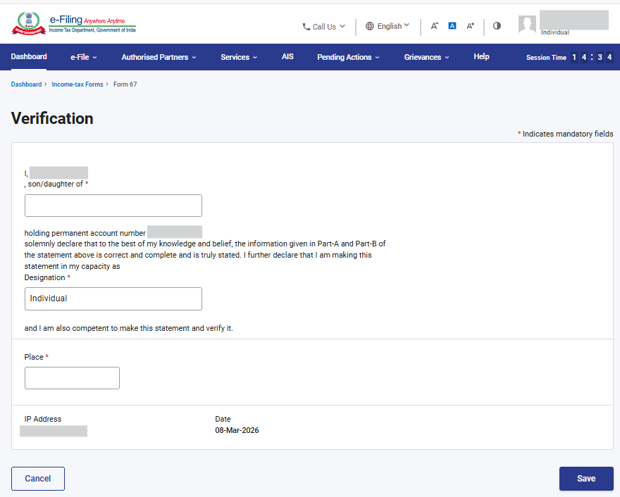
Step 7.4.a: Verification tab is now confirmed, click on Attachments tab.
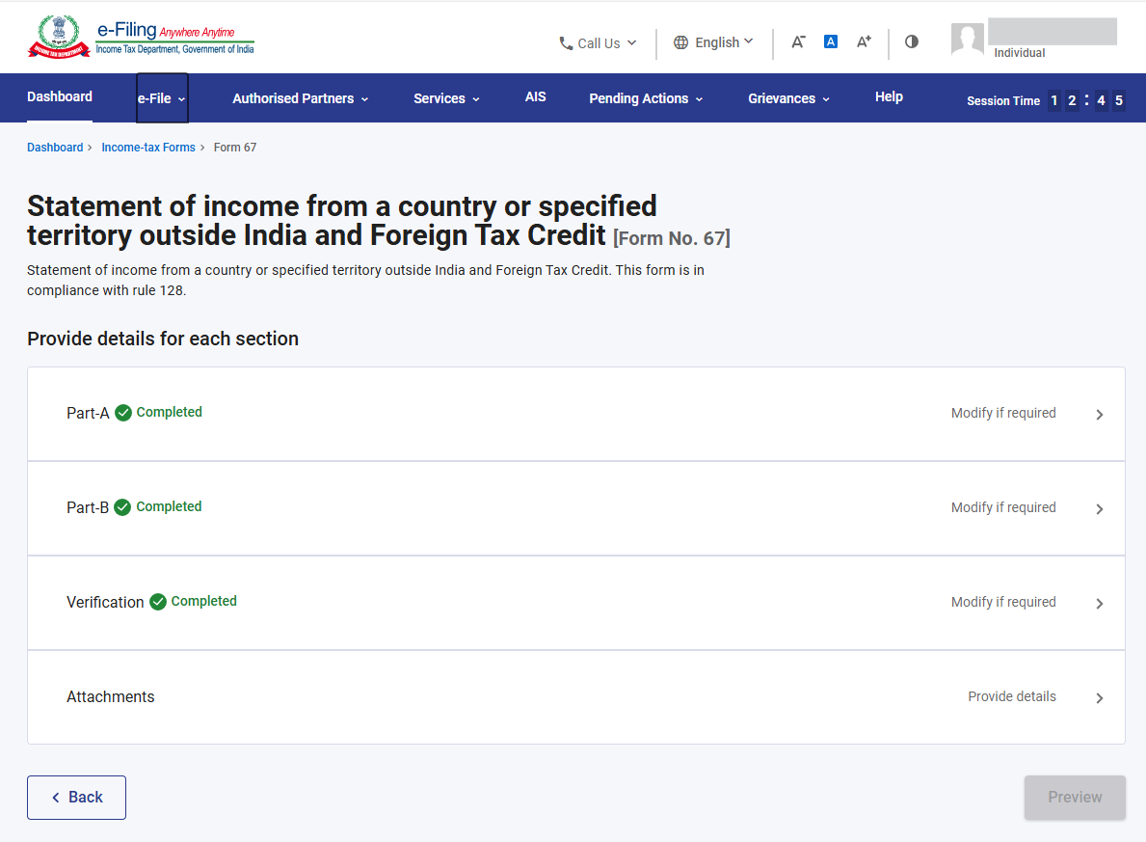
Step 7.4.b: It contains details of the Foreign Tax paid.
Note: Here assessee has to attach proof of payment/deduction of foreign tax. If there are multiple files than a zip file of the same should be created and attached. After attaching the required files click Save.
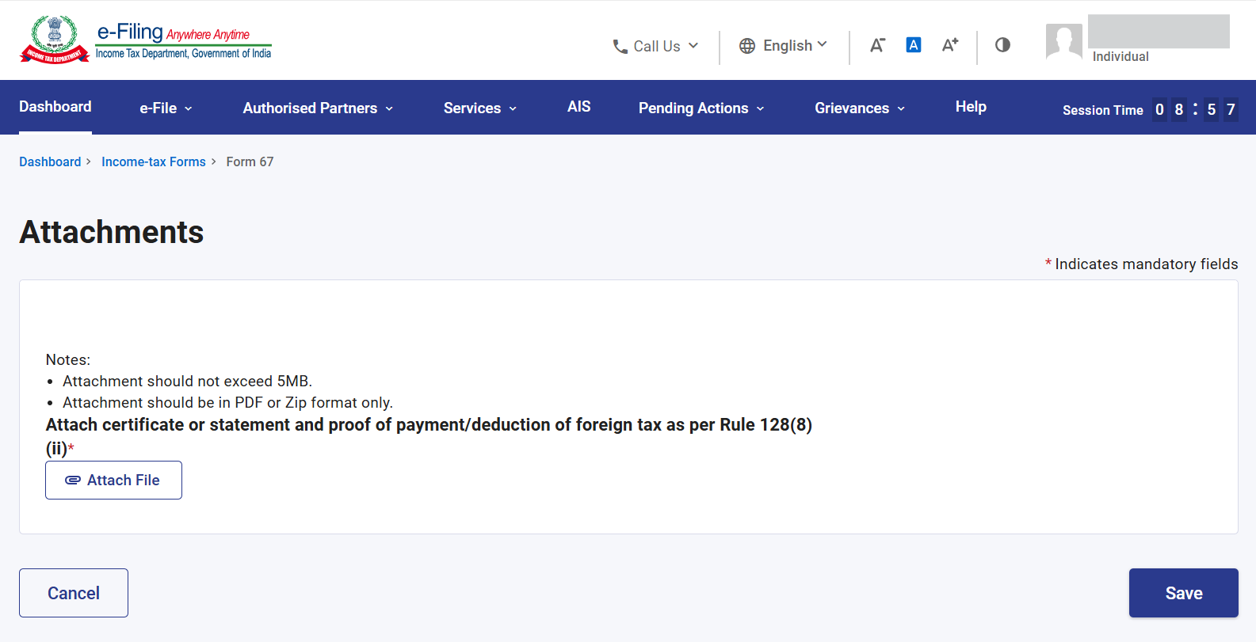
Step 8: All tabs are confirmed now. Click on Preview
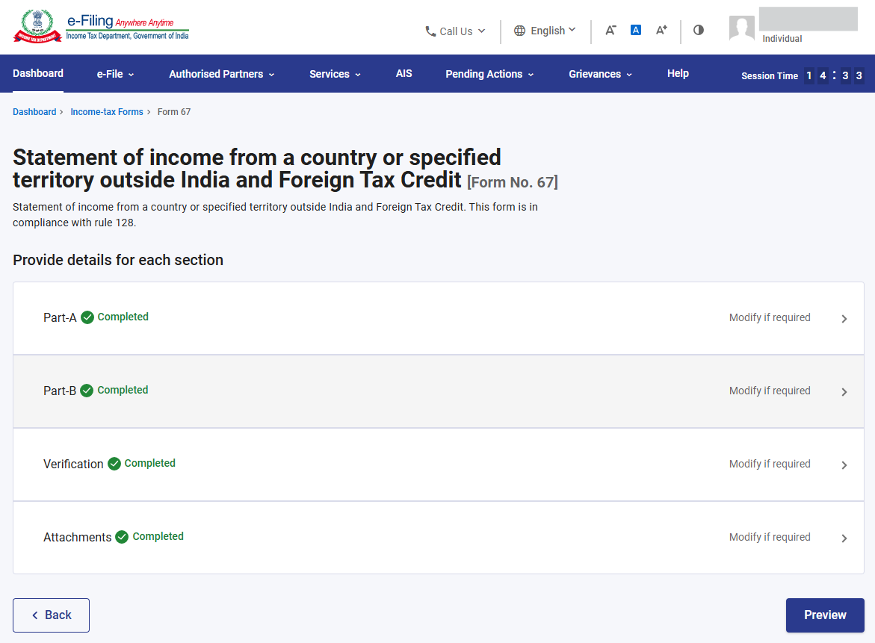
Step 9: This is the Preview of the Form. Click on Proceed to e-Verify, if details are correct in Preview, else you can edit the details.
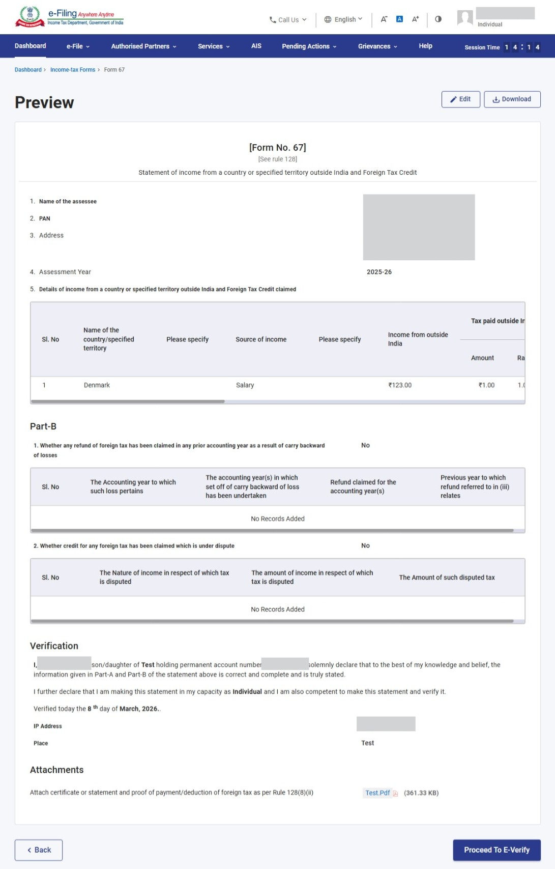
Step 10: You can e-Verify the Form through any of the modes of verification.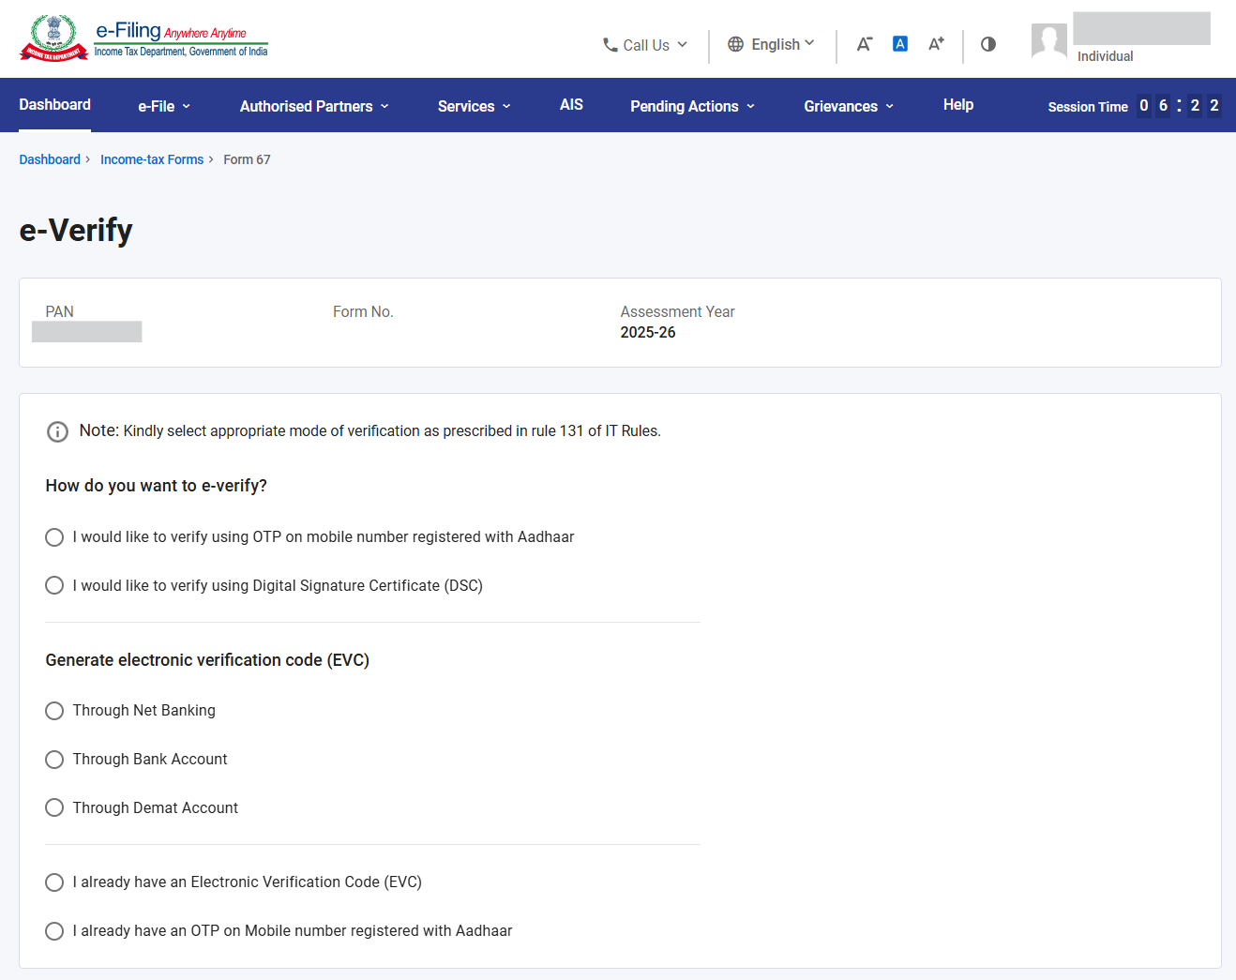
After e-Verification, Form 67 will be submitted. Acknowledgement number will be generated and communicated on registered e-mail Id and Mobile Number.

5. How to view filed form?
Go to e-file >Income Tax Forms > View Filed Forms>Forms as per Income Tax Act 1961.

