Revision History
Ver. | Date | Author | Reviewer/ Approver | Comments
01 | 19/01/2026 | Change and Learning Team  CA Vivek | Reviewer: Jyoti/ Monisha | Not Approved.MSP Remarks submitted.
02 | 23/02/2026 | Change and Learning Team  CA Vivek | Reviewer: Jyoti/ Monisha | Re-submitted Draft.

Reviewed By
SI. | Organization | Name | Designation
01 | Infosys | Jyoti/ Monisha | Business analyst
02 | ITD | M Devaki | Deputy Commissioner of Income Tax (DCIT)

Instant e-PAN User Manual

1. Overview
The Instant e-PAN service is available to all Individual taxpayers, who have not been allotted a Permanent Account Number (PAN) but possess Aadhaar.
This is a pre-login service, where you can:
- Obtain digitally signed PAN in electronic format, free of cost, with the help of Aadhaar and your mobile number linked with Aadhaar,
- Create e-Filing account based on e-KYC details after allotment of PAN, and
- Check status of pending e-PAN request / Download e-PAN either before or after logging in to the e-Filing portal.

2. Prerequisites for availing this service
- Individual who has not been allotted a PAN
- Valid Aadhaar and mobile number linked to Aadhaar
- User not a minor as on date of request; and
- User not covered under the definition of Representative Assessee u/s 160 of the Income Tax Act.
Note: As per provisions of Section 139A of Income Tax Act, 1961 or section 262 of Income Tax Act,2025, a person should not possess more than one PAN. As per Section 272B (1) of income tax act, 1961 or section 467 of new Income tax act, 2025 If a person fails to comply with the mentioned provisions, i.e. if a person possesses more than one PAN, it will attract a penalty of Rs. 10,000.

3. Step-by-Step Guide
3.1 Generate New e-PAN
Step 1: Go to the e-Filing portal homepage, click ‘Instant e-PAN’.
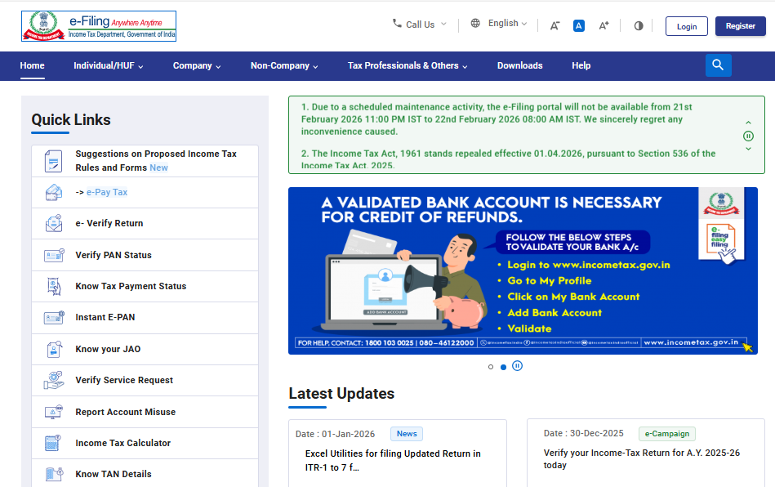

Step 2: On the ‘e-PAN’ page, click ‘Get New e-PAN’.
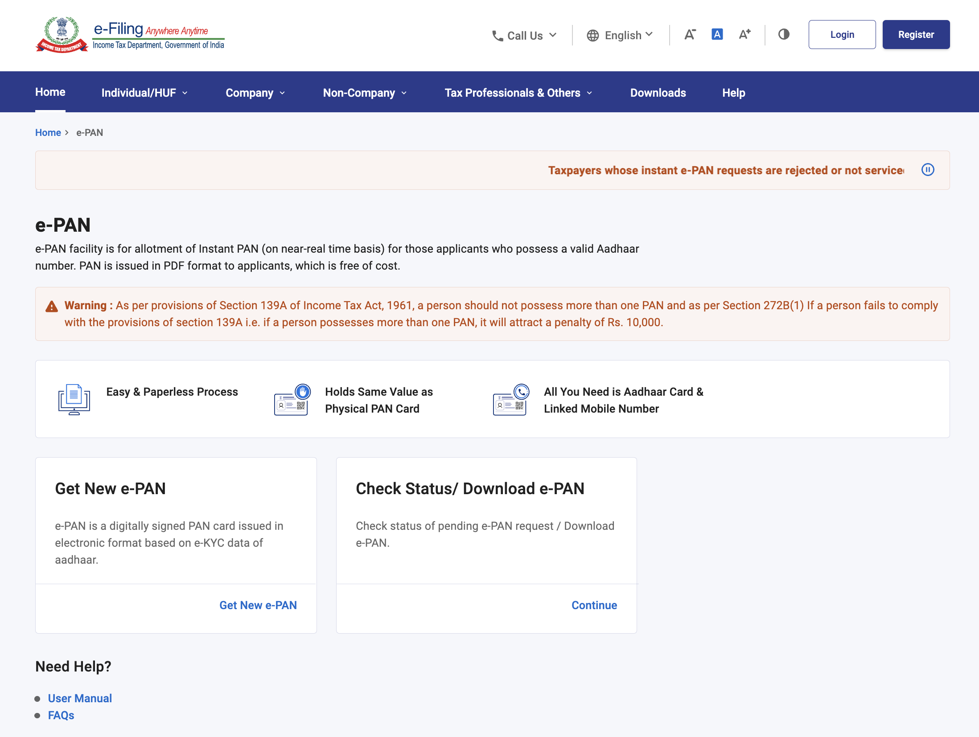

Step 3: On the Get New ‘e-PAN’ page, enter your 12-digit Aadhaar number, select the ‘I confirm that’ checkbox and click ‘Continue’.
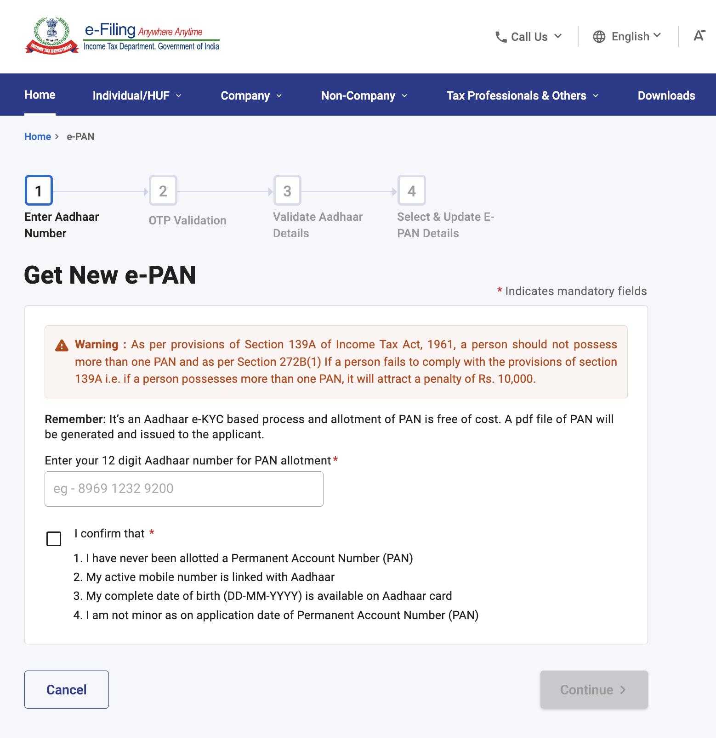

Note:
- If the Aadhaar is already linked to a valid PAN, the following message is displayed-
‘Entered Aadhaar Number is already linked with a PAN.’
- If the Aadhaar is not linked with any mobile number, the following message is displayed–
‘Entered Aadhaar Number is not linked with any active mobile number.’

Step 4: On the ‘OTP validation’ page, click ‘I have read the consent terms and agree to proceed further’. Click ‘Continue’.
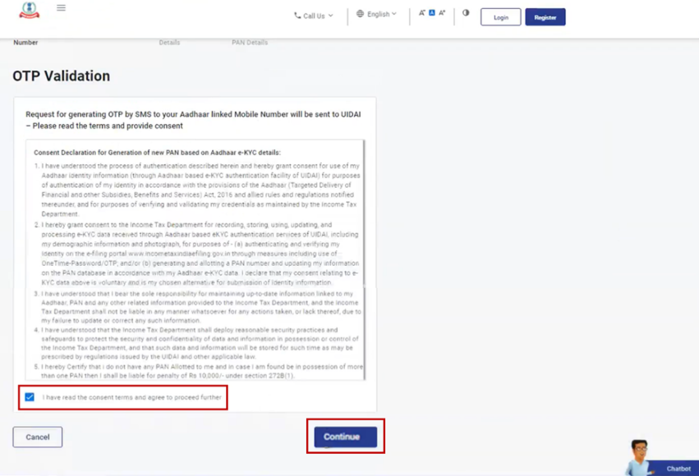

Step 5: On the ‘OTP validation’ page, enter the 6-digit OTP received on the mobile number linked with Aadhaar, select the checkbox to validate the Aadhaar details with UIDAI and click ‘Continue’.
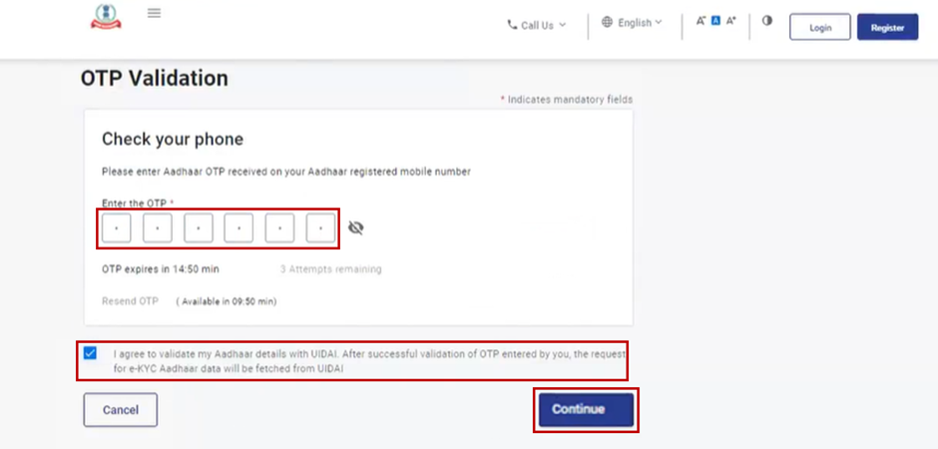
Note:
- OTP will be valid for 15 minutes only.
- You have 3 attempts to enter the correct OTP.
- On clicking Resend OTP, a new OTP will be generated and sent.

Step 6: On the Validate Aadhaar Details page, select the ‘I Accept that’ checkbox and click ‘Continue’.
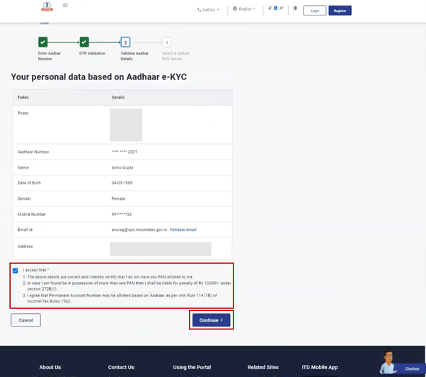
Note:
- Linking / Validating email ID (registered with your Aadhaar) is optional.
- If you have updated your email ID in Aadhaar but it has not been validated, click ‘Validate Email’. On the ‘Validate Email’ ID page, enter the 6-digit OTP received on your mobile number linked with Aadhaar and click ‘Continue’.
- If you have not updated your email ID in Aadhaar, click Link Email ID. On the ‘Validate Email’ ID page, enter the 6-digit OTP received on your mobile number linked with Aadhaar and click ‘Continue’.

On successful submission, a success message is displayed along with an Acknowledgement Number. Please keep a note of the Acknowledgement ID for future reference. You will also receive a confirmation message on your mobile number linked with Aadhaar.
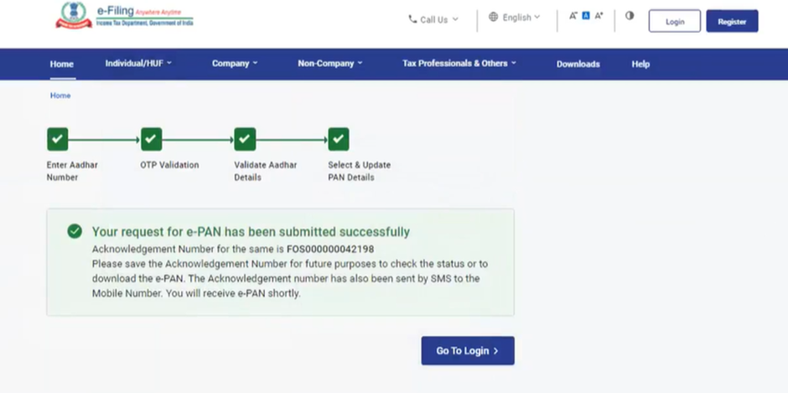

3.2 Check status of pending e-PAN request / Create e-Filing Portal account / Download e-PAN
Step 1: Go to the e-Filing portal homepage and click ‘Instant e-PAN’.
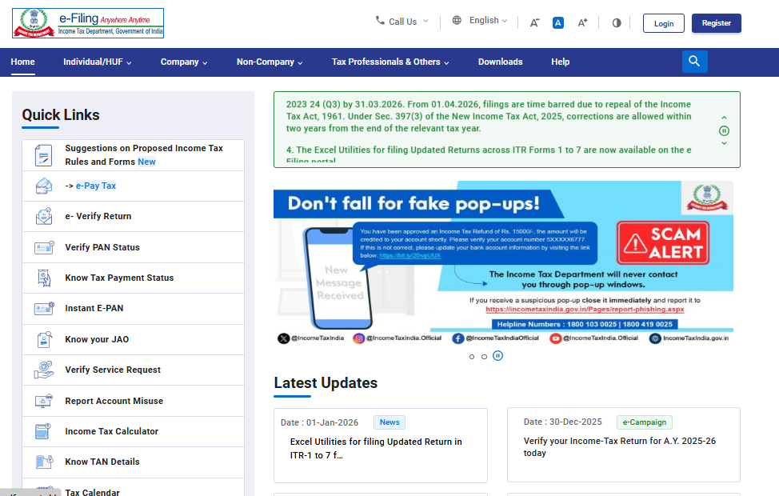
Step 2: On the e-PAN page, click ‘Continue’ on the ‘Check Status / Download e-PAN’ option.
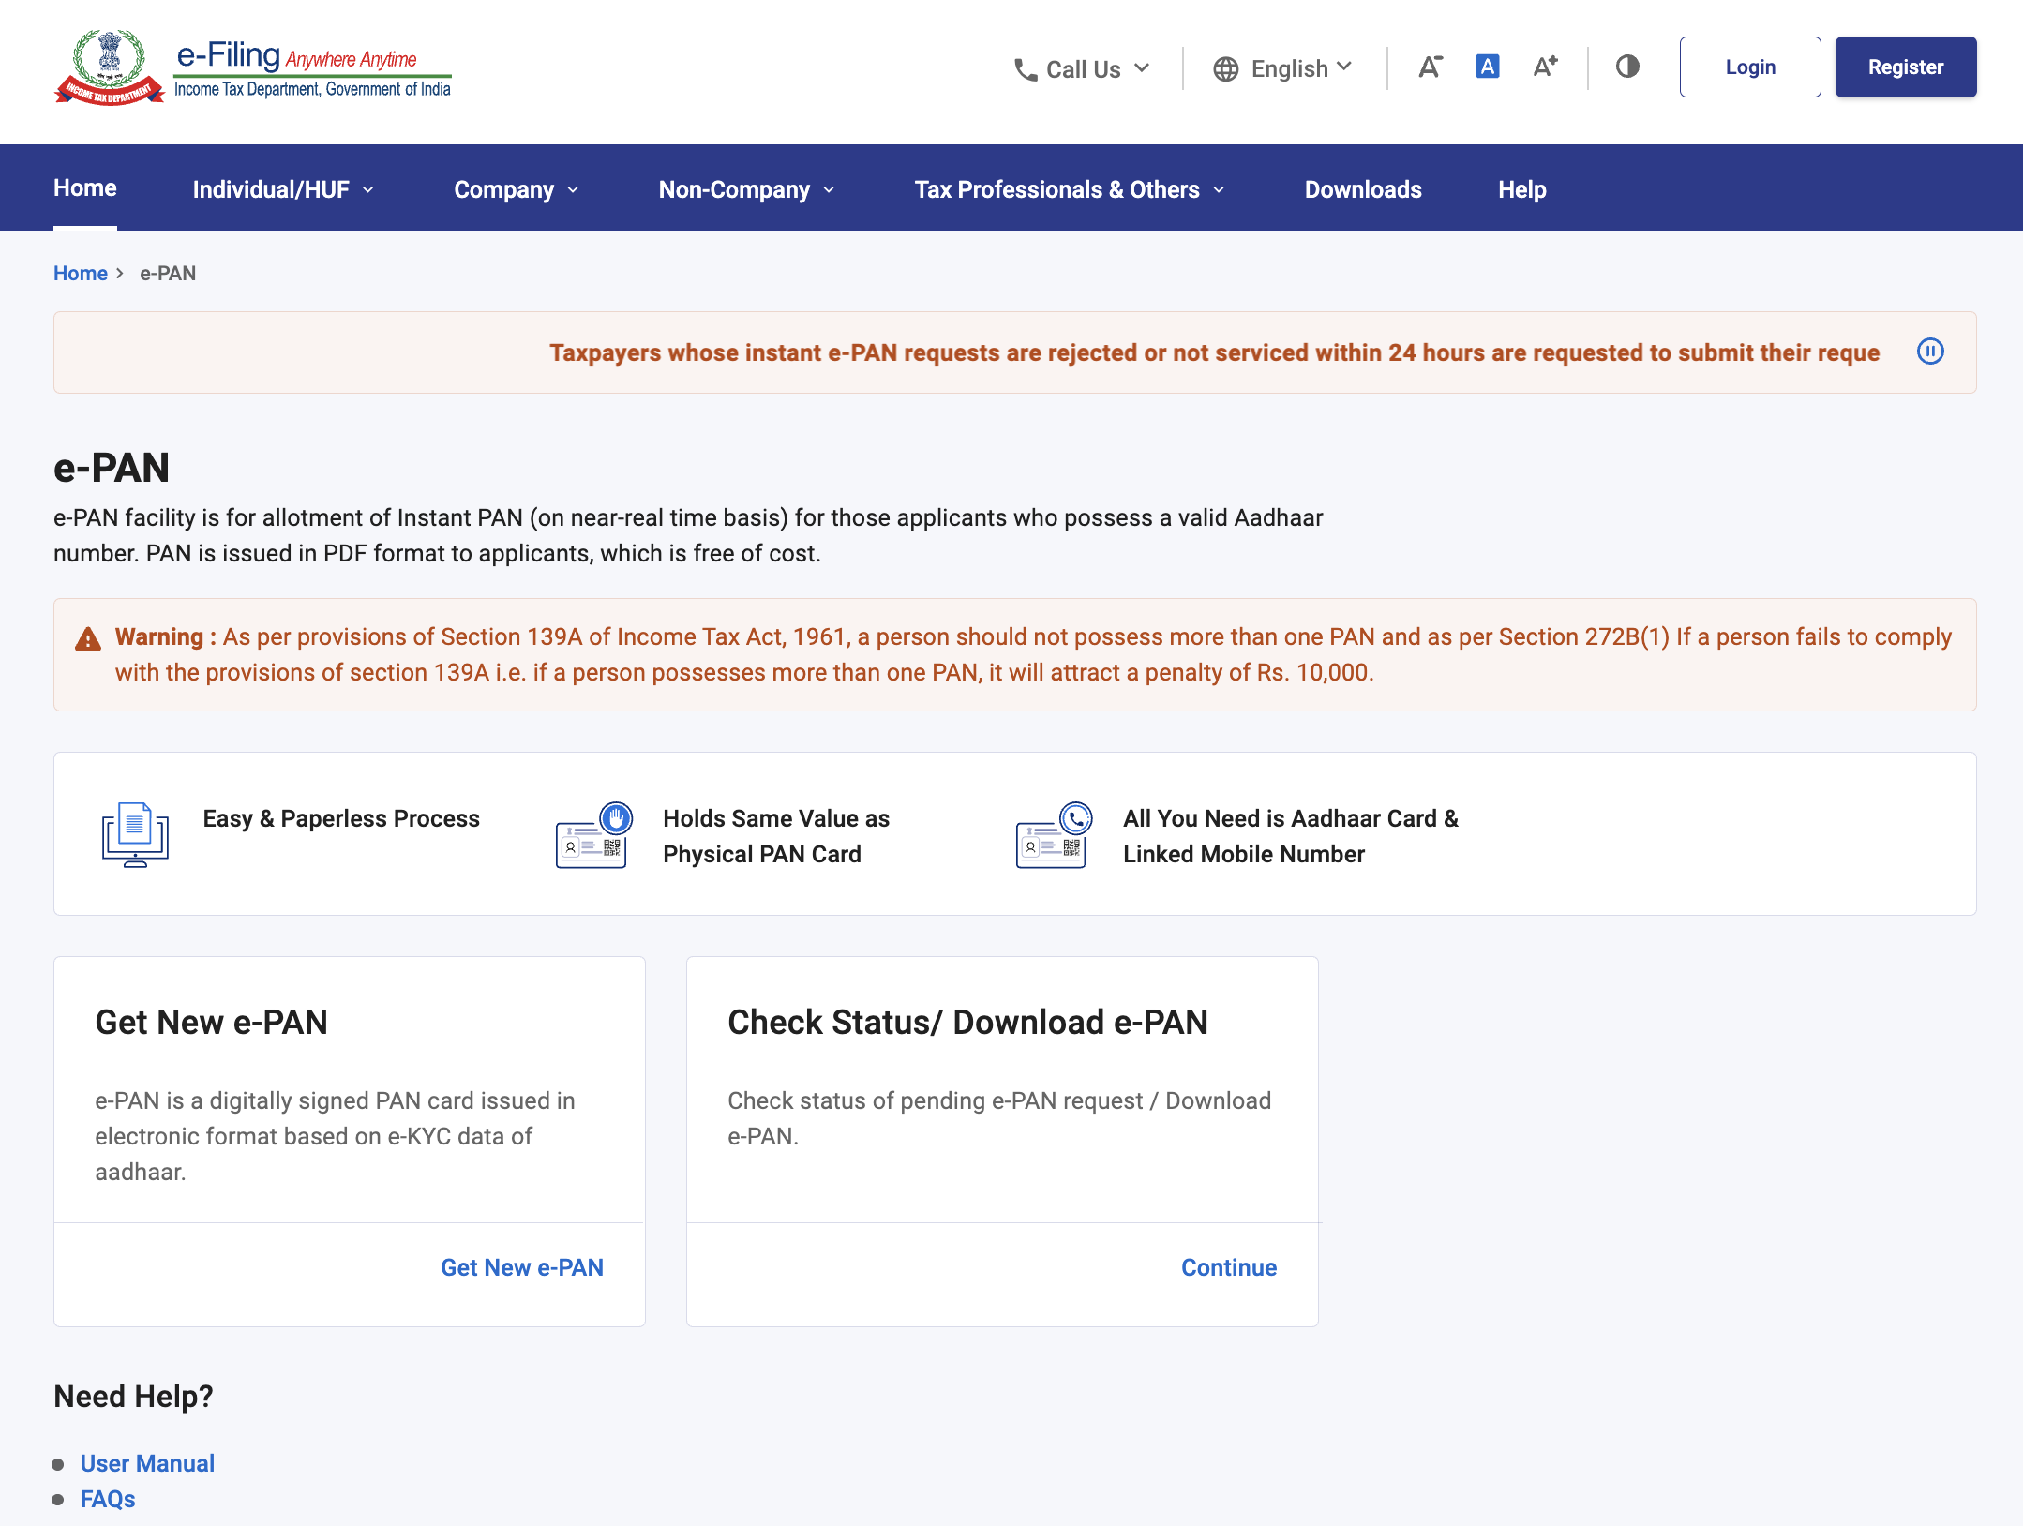
Step 3: On the ‘Check status / Download PAN’ page, enter your 12-digit Aadhaar and click ‘Continue’.
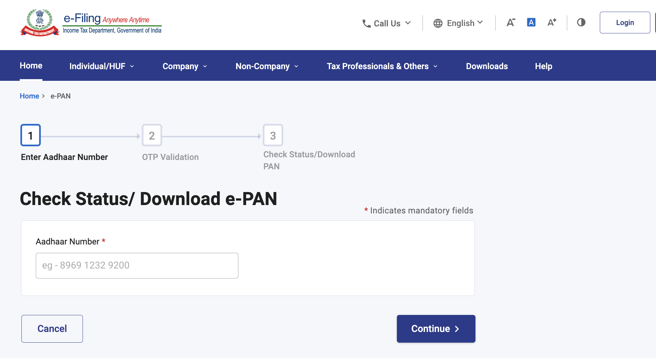
Step 4: On the ‘OTP Validation’ page, enter the 6-digit OTP received on your mobile number registered with Aadhaar and 'click ‘Continue’.
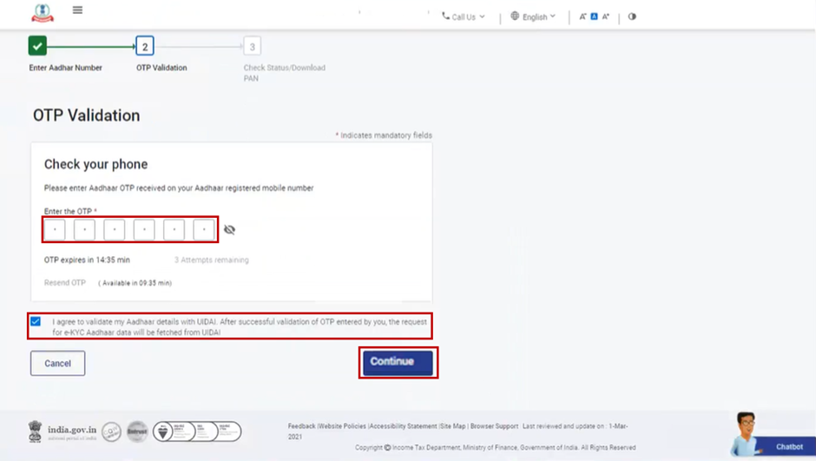
Note:
- OTP will be valid for 15 minutes only.
- You have 3 attempts to enter the correct OTP.
- On clicking ‘Resend OTP’, a new OTP will be generated and sent.

Step 5: On the Current status of your e-PAN request page, you will be able to see the status of your e-PAN request. In case the new e-PAN has been generated and allotted, click ‘View e-PAN’ to view or ‘Download e-PAN’ to download a copy. Click ‘Create e-Filing Account’ to register on the e-Filing portal.
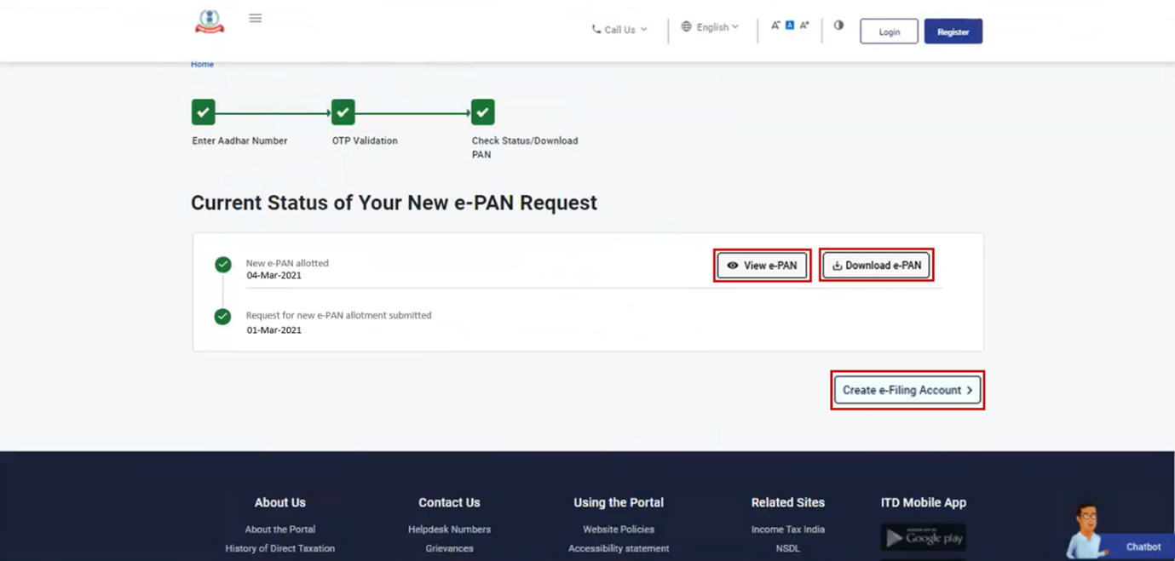
Note: If did not validate your email ID (as per your Aadhaar KYC) when generating your e-PAN, or while updating PAN details, it is compulsory to do so during registration.

3.3 Download e-PAN – Post Login
Step 1: Log in to the e-Filing portal using your User ID and password.
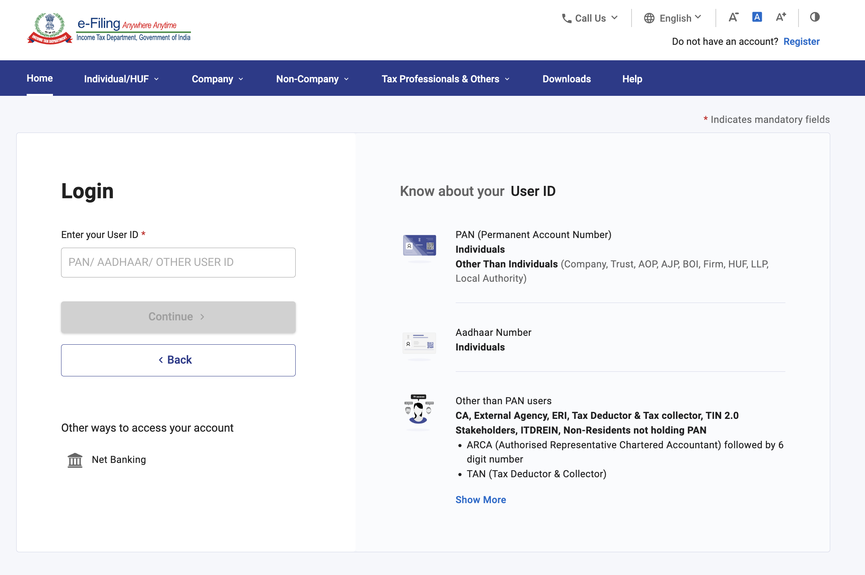
Note: You need to Register yourself on the e-Filing portal after receiving e-Pan. Only after successful registration, you can log in to the portal. Go to the Register for e-Filing (Taxpayer) user manual to learn more.
Step 2: On your Dashboard, click ‘Services’ > ‘View / Download e-PAN’.
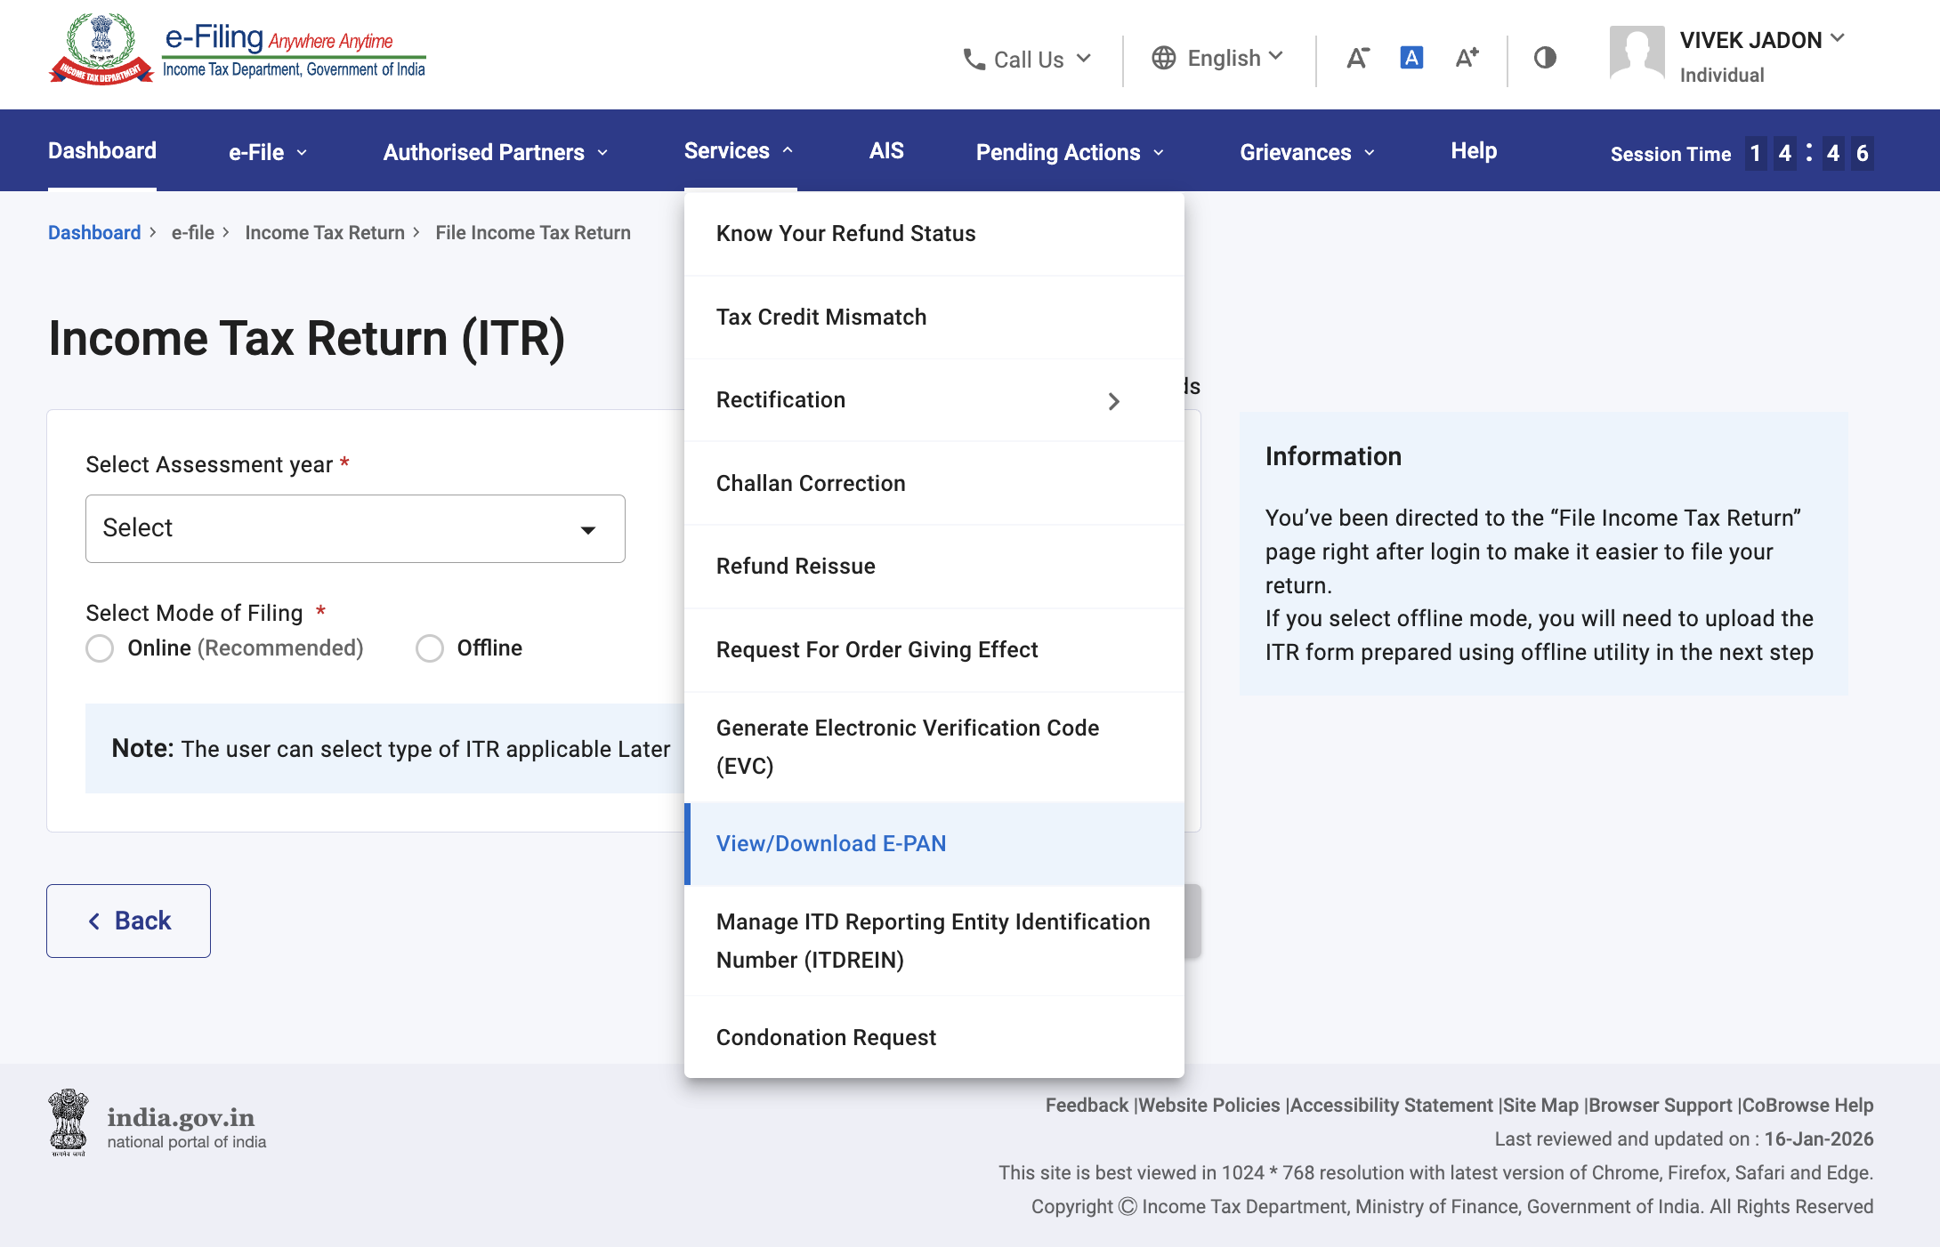
Step 3: On the ‘Enter Aadhaar Number’ page, enter your 12-digit Aadhaar number and click ‘Continue’.
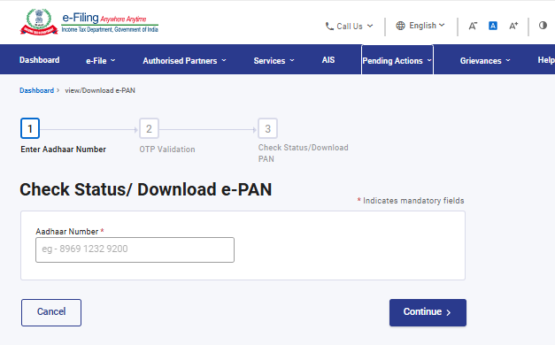
Step 4: On the ‘OTP Validation’ page, enter the 6-digit OTP received on your mobile number registered with Aadhaar and click ‘Continue’.
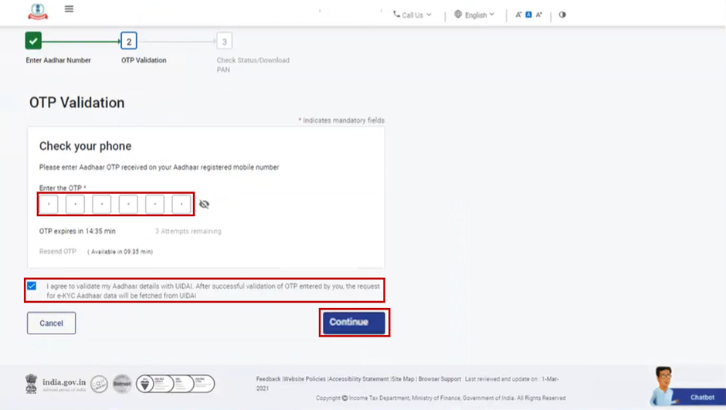

Note:
- OTP will be valid for 15 minutes only.
- You have 3 attempts to enter the correct OTP.
- On clicking Resend OTP, a new OTP will be generated and sent.
Step 5: On the ‘View / Download e-PAN’ page, you will be able to see the status of your e-PAN request. In case the new e-PAN has been generated and allotted, click ‘View e-PAN’ to view or ‘Download e-PAN’ to download a copy.
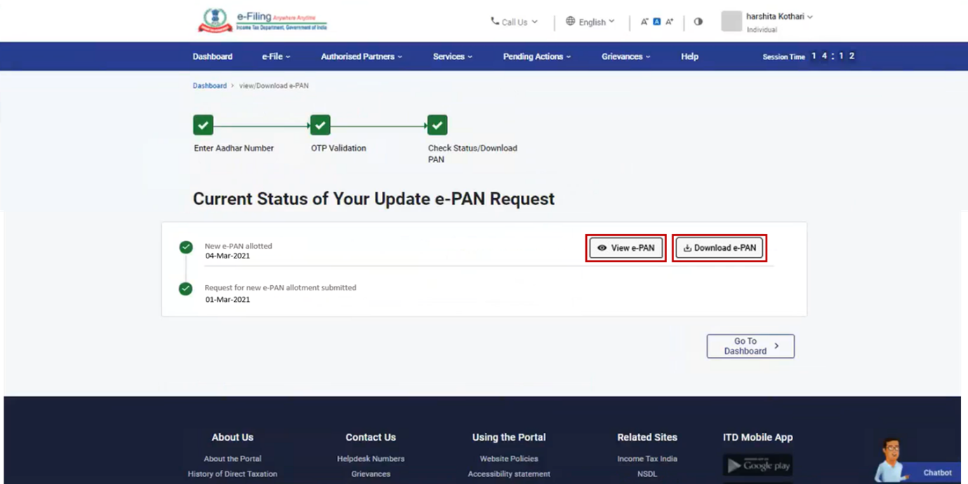
4. Related Topics
- Register for e-Filing (Taxpayer)
- Dashboard and Worklist
- Login
- Verify your PAN
- Link Aadhaar
- Know your TAN Details

