Revision History
Ver. | Date | Author | Reviewer/ Approver | Comments
01 | 19/01/2026 | Change and Learning Team  CA Vivek | Reviewer: Jyoti/ Monisha | Not Approved.MSP Remarks submitted.
02 | 23/02/2026 | Change and Learning Team  CA Vivek | Approver: M Devaki | Re-submitted Draft.

Reviewed By
SI. | Organization | Name | Designation
01 | Infosys | Jyoti/ Monisha | Business analyst
02 | ITD | M Devaki | Deputy Commissioner of Income Tax (DCIT)

Know Your JAO User Manual

1. Overview
The ‘Know Your JAO’ service is available to taxpayers who have a valid PAN.
This service is available to both registered or unregistered user on e-Filing portal.
This service allows you to view the details of the Jurisdictional Assessing Officer (JAO) for a particular PAN. You do not need to login to e-Filing portal to avail this service.

2. Prerequisites for availing this service
- Valid PAN
- Valid mobile number

3. Step-by-Step Guide
Step 1: Go to the e-Filing portal homepage. In quick links section, click ‘Know Your JAO’.
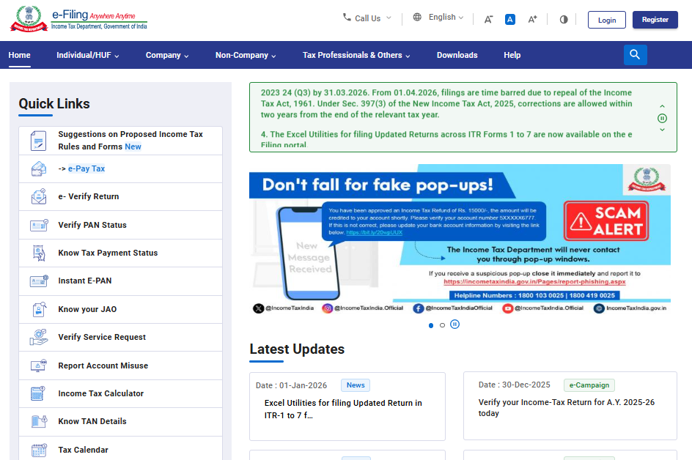
Step 2: On the ‘Know Your Jurisdictional Assessing Officer’ page, enter your PAN and a valid mobile number and click ‘Continue’.
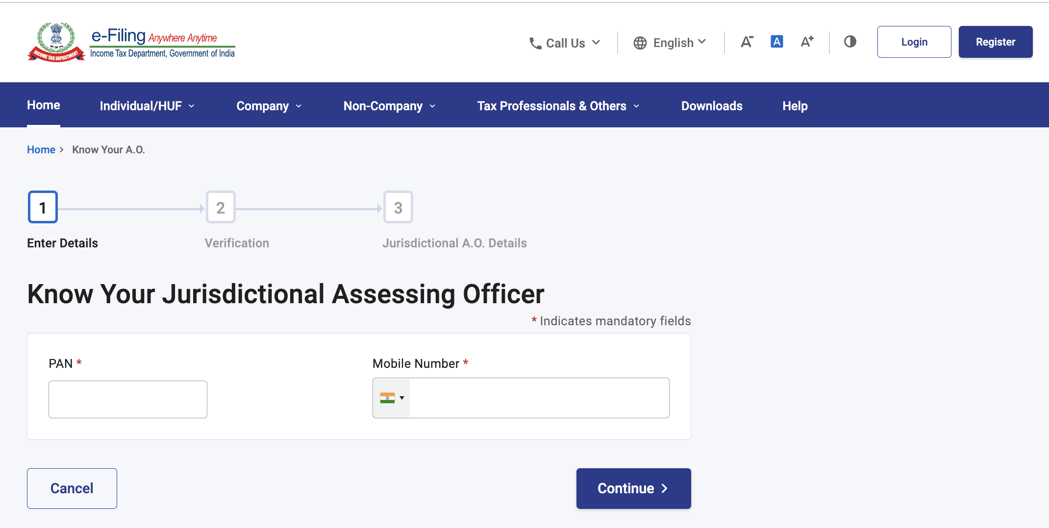

Step 3: You will receive a 6-digit OTP on the mobile number you entered in Step 2. Enter the OTP and click ‘Validate’.
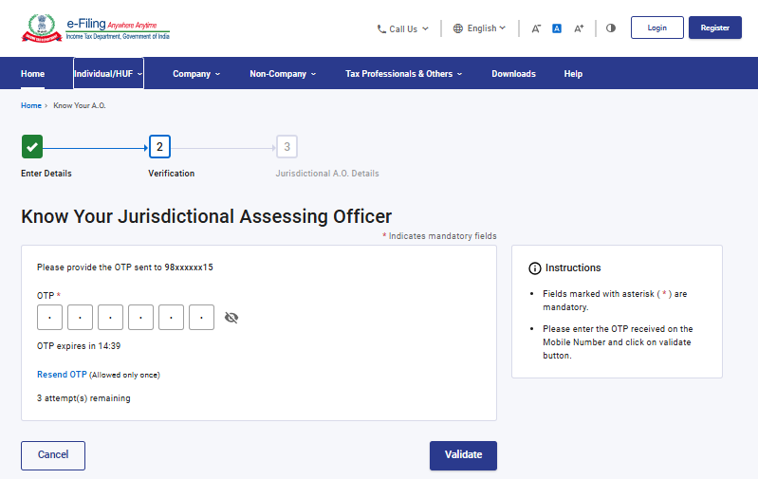
Note:
- OTP will be valid for 15 minutes only.
- You have 3 attempts to enter the correct OTP.
- The OTP expiry countdown timer on screen tells you when the OTP will expire.
- On clicking ‘Resend OTP’, a new OTP will be generated and sent.

On successful OTP validation, you will see the Jurisdictional Assessing Officer Details (such as Area Code, AO Type, Range Code, AO Number, Jurisdiction, Address and email ID of the JAO), along with status of your PAN.
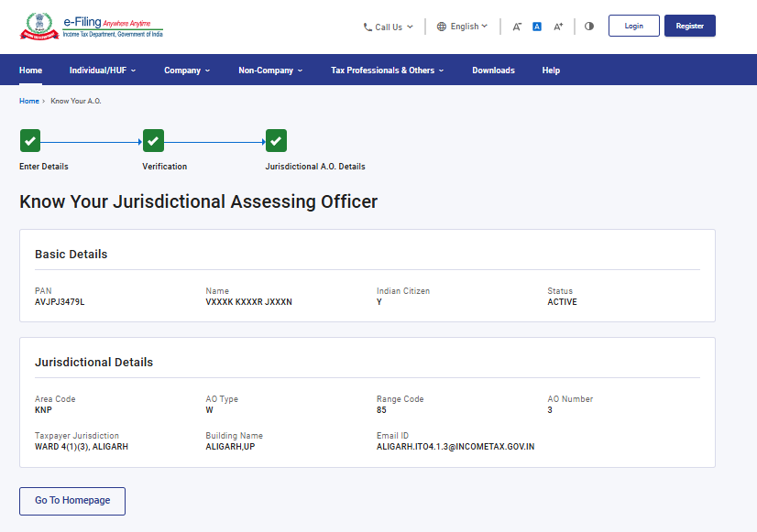

4. Related Topics
- Verify PAN
- Instant e-PAN
- Know TAN Details

