Register for e-Filing (Taxpayer) User Manual
1. Overview
This Pre-Login Service is available to all Taxpayers. This manual is meant for all taxpayers (except Companies who have another exclusive User Manual on the e-filing portal) who want to register and access the e-Filing portal. The Registration service enables the taxpayer to access and track all tax-related activities.
2. Prerequisites for availing this service
- Valid and active PAN
- Valid Mobile Number
- Valid email ID
3. Step-by-Step Guide
Step 1: Go to the e-Filing portal homepage, click Register.
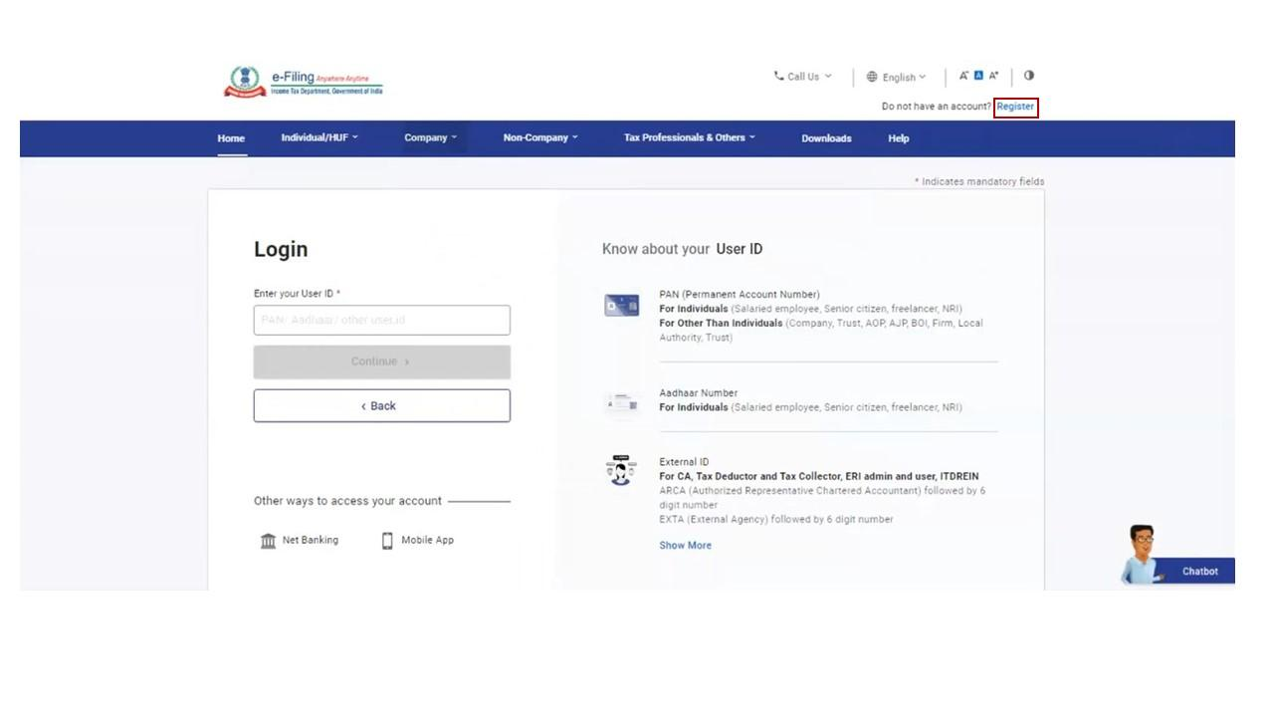
Step 2: Enter your PAN under Register as a Taxpayer option and click Validate. In case the PAN is already registered or invalid, an error message is displayed.
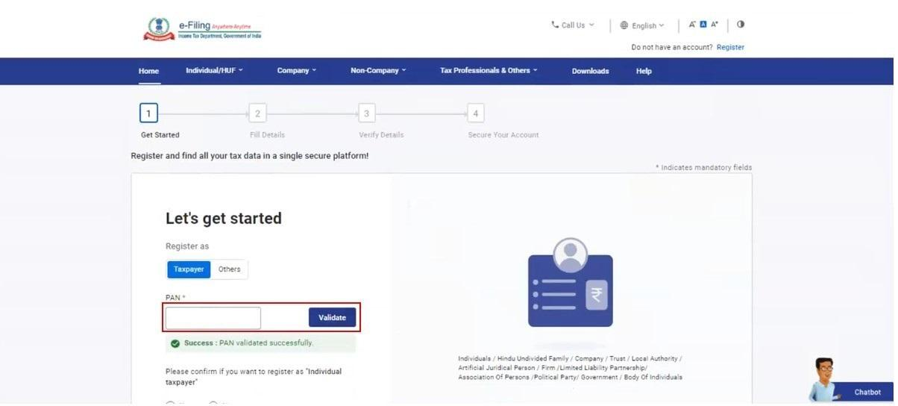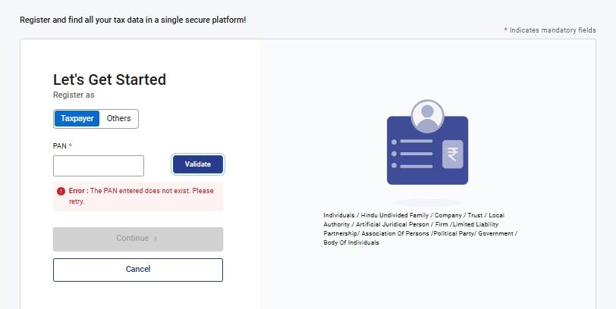
If PAN and Aadhar are linked then in pop up message, select checkbox to Confirm to validate details with UIDAI database.
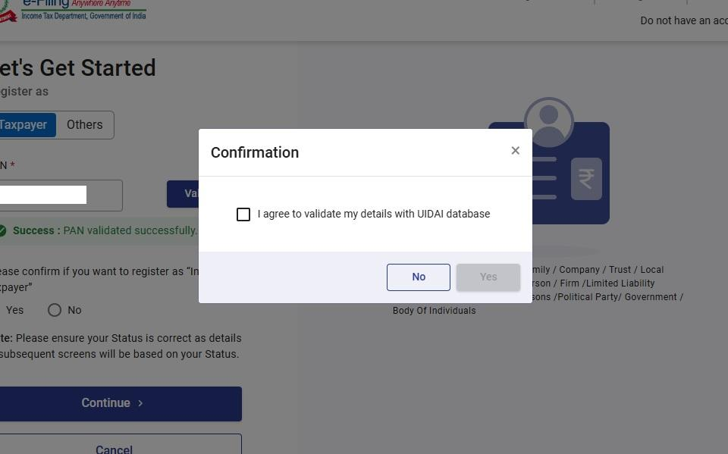
Step 3: Enter all the mandatory details including Name, DOB / DOI, Gender (if applicable) and Residential Status as per your PAN on the Basic Details page and click Continue.
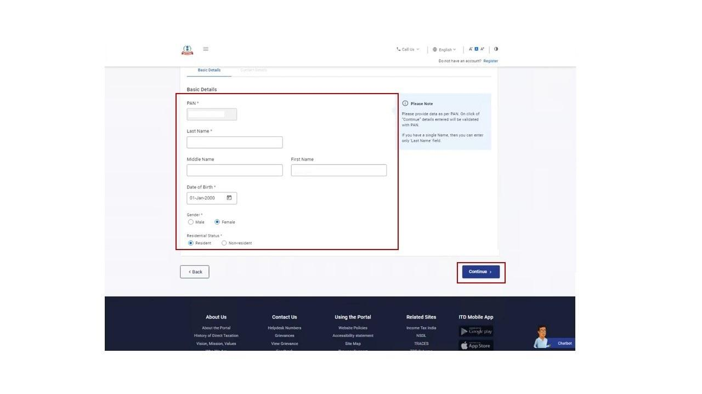
Step 4: After PAN is validated, the Contact Details page appears for individual taxpayers. Enter your Contact Details including Primary Mobile Number, email ID and Address. Click Continue.
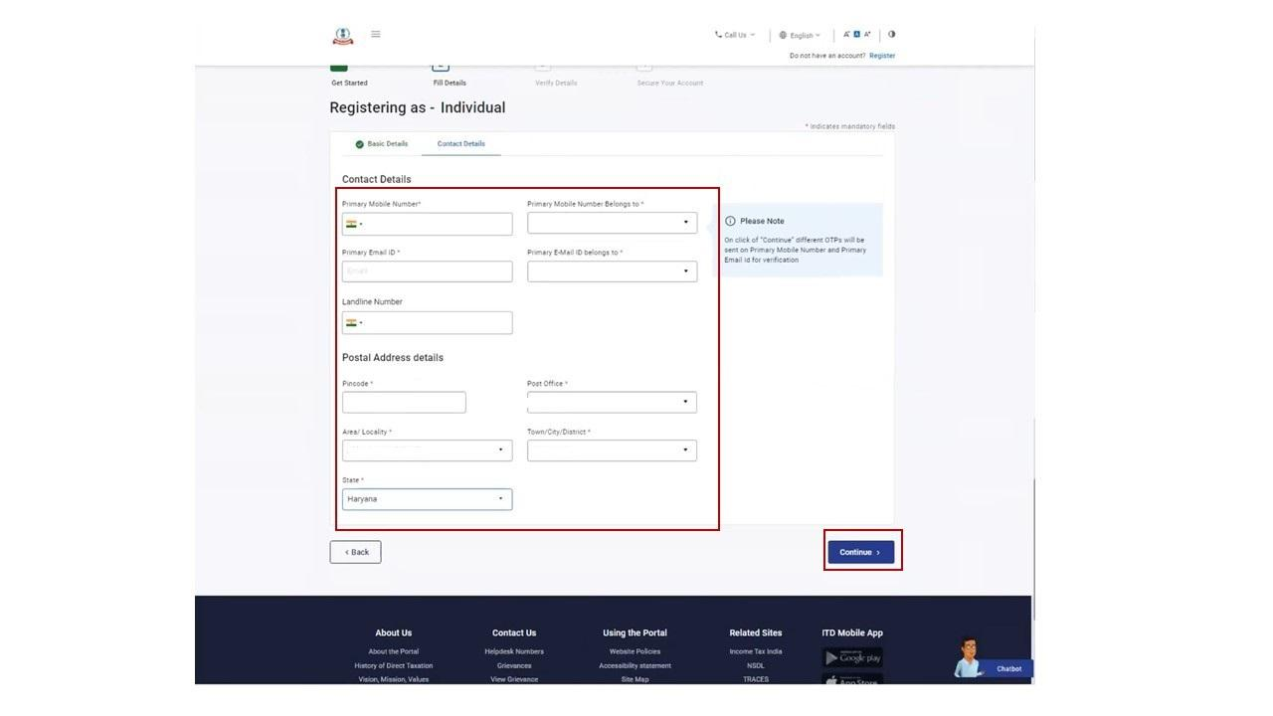
Step 5: Two separate OTPs are sent to the primary mobile number and email ID mentioned, Enter the separate 6-digit OTPs received on the mobile number and email ID and click Continue.
Note:
- OTP will be valid for 15 minutes only.
- You have 3 attempts to enter the correct OTP.
- The OTP expiry countdown timer on screen tells you when the OTP will expire.
- On clicking Resend OTP, a new OTP will be generated and sent.

Step 6: Edit the details in the Basic detail page if necessary and click Confirm.
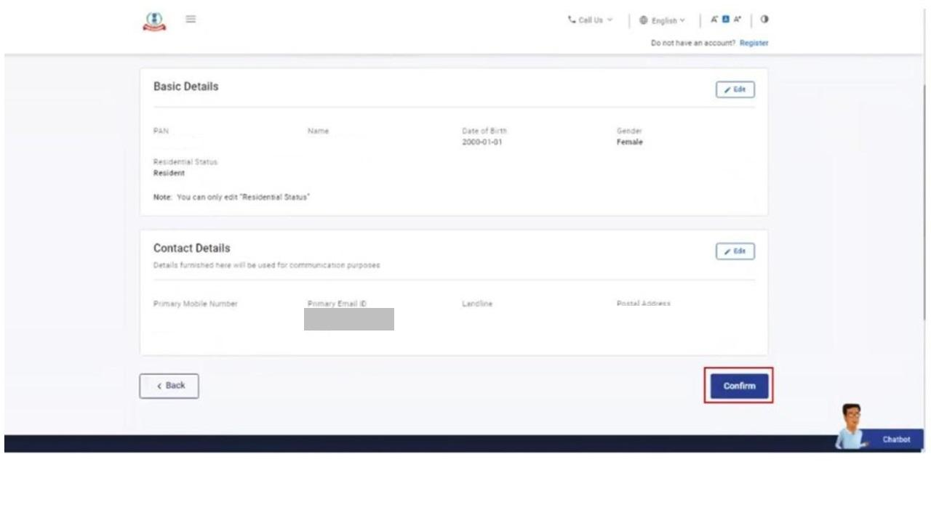
Step 7: On the Set Password page, enter your desired password in both the Set Password and Confirm Password textboxes. Enter your personalized message and click Register.
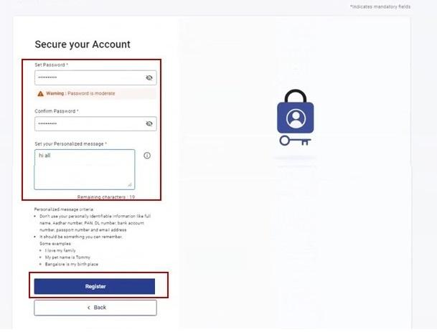
Note:
- Do not click Refresh or Back.
- While entering your new password, be careful of the password policy:
  - It should be at least 8 characters and at most 14 characters.
  - It should include both uppercase and lowercase letters.
  - It should contain a number.
  - It should have a special character (e.g. @#$%).
Step 8: When you are successfully registered, click Proceed to Login, to begin the login process.
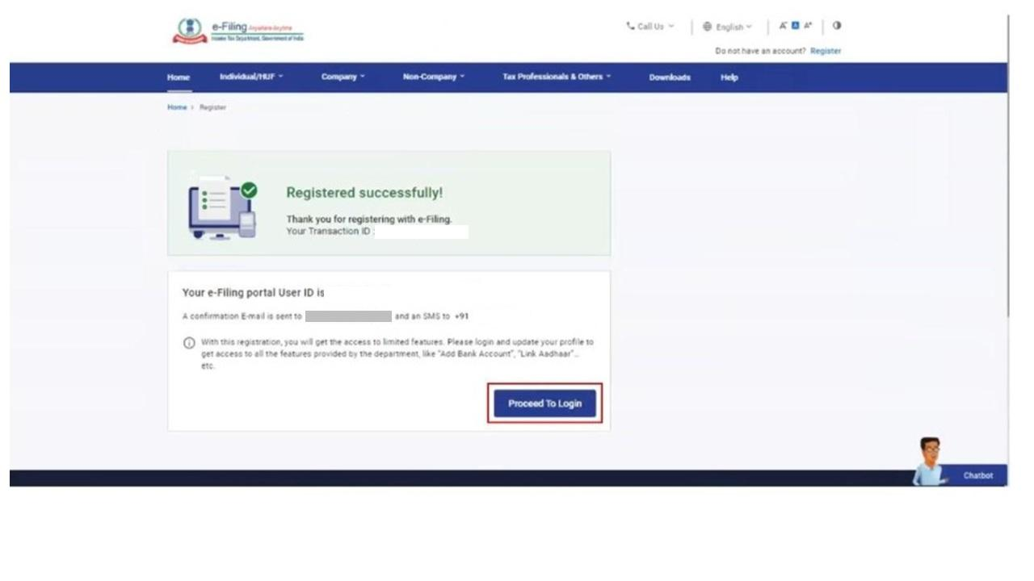

4. Related Topics
- Login
- Dashboard
- PAN Aadhaar Link
- Income Tax Return

